Marking scheme
FORM 4 BIOLOGY PRACTICAL
Term 3 2022
Time 1$\frac{3}{4}$ hours
Q1. You are provided with specimen Q
- (i) Identify main part of the specimen (1mk)

(Tap) root

(ii) State the functions of the part named in (a) (i) above (2mks)

It provides support
It absorbs water; and mineral salts;
It stores food;

(b)Using a surgical blade provided, cut a cube of 2cm x 2cm x 2cm; grind; add 3mls of distilled water, stir, then filter the paste. Using the filtrate test the foods present using the reagents provided. (8mks)

Food | Procedure | Observation | conclusion
Reducing  Sugar | To the filtrate  In test tube, add equal  Amount of Benedicts  Solution then heat/warm; | The filtrate changes colour from blue, to green, yellow and finally orange; | Reducing  Sugar  Present;
Vitamin c/  Ascorbic  Acid, | Put DCPIP  in a test tube, drop by drop  add the  filtrate; | The solution  Remains blue; | There is absence of  Vitamin C

(c) You are provided with specimen R and S
(i) Write down any two similarities between specimen R and S (2mks)
Both have two scars/both are fruits;
Both have stored food;
Both formed after fertilization/double fertilization;
Both dispersed by man.

(ii) Tabulate any two differences between specimen R and S (2mks)
R | S
Not fleshy | Its fleshy/succulent/juicy
Has the ability to germinate when sown | Has no ability to germinate when sown
Its white/creaming colour | Its orange in colour
Is scented | Not scented;
Has no remains of sepal | Has remains of sepal
It feels hard | It feels spongy

(ii) Using a blade provide; carefully make transverse section of specimen S.
Make a labelled diagram of the cut section. Label any three parts. (4mks)
Label 2mks
Proportionality 1
Magnification 1mk
Continuous outline 1mk
Max 4mks
(ii) Name the type of placentation (1mk)
axile
2.Study photographs shown below then answer the questions.

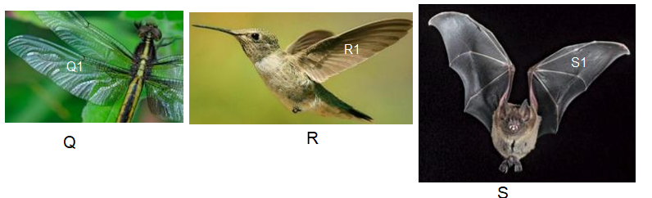

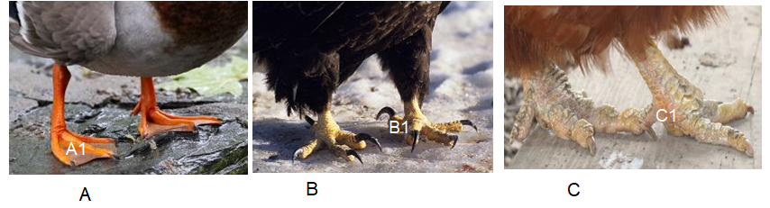

(a) State the type of evolution represented by structures Q1, R1 and S1. (1mk)
Convergent evolution

b) Explain the type of evolution identified in (a) above. (1mk)
Different structures with different embryonic origins are modified to perform similar functions

(c) Give the evolution term used to describe structures;

(i) Q1, R1 and S1. (1mk)
Analogous structures

(ii)A1, B1 and C1. (1mk)

Homologous structures

d). (i) Name classes for organisms labeled Q, R and S.
Q Insecta; (1mk)

R aves (1mk)

S mammalia (1mk)

(ii) Give two reasons for placing S in the class above (2mks)
Body covered with hair/fur
Has mammary glands
Has external ears/pinna

e) (i) Suggest the diet of animals B and R.
B flesh (1mk)

R nectar from flowers (1mk)

(ii) How is beak of animal B adapted to its function? (2mks)
Strong, curved and sharp; to rip flesh from bones.

3.Study the photomicrographs of cells below and answer the questions given.
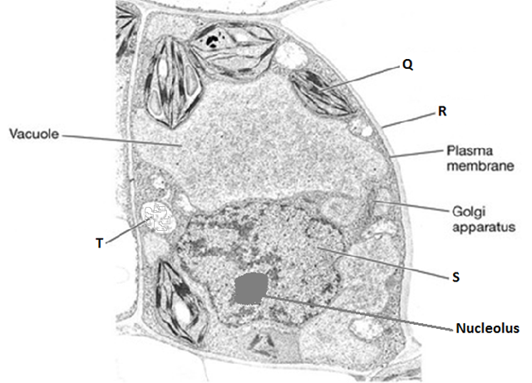

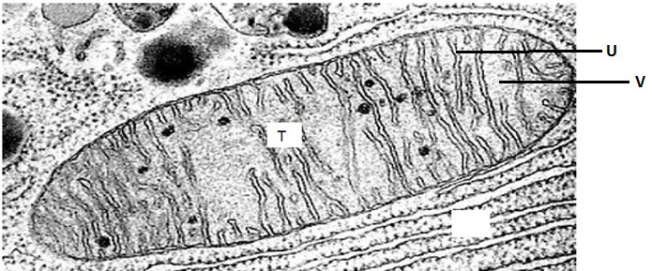
- Name the parts labeled. (3mks)
Q – Chloroplast;
R – Cell wall;
U- Cristae;

- What is the function of
- Organelle Q. (1mk)
Site for photosynthesis;
- Golgi bodies. (2mks)
- Package and transport glycoproteins;
- Transport of synthesized materials out of the cell as secretions;
- Section of synthesized proteins and carbohydrates;
- Form lysosomes;

- How is organelle T adapted to its function? (1mks)
- - inner membrane folded into cristae to increase surface area for attachment of respiratory enzymes;
- - matrix have numerous enzymes to catalyse respiratory reactions;

