NAME ……………………………………..…… DATE ……………………ADM NO. ……..

INDEX NO. …………….………………….. SIGNATURE ….………..…..………..

231/2
BIOLOGY
PAPER TWO
FORM FOUR
TIME: 2 HOURS

OPENER EXAMINATION TERM 3, 2022
Kenya Certificate of Secondary Education

INSTRUCTIONS TO CANDIDATES: -
  - Write your name, Admission number and class in the spaces provided above.
  - Answer all the questions in the spaces provided
  - Candidates should answer the questions in English.

- a) What is meant by the term genetic counseling? (1mk)

b) State two examples of discontinuous variation in humans. (2mks)

c) A female with sickle cell trait marries a normal man. The allele for sickle cell is HbS and the normal allele is HbA. Determine the probability that their first born will have the sickle cell trait. Show your working. (5mks)

- The diagram below shows surface view of a human brain.
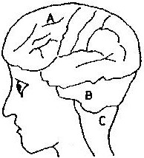

a) Name the parts labeled B and C. (2mk)
B
C
b) State three functions of the part labelled A (3mk)

(c) State what would happen if the part labelled A was damaged (1mk)

(d) Name any two tactic responses of plants (2mks)

3. A response exhibited by a certain plant tendril is illustrated below
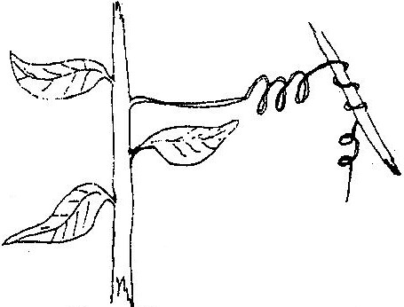

a) i) Name the type of response (1mk)

ii) Explain how the response named in (a)(i) above occurs. (2mk)

b) What is the importance of tactic responses to microscopic organisms? (1mk)

c) State four applications of plant hormones in agriculture. (4mk)

4. (a)(i) How do animals obtain nitrogen element in their bodies? (1mk)

(ii) State the importance of the process of denitrification in nitrogen cycle. (2mks)

(iii) In what form is the protein material in dead organism converted into by saprophytic bacteria and Fungi? (1mk)

(b) Study the pyramid of numbers below and answer the questions that follow.

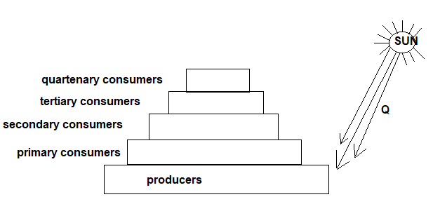

- Identify energy Q (1mk)

(ii) What is the role of energy Q in producers? (1mk)

(c) Using an arrow of about 1cm indicate the energy flow in the pyramid. (1mk)

(d) Through which process is energy lost in a food chain. Name one. (1mk)

5. The table below shows the approximate percent concentration of various components in blood plasma entering the kidney glomerular filtrate and urine of a healthy human being.

Component | Plasma | Glomerular | Urine Filtrate
Water | 90 | 90 | 94
Glucose | 0.1 | 0.1 | 0
Amino Acids | 0.05 | 0.05 | 0
Plasma proteins | 8.0 | 0 | 0
Urea | 0.03 | 0.03 | 2.0
In organic ions | 0.72 | 0.72 | 1.5

a) Name the process responsible for the formation of glomerular filtrate. (1mk)

- What process is responsible for the absence of glucose and amino acids in urine? (1mk)

- Explain why there are no plasma proteins in the glomerular filtrate. (1mk)

- Besides plasma proteins what other major component of blood is absent in the glomerular filtrate. (1mk)
- Why is the concentration of urea in urine much higher than its concentration in the glomerular filtrate? (2mk)

- Name the tubules that drain:-
- Urine from kidney to urinary bladder (1mk)

- Urine from urinary bladder to external environment (1mk)

SECTION B
Answer question 6 compulsory and either question 7 or 8 in the spaces provided after question 8

6. The table below shows the rate of product formation for two enzymes, K and L over a range of pH values.
pH | 1.0 | 2.0 | 3.0 | 4.0 | 5.0 | 6.0 | 7.0 | 8.0 | 9.0 | 10.0
Rate of product formation for enzyme K ( mg/hr) | 34.5 | 40.5 | 35.5 | 15.0 | - | - | - | - | - | -
Rate of product formation for enzyme L (mg/hr) | - | - | - | 15.0 | 20.0 | 30.0 | 40.5 | 23.5 | 11.0 | 6.0

- On the same axis, plot graphs of the rate of product formation against pH. (8mks)

- Account for the rate of product formation for enzyme K between
- pH 1.0 and 3.0 (3mks)

- pH 3.0 and 7.0 (3mks)

- From the graph, determine
- The pH value at which the rate of product formation of the two enzymes was the same. (1mk

- The value of the rate of product formation for enzyme K and L at the pH value stated in c (i) above. (1mk)

- The optimum pH value for enzyme L. (1mk)

- State one variable that may lead to the change in the optimum rate of product formation of the two enzymes. (1mk)

Suggest with a reason, the likely part of the human alimentary canal where enzyme K would be found. ( 2mks)

7. Explain the various ways in which a typical cell is adapted to its functions (20mks)

8. Describe the structure and functions of the various parts of the mammalian ear (20mks)

