**NAME ……………………………………..…… DATE ……………………ADM NO. ……..**

**INDEX NO. …………….………………….……..….. SIGNATURE ….………..…..………..**

**231/1**

**BIOLOGY**

**PAPER ONE**

**FORM FOUR**

**TIME: 2 HOURS**

**OPENER EXAMINATION TERM 3, 2022**

***Kenya Certificate of Secondary Education***

**INSTRUCTIONS TO CANDIDATES: -**

* + *Write your name, Admission number and class in the spaces provided above.*
  + *Answer all the questions in the spaces provided*
  + *Candidates should answer the questions in English.*

*Answer all questions in the spaces provided*

1. Give a reason why using a sharp blade is necessary when sectioning during preparation of specimens for observation under the microscope. (1mk)
2. The following reaction may occur in a forward and backward direction



a) Name the organelle where the above reaction occurs.

(i) Forward direction (1mk)

(ii) Backward direction (1mk)

(b)Give one difference for the two organelles named in (a) above (1mk)

|  |  |
| --- | --- |
| Chloroplast | Mitochondrion |
|  |  |
|  |  |

1. The chart below represents how respiratory gases are transported in the human blood.

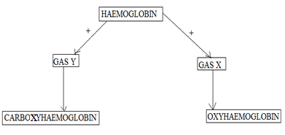

1. Identify gas Y. (1mk)
2. Name the advantages that oxyhaemoglobin has over carboxyhaemoglobin. (2mks)

|  |  |
| --- | --- |
| Oxyhaemoglobin | Carboxyhaemoglobin |
|  |  |

1. The paddles of whales and the fins of fish adapt these organisms to aquatic habitats.

a) Name the evolutionary process that may have given rise to these structures. (1mk)

b) What is the name given to such structures? (1mk)

c) Give two examples of vestigial organs in man. (2mks)

1. State one physiological and one structural difference between a cell wall and cell membrane. (2mks)

|  |  |  |
| --- | --- | --- |
|  | Cell wall | Cell membrane |
| Physiological |  |  |
| Structural |  |  |

1. Name the organelles that carry out the following functions (2mks)
2. Formation of spindle fibres
3. Osmoregulation
4. The diagram below shows part of alimentary canal of a mammal

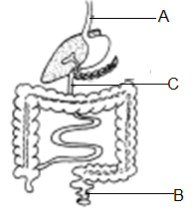

1. Name the parts labeled A and C (2mks)

A -

C -

1. State the function of the part labeled B. (1mk)
2. Name the part of the chloroplast where the following reactions occur.

a) Carbon (IV) oxide fixation. (1mk)

b) Photolysis. (1mk)

1. Polydactyl is a genetic disorder in which people inherit an extra digit. Polydactyl is caused by a dominant allele (B). The table below describes the different genotypes for polydactyl.
2. Complete the table below by giving the correct genotype, alleles of each genotype and the expected number of fingers per hand. (4mks)

|  |  |  |
| --- | --- | --- |
| Genotype | Alleles | Expected number of digits per hand. |
| Homozygous dominant |  | Six |
|  | bb |  |
| Heterozygous. | Bb |  |

1. The table below shows results of marriages between various parents. Complete the table by writing the probability of each marriage producing a child with polydactyl. One has been done for you. (2mks)

|  |  |
| --- | --- |
| Parental genotypes. | Probability of child with polydactyl |
| Bb X BB | 1 |
| Bb X bb |  |
| Bb X Bb |  |

1. (a) What are the end-products of respiration in animals when there is sufficient oxygen supply?

(1mks)

1. State two characteristic of visking tubing used in osmosis process? (2mks)
2. . Explain the physiological process responsible for keeping the seedlings upright. (3mks)
3. List down substances that depend on diffusion, to be exchanged across the placenta of a female Human being. (3mks)

1. (a) What is meant by the term seed dormancy? (1mk)

(b) State any two external causes of seed dormancy (2mks)

1. Explain what is meant by the following terms?
2. Plasmolysed cell (2mks)
3. A crenated cell (2mks)
4. . List down any two domestic applications of anaerobic respiration (2mks)
5. State two processes through which heat energy produced by respiration lost from human body?

(2mks)

1. Account for the absence of glucose and proteins in the glomerular filtrate.

(a) Glucose (1mk)

(b) Proteins (1mk)

1. Plants relatively have less waste to excrete than animals. Give two reasons to explain this observation. (2marks)
2. Homeostasis is defined as the maintenance of a stable internal environment in the body.

What is meant by expression ‘internal environment’? (1 mk)

1. Name one factor that is maintained at a relatively constant level in the body by the following organs. (2mks)
2. Liver
3. Kidneys
4. . Explain two ways in which the trachea is adapted to perform its functions. (2mks)
5. The diagram below represent the reflex arc in human

**

(a) Name the parts labelled P and S (2mks)

(b) State the function of the part labelled Q (1mk)

(c) Name the fluid contained in part labelled R. (1mk)

1. State two classes of the classes of the phylum Arthropoda in which the body is divided into cephalothorax and abdomen. (2mks)
2. Briefly explain two adaptive features present in animal respiratory surfaces that are absent in plant respiratory surfaces. (2mks)
3. . State two external characteristics that distinguish mammals from other vertebrata (2mks)
4. State two functions of the choroids in the human eye. (2mks)
5. Explain the effect of temperature above 400C to the germinating seed. (4mks)

1. . Examine the diagrams below and answer the questions that follow.

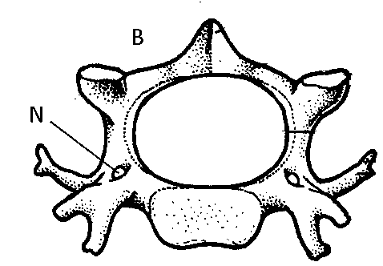

(a) Give the identity of bone shown in the diagram above(1mks)

(b) Give **two** reasons for your answer in a(i) above ( 2mks)

1. a) State two effects of dumping untreated sewage into a river. (2 mks)

b) Name the causative agents of amoebic dysentery disease in human. (1 mk)

1. What is the importance of the following in external fertilization?

a) Laying of many eggs (1 mark)

b) Mention two adaptations of human sperm to its function ( 2 mks)