NAME ……………………………………………………………….ADM……………CLASS…………….
MID TERM THREE EXAM 2022
FORM THREE BIOLOGY PAPER ONE
Answer all questions in the spaces provided
- Insects’ blood is noted to lack a respiratory pigment. Explain (1 mark)
………………………………………………………………………………………………………………………………………………………………………………………………………………………………
- State the function of the following parts of a nephron.
- Loop of Henle (1 mark)
………………………………………………………………………………………………………………………………………………………………………………………………………………………………
- Distal convoluted tubule. (1 mark)
………………………………………………………………………………………………………………………………………………………………………………………………………………………………
- Most terrestrial plants do not grow well in water logged soils. Give a reason for this (1mark)
………………………………………………………………………………………………………………………………………………………………………………………………………………………………
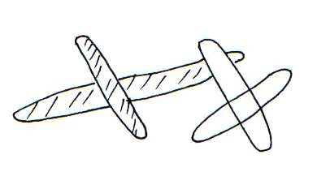
- The diagrams below show a pair of homologous chromosomes. Study them and answer the questions that follow.

- State the phenomenon shown above (1mark)
………………………………………………………………………………………………………………………………………………………………………………………………………………………………
(ii) What is the genetic significance of the phenomenon above? (2 marks)
………………………………………………………………………………………………………………………………………………………………………………………….………………………..…………
- Give two destinations of food translocated from the leaves of plants. (2 marks)
………………………………………………………………………………………………………………………………………………………………………………………………………………………………
- Name the organelle that is likely to be found in abundance in:
- An enzyme secreting cell.
………………………………………………………………………………………………………………
- Cells producing lipid related secretions.
………………………………………………………………………………………………………………
- Areas where the cells have raptured
………………………………………………………………………………………………………………
- A small boy remarked that his dog looks larger on cold days than on hot days. Give a biological explanation for this. (2 marks)
………………………………………………………………………………………………………………………………………………………………………………………….………………………..…………
- The table below shows the percentage composition of carbon (IV) oxide and oxygen in inhaled and exhaled air.
Gases | Inhaled air | Exhaled air
Oxygen | 20 % | 17%
Carbon (IV) oxide | 0.04% | 4.0%
Explain the differences in percentage of the two gases in inhaled and exhaled air.
- Oxygen (2 marks)
………………………………………………………………………………………………………………………………………………………………………………………….………………………..………….
- Carbon (IV) oxide (2 marks)
………………………………………………………………………………………………………………………………………………………………………………………….………………………..…………
- The diagram below represents a pyramid of biomass derived from a certain ecosystem.
Consumer
Producer

- Suggest the type of ecosystem from which the pyramid was derived (1 mark)
………………………………………………………………………………………………………………………………………………………………………………………….………………………..…………
- State the significance of short food chains in an ecosystem. (1 mark)
………………………………………………………………………………………………………………………………………………………………………………………….………………………..…………
- Distinguish precisely between diabetes mellitus and diabetes insipidus ( 2 marks)
………………………………………………………………………………………………………………………………………………………………………………………….………………………..………………………….

- The set up below shows apparatus to demonstrate a certain biological process
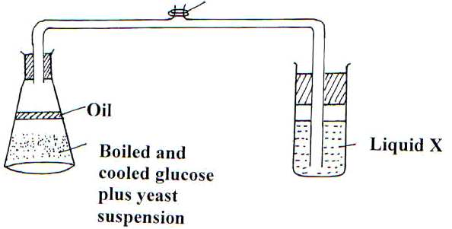

- What biological process was being investigated in the experiment (1 mark)
……………………………………………………………………………………………………………………………………………………………………………………….…………………………..…………
- Write down a word equation that represents the reaction above. (1 mark)
……………………………………………………………………………………………………………………………………………………………………………………….…………………………..…………
- In the above set up, why was it important to boil and cool glucose before adding yeast? (1 mark)
……………………………………………………………………………………………………………………………………………………………………………………….…………………………..…………
- Name the excretory products eliminated by the following animals.
- Tilapia. (1 mark)
………………………………………………………………………………………………………………………………………………………………………………………………………………………………
- Chicken. (1mark)
………………………………………………………………………………………………………………………………………………………………………………………………………………………………
- Name the causative organism of the following diseases.
- Malaria (1mark)
………………………………………………………………………………………………………………………………………………………………………………………………………………………………
- Bilharzia (1mark)
………………………………………………………………………………………………………………………………………………………………………………………………………………………………
- Identify the part of light microscope which serve each of the functions described below
- Making rough focus ( 1mark)
………………………………………………………………………………………………………………………………………………………………………………………………………………………………
- Reflecting light from the source (1 mark)
………………………………………………………………………………………………………………………………………………………………………………………………………………………………
- State two characteristics of aerenchyma tissue. (2marks)
………………………………………………………………………………………………………………………………………………………………………………………………………………………………
- What is the significance of transpiration in plants? (3marks)
………………………………………………………………………………………………………………………………………………………………………………………………………………………………………………………………………………………………………………………………………………………………………………………………………………………………………………………………
- State two ways in which xylem vessels are adapted to their functions. ( 2marks)
………………………………………………………………………………………………………………………………………………………………………………………………………………………………………………………………………………………………………………………………………………………………………………………………………………………………………………………………
- State the characteristics that distinguish the following organisms into their respective classes (3 marks)
Millipedes,spider and tsetse fly.
………………………………………………………………………………………………………………………………………………………………………………………………………………………………………………………………………………………………………………………………………………………………………………………………………………………………………………………………
- How do identical twins and fraternal twins arise?
- Identical twins (2 marks)
……………………………………………………………………………………………………………………………………………………………………………………………………………………………
- Fraternal twins. (2 marks)
………………………………………………………………………………………………………………………………………………………………………………………………………………………………
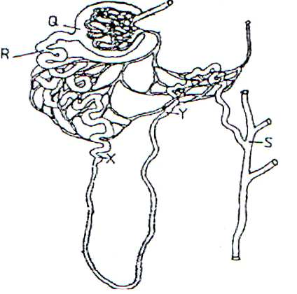
- The diagram below illustrates part of a nephron from a mammalian kidney.

- Name the fluid found in the part labeled Q. (1 mark)
………………………………………………………………………………………………………………………………………………………………………………………………………………………………
- Identify the process responsible for the formation of the fluid named in (a) above (1mark)
………………………………………………………………………………………………………………………………………………………………………………………………………………………………
- Which two hormones exert their effect in the nephron? (2 marks)
………………………………………………………………………………………………………………………………………………………………………………………………………………………………………………
- The experiment illustrated below was set up to investigate a certain physiological process using a raw tuber.
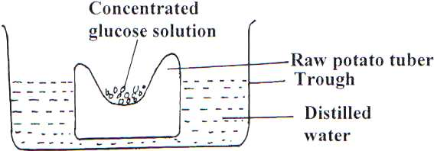

- Suggest a possible physiological process that was being investigated. (1 mark)
………………………………………………………………………………………………………………………………………………………………………………………………………………………………
- Explain the results obtained in the above experiment after a few hours (2 marks)
………………………………………………………………………………………………………………………………………………………………………………………………………………………………
- State the observations that would have been made if the experiment was repeated using boiled potato.
………………………………………………………………………………………………………………………………………………………………………………………………………………………………

22. A certain plant was found to have 22 chromosomes in its calyx cells. State the number of chromosomes present in. (3 marks)

a) Embryo sac nucleus

................................................................................................................................................................... b) Primary endosperm nucleus.
...................................................................................................................................................................
c)Pollen grains

...................................................................................................................................................................

...................................................................................................................................................................
23.Define the following term (2mk)

a)Growth
...................................................................................................................................................................

...................................................................................................................................................................
b)Development

...................................................................................................................................................................

...................................................................................................................................................................

24. Account for the loss in dry weight of cotyledons in a germinating bean seed. (2 mark)

...................................................................................................................................................................

...................................................................................................................................................................

25. The diagram below represents the internal structure of a bean seed.

plumule x

hypocotyl

Y
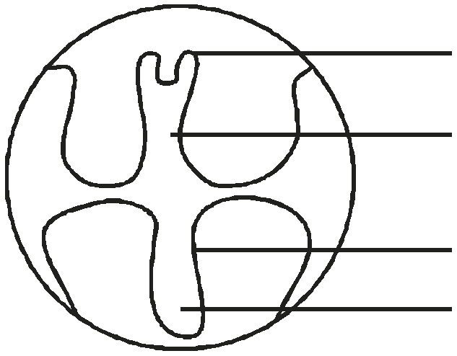

a) Name the parts the seed embryo represented by letter X and Y. (2 marks)

X .............................................................................................................................................................. Y ..............................................................................................................................................................
b) What type of germination would result if the hypocotyl elongates faster. (1 mark)

................................................................................................................................................................... c) What is the significance of the part labelled Y emerging first during germination. (1 mark)
...................................................................................................................................................................

26. a) State TWO processes which occur during anaphase of mitosis. (2 marks)

...................................................................................................................................................................

...................................................................................................................................................................

................................................................................................................................................................... b) What is the significance of meiosis? (1 mark)
...................................................................................................................................................................

...................................................................................................................................................................
27.Below is a simplified diagram of a flower.

i) Suggest its agent of pollination. (1 mark)

....................................................................................................................................................................

.................................................................................................................................................................... ii) Name the type of ovary shown above. (1 mark)
....................................................................................................................................................................

iii) Explain one observable mechanism that will hinder self pollination and fertilization in the above flower. (1 mark)

....................................................................................................................................................................

....................................................................................................................................................................

28.State four functions of water during germination (4mks)
...................................................................................................................................................................

...................................................................................................................................................................

...................................................................................................................................................................

...................................................................................................................................................................

...................................................................................................................................................................

...................................................................................................................................................................
29.State three factors that causes seed dormancy (3mks)
...................................................................................................................................................................

. ...................................................................................................................................................................

...................................................................................................................................................................

..................................................................................................................................................................

...................................................................................................................................................................

...................................................................................................................................................................

30)Give two examples of meristematic cells (2mks)
...................................................................................................................................................................

...................................................................................................................................................................

...................................................................................................................................................................

...................................................................................................................................................................

