BIOLOGY PAPER 1 FORM 3 MARKING SCHEME MID TERM 3 2022

1. Insects blood is not used for transportation of respiratory gases.
2. (i) Reabsorption of salts.
(ii) reabsorption of water.
3. Lack of O₂ for respiration.
4. (i) Crossing over.
(ii) Variations; which may lead to new genetic forms either advantages or disadvantages to the
Organism/may lead to evolution.
5. To roots/stems for storage.
- Oxidized to produce energy.
- Converted into fats and oils
- Converted into cellulose to make new cell walls (Any 2)
6. (a) Golgi bodies
(b) Smooth endoplasmic reticulum
(c) Lysosomes
7. Cold days
Contraction of erector Pilli muscles; hair lies flat hence the dog appears larger; /vasoconstriction.
Hot days
Relaxation of erector Pilli muscles, hair lies flat hence the dog appears smaller; /vasodilation.
8. (a) O₂ is used by body cells for respiration.
(b) CO₂ is released by body cells during respiration.
9. (a) Aquatic ecosystem
(b) The shorter the food chain, the more energy can be derived from it, hence the larger the population it
can support
10. Diabetes mellitus – condition resulting from insufficient production of insulin causing presence of
glucose in urine.
Diabetes insipidus – A condition where less of antidiuretic hormone is secreted hence large volume of
water is passed out in urine.
11. (a) Gas produced during anaerobic respiration.
(b) Glucose Ethanol + Carbon (IV) oxide + Energy
(c) To remove O₂; cooling provide suitable temperature for enzymatic reaction /avoid destroying/killing
yeast
12. (i) Ammonia
(ii) Uric acid
13. (i) Plasmodium sp
(ii) Schistosoma sp
14. (i) Coarse adjustment knob
(ii)mirror
15. Have air spaces to facilitate buoyancy
16. Cools the plants
- Turgidity in plants
- Enables the plant loose excess water into atmosphere.
17. Thick-walled – Help to strengthen and support the stem
- Lignified walls
18. Millipedes have two pairs of legs per segment.
- Tsetse fly has wings
- Spider has a cephalothorax
19. (i) Identical twins arise when a male gamete fertilizes the same ovum in an ovary and hence the
similarity
(ii) Fraternal twins arise when male gametes fertilizers ova from different ovaries

20. The diagram below illustrates a Nephron from a mammalian kidney
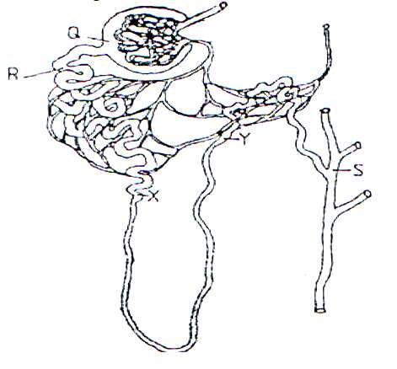

- Name the fluid in the part labeled Q (1mk)
Glomerular filtrate
- Identify the process responsible for the formation of the fluid named in (a) above. (1 mk)
Ultra-filtration/pressure filtration;
- Which two hormones exert their effect in the Nephron?
Antidiuretic hormone/vasopressin; Aldosterone;
21. (a) Osmosis
(b) The amount of sucrose solution increase; the sucrose solution has higher osmotic pressure hence
passes into the potato cavity.
(c) There would be no movement of water; because the photoplasm is killed by boiling, hence the semi-
permeable membrane.

22.a) 22 chromosomes
b)33 chromosomes
c) 11 chromosomes
23a)quantitative permanent increase in a size of an organism
b)quantitative complexty of cells
24.-stored food in the cotyledon is hydrolysed and used to make energy used for germination

25. a) X - Epicotyl;
Y - Radicle; rej Radical

b) Epigeal germination;

c) Provides anchorage; to growing seedling / absorb water/ mineral salt; form the soil

26. a) Sister chromatids separate; sister chromatids move to opposite poles. Accept chromatids separate at the centromere.

b) - Gametes formation (accept formation of sex cells);
- Source of variation ;

27. i) Insect 1 × 1 = 1 mark

ii) Epiqynous 1 mark

iii) Heterostyly - shorter stamens than pistils renders it impossible for the pollen grains from stamens to reach the stigma 1 mark

28.-hydrolysing and dissolving food
-transporting dissolved food substances
-softening the testa
-provide a medium for enzyme to act on
-activate the enzyme

29.-undeveloped embryo
-chemical inhibitors
-low concentration of hormones
-hard impermeable seed coat
-absence of light wavelength
-freezing of seeds
30)-apical meristem
cock cambium meristem
-vascular cambium

