NAME: ……………………………………..……………………. DATE: ………………

ADM NO: .……….. SIGNATURE: .………..…

231
BIOLOGY
FORM THREE
TIME: 2$\frac{1}{2}$ HOURS

OPENER EXAMINATION TERM 3, 2022
Kenya Certificate of Secondary Education

INSTRUCTIONS TO CANDIDATES: -
  - Write your name, Admission number and class in the spaces provided above.
  - Answer all the questions in the spaces provided
  - Candidates should answer the questions in English.

1. What is the role of the following to a germinating seed?
- Endosperm (1mk)

- Water (3mks)

2(a) Name any two meristematic tissue of a seedling. (2mks)

(b)State two advantages of metamorphosis to the life of insects. (2mks)

3. Explain how birds of prey like vulture are adapted to obtaining food. (2mks)

4. State two importance of classification of living organisms. (2marks)

5. Complete the table below, outlining the differences between members of Class Diplopoda and Chilopoda based on the characteristics given. (4 marks)
Characteristic | Diplopoda | Chilopoda
Body shape
Number of legs per segment

6. a. State two reasons why the snake is classified as a reptile. (2 marks)

b. Name the structure which enables Paramecium to move. (1mark)

7. a) How is the human stomach adapted for
i) Protein digestion (2mks)

ii) Churning (2mks)

b) What happens to the glucose synthesized during photosynthesis. (2mks)

8. State two ways in which the muscles of a mammalian heart are special. (2mks)

9. During a practical investigation on food tests, students were provided with the following reagents.
- Benedict’s solution.
- Sodium hydrogen carbonate.
- dilute hydrochloric acid.

a) Identify the food substance the students were to test. (1mk)

b) State the role of the following in the experiment.

i) Dilute hydrochloric acid. (1mk)

ii) Sodium hydrogen carbonate. (1mk)

10. Explain the role of carbonic anhydrase in red blood cells. (3mks)

11.(a) How do animals use the energy produced during respiration? (4mks)

(b) Write down two features of mitochondria. (2mks)

12. Explain the effect of the factors listed below to the process of diffusion
- Temperature below 0⁰C (2mks)

- Smaller surfaces area to volume ratio (3mks)

13. Some hydrophytes grow in fresh water habitat. List down three characteristics of fresh water
condition that influence plant growth. (3mks)

14. The diagram below illustrates the mechanism of blood glucose concentration
Corrective mechanism A

Excess

Normal glucose level Normal glucose level

Deficiency
Corrective mechanism B

- What principle of homeostasis is illustrated in the diagram? (1 mark)

(b) Name the condition that may result from further excess (1 mark)

(c) State how the corrective mechanism B restores blood glucose to normal level. (2 marks)

15. The diagram below shows a portion of a lower epidermis of a Sukuma wiki leaf.
Q
P

(a) Name the parts labeled P and Q. (2mks)
P
Q

b) Briefly describe the photosynthetic theory of stomatal opening. (5mks)

c) State one modification in the stomata of xerophyte plant other than being sunken and
hairy (1mk)

16. The diagram below shows a section through the mammalian skin

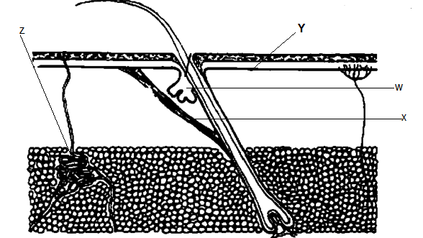
(a) Name the parts labelled W and X (2mks)
W
X
(b) State the function of the parts labelled Y and Z (2mks)

(c) Explain the changes that occur in the skin when it is cold (4mks)

17. Below is a cross section through a plant organ. Use it to answer the questions that follow
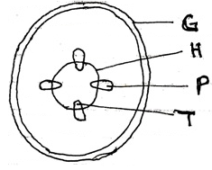
a) Giving a reason, identify the figure shown above. (2mks)

b) State three characteristics of the tissue labeled H (3mks)

c) Name one substance transported by part labeled P (1mk)

d) State the function of part G. (1mk)

e) Name the substance used to strengthen part labeled T (1mk)

18. Study the diagram below which represents the nitrogen cycle to answer the questions that follow.
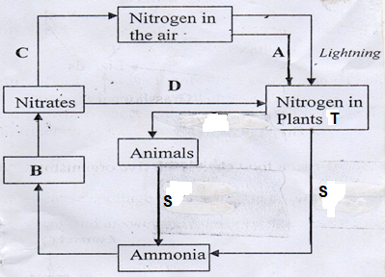

- State the processes (3mks)
C

D
A

- Name the bacteria found in root nodules of plant T (1mk)

- Name the mechanism S that lead to production of ammonia from both plants and animals
(1mk)

19. a) Describe the process of fertilization in a flowering plant (15mks)

b) State the changes that take place in a flower after fertilization (5mks)

