FORM THREE BIOLOGY
OPENER EXAMINATION TERM 3, 2022
MARKING SCHEME
TIME 2$\frac{1}{2}$ hours
Answer all questions in the spaces provided
1. What is the role of the following to a germinating seed?
- Endosperm (1mk)
Store food necessary for germination;
- Water (3mks)
- Activate the (germination) enzymes;
- Hydrolyse the stored food;
- It’s a transport agent for hydrolysed food;
- It’s a solvent for hydrolysed food;
- It softens the seed coat/testa;

2(a) Name any two meristematic tissue/growing parts of a seedling. (2mks)
Root tip;
Shoot tip;
Cambium;

(b) State two advantages of metamorphosis to the life of insects. (2mks)
- Different stages feed on different types of food;
- The adult and larvae exploit different (food) niches
- Do not compete for food;
- Pupa can survive adverse conditions /pupa is a non-feeding
- Stage/pupa enables organisms to undergo through adverse conditions;
- Dispersal phase prevents overcrowding;

3. Explain how birds of prey like vulture are adapted to obtaining food. (2mks)
- It has sharp/hooked/strong beaks for killing ripping off fresh from bones;
- It has curved/ strong/sharp claws for grabbing/holding the prey;
4. State two importances of classification of living organisms. (3marks)
Enable identification of living organisms into their correct groups for reference;
To understand the evolutionary relationship between different organisms;
Biologists are able to arrange in an orderly and comprehensible manner the knowledge available on characteristics of organisms;
Biologists are able to predict traits of organisms they may not have seen;
To monitor and know the disappearing species;

5.Complete the table below, outlining the differences between members of Class Diplopoda and Chilopoda based on the characteristics given. (4 marks)
 | Diplopoda | Chilopoda
Characteristic
Body shape | cylindrical | Laterally flattened
Number of legs per segment | 4 | 2

6..a. State two reasons why the snake is classified as a reptile. (2 marks)
Has scales;
Lay eggs;
Its poikilothermic;
Move by creeping;

b. Name the structure which enables Paramecium to move. (1mark)
cilia;
7.a) How is the human stomach adapted for
i) Protein digestion (2mks)
Have gastric gland that secret gastric juice; which has pepsin enzyme for digestion of proteins; and rennin enzyme for curdling of protein in milk;
ii) Churning (2mks)
Thick muscular wall which contract and relax to bing about churning;

b) what happens to the glucose synthesized during photosynthesis. (2mks)
- used for plant respiration;
- excess converted to starch/cellulose and stored for future use;

8. state two ways in which the muscles of a mammalian heart are special.(2mks)
- myogenic;
- do not fatigue;
9. During a practical investigation on food tests, students were provided with the following reagents.
- Benedicts solution.
- Sodium hydrogen carbonate.
- dilute hydrochloric acid.
a) Identify the food substance the students were to test.(1mk)
non – reducing sugar;
b) State the role of the following in the experiment.
i) Dilute hydrochloric acid.(1mk)
hydrolyse/breaks down sucrose/reducing sugars into reducing sugars/glucose/fructose;
ii) Sodium hydrogen carbonate.(1mk)
Neutralize acid;

10.. Explain the role of carbonic anhydrase in red blood cells.(3mks)
- converts carbon (IV) oxide to carbonic acid which easily dissociates into hydrogen ions(H+) and hydrogen carbonate ions; for easier transportation ; reducing acidity in the blood;

11.(a) How do animals use the energy produced during respiration? (4mks)
- Provide energy for movement/locomotion/contraction of muscles;
- For defense/flee from predator;
- Heat energy to provide optimum temperature for enzyme action;
- Energy for cell division;
- Energy for transmission of impulses in nerves/neurons;
- Absorption of mineral salts in alimentary canal;
- Reabsorption of salts/sodium ions in kidney tubules;
- Excretion of waste from body cells;
(b) Write down two characteristic features of mitochondria. (2mks)
- Its sausage – shaped;
- It has double membranes;
- Inner membranes is (greatly) folded to form cristae;
- It has fluid filled matrix;

12. Explain the effect of the factors listed below to the process of diffusion
- Temperature below 0⁰C (2MKS)

The rate of diffusion would decrease; since the molecules have low kinetic energy/less activated;

- Smaller surfaces area to volume ratio (3mks)

The process would be slow/or stop altogether; since the distance covered by (diffusing) molecules would be more; therefore, require a transport system;

13. Some hydrophytes grow in fresh water habitat. List down three characteristics of fresh water Condition that influence plant growth. (3mks)

- Low concentration of dissolved gases;
- Light intensity decreases with increase in depth;
- Temperature decreases with increase in depth/temperatures are stable;
- Low concentration of mineral salts;
- waves and water currents influence plant growth/are usually common;
14.The diagram below illustrates the mechanism of blood glucose concentration

Corrective mechanism A

Excess

Normal glucose level Normal glucose level

Deficiency
Corrective mechanism B

- What principle of homeostasis is illustrated in the diagram? (1 mark)
Feedback mechanism;
(b) Name the condition that may result from further excess (1 mark)
Diabetes mellitus;
(c) State how the corrective mechanism B restores blood glucose to normal level (2 marks)
Pancreas is stimulated to secrete glucagon into bloodstream; on reaching the liver glucagon: Stimulates liver cells to convert glycogen into glucose; Stimulates liver cells to decrease oxidation of glucose into water, carbon (IV) oxide and energy;
15.The diagram below shows a portion of a lower epidermis of a sukuma wiki leaf.
Q
P

(a) Name the parts labeled P and Q. (2mks)
P stomatal pore/opening / aperture/ stoma; rej. Stomata.
Q Epidermal cell; Rj Epidermis

b)Briefly describe the photosynthetic theory of stomatal opening. (5mks)
Guard cells have chloroplasts; hence the presence of light during the day photosynthesis occurs in the guard cells; producing sugar in the guard cells that increases osmotic pressure; water from epidermal cells enters into guard cells causing turgidity of cells; the inner walls of the guard cells are thicker than outer walls; hence outer walls stretch more (during turgidity); causing guard cells to bulge outwards; (stomata open). guard cells have thicker inner wall than outer walls; hence outer walls stretch more (during turgidity); causing guard cells to bulge outwards; (stomata open).

c)State one modification in the stomata of xerophyte plant other than being sunken and
hairy (1mk)
Reversal / stomatal rhythm;
Small stomatal pore / aperture / opening;

16.The diagram below shows a section through the mammalian skin

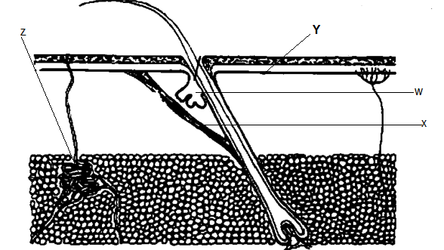

(a) Name the parts labelled W and X (2mks)
W Sebaceous gland;
X Erector pili muscles;
(b) State the function of the parts labelled Y and Z (2mks)
Y – Produces melanin which protects the body against U.V light/determines the skin colour;
Z – Secrets sweat which evaporates to bring about cooling or
Sweat also removes excretory products/excess salts/water ;

(c) Explain the changes that occur in the skin when it is cold (4mks)

Vasoconstriction; hence less blood flows to the skin surface; reducing heat loss; no sweating; heat produced thought metabolisms/shivering; is retained in the body;
6 marks max 4 mks
17. Below is a cross section through a plant organ. Use it to answer the questions that follow
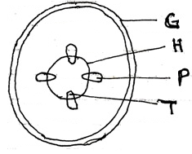
a) Giving a reason, identify the figure shown above. (2mks) Dicotyledonous stem;
Reason: Presence of vascular cambium ;or
Arrangement of vascular bundles in concentric manner;

b) State three characteristics of the tissue labeled H (3mks) Have actively dividing cells;
Its cell lacks vacuoles;
Its cells have thin cell wall;
Its cells have dense cytoplasm;

c) Name one substance transported by part labeled P (1mk) Amino acid/sucrose/fatty acid and glycerol; Rej.glucose
d) State the function of part G. (1mk) Protection from mechanical injury/entry of micro-organism;
e) Name the substance used to strengthen part labeled T (1mk)
Lignin;

18.Study the diagram below which represents the nitrogen cycle to answer the questions that follow.

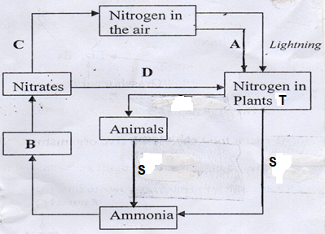

- State the processes (3mks)
C Dentrification;
D Absorption;
A Nitrogen fixation;
- Name the bacteria found in root nodules of plant T (1mk)
Rhizobium;
- Name the mechanism S that lead to production of ammonia from both plants and animals (1mk)
Death & decay;
19.a) Describe the process of fertilization in a flowering plant (15mks)
After pollination the pollen grains adhere to the stigma; due to secretion of a sticky substance by the stigma cells; The pollen grain absorbs nutrients from the stigma; and develops a pollen tube; The pollen tube grows down the style; by digesting the tissues of the style; The pollen tube has two nuclei the tube nucleus; and the generative nucleus; The tube nucleus initiates and maintains the growth of the pollen tube; Generative nucleus divides by mitosis; into two male nuclei; which follow behind the tube nucleus; finally the pollen tube enters the embryo sac through the micropyle; it bursts open and tube nucleus degenerates/disintegrates. One of the male nucleus fuses with the egg to form a zygote; the other male nucleus fuses with the two polar nuclei to form triploid nucleus; (primary endosperm nucleus) The process involves double fertilization;
Maximum 15mks
b) State the changes that take place in a flower after fertilization (5mks)
b) Integument changes into seed coat /testa;
Zygote into embryo;
Ovary wall into pericarp;
Ovary into fruit;
Ovule into seed;
Triploid nucleus into endosperm;
Style dries up /falls off leaving a scar;
Corolla dries up /falls off;
Stamen dries up;
Re: degenerates or distintegrates.
(Maximum 5marks)

