**Name……………………………………… ADM NO…………………SIGN ……….……date……….…**

**231**

**BIOLOGY**

**FORM 2**

**2 Hours**

**END OF TERM 2 EXAMINATION**

**INSTRUCTIONS TO CANDIDATES**

1. Write your name and admission Number in the spaces provided above.
2. Sign and write date of examination in the spaces provided above.
3. Answer **ALL** questions in the spaces provided.
4. All workings **must** be clearly shown where necessary.

*This paper consists of 7 Printed pages. Candidates should check the question paper to ensure that all the*

*Papers are printed as indicated and no questions are missing*

1. State the importance of the following in a living organism

(a) Locomotion. (2marks)

(b) Respiration (1mark)

1. Name the cell organelles which would be abundant in (2marks)

(a) Sperm cell

(b) Pancreas.

1. State the functions of the following in the heart. (1mk )
2. Sino Atrio Node (SAN)

(b) Interventricular septum

1. Name two antigens that determine human blood groups. (2 marks)
2. a) Explain why blood group O is a universal donor. (1 mark)

b) i) Name the blood vessel that links arterioles to venules. (1 mark)

ii) What is the adaptive advantage of arteries having a narrower lumen? (1 mark)

1. (a) Name the tissues that transport water in plants. (1mk)

(b) State why the tissue above is said to be dead. (1mk)

1. The diameter field of view of a light microscopic is 6.5mm. Plant cells lying across the diameter are 12.Determine the size of one cell in micrometers. (2 marks)
2. State **two** adaptations of the phloem tissue. (2 marks)
3. Name the process that results to formation of tissue fluid. (1mk)
4. What is serum? (1mks)
5. The diagram below shows a transverse section of a plant organ.



a) Name the class to which the plant organ was obtained. (1mark)

b) Give a reason for your answer in (a) above. (1mark)

12.a) Which component of the blood gives the body immunity? (1 mark)

(b) Distinguish between natural and acquired immunity. (2 marks)

13.(a) Define the term excretion (1mk)

(b) In what state is water excreted in man? (1mks)

(c)Why do plants not excrete salts in their excretory products (1mk)

14.Under what conditions does a green plant excrete oxygen? (1mks)

15.Study the diagram below and answer the questions that follows

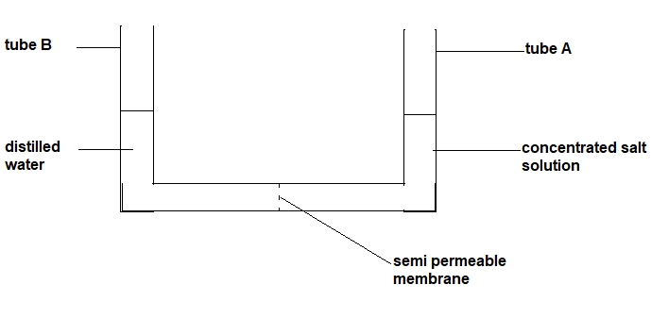

The experimental set up was left for 8 hours

1. Using your biological knowledge, show the level of fluids after 8 hours ( 2 marks)
2. Which process was being investigated in the experiment? ( 1 mark)

16.Study the diagram of excretory system in man and answer the questions that follows



1. Name parts labeled (2 marks)
2. What is the function of the part labeled S ? (2 marks)

17.The diagram below shows gaseous exchange in tissues.

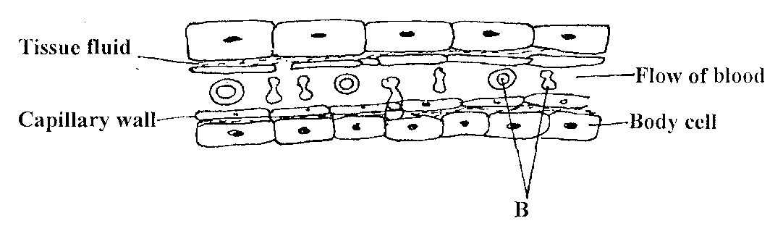

a) Name the gas that diffuses:

i) To the body cells (1mk)

ii) From the body cells(1mk)

b) name cell labeled B(1mk)

c) Which compound dissociates to release the gas named in (a) (i) above?(1mk).

18.Other than carbon (IV)oxide, name other products of anaerobic respiration in plants(2mks)

19. (a) Name **one** structures for gaseous exchange in amphibians. (2mks)

(b ) What is the effect of relaxation of diaphragm muscles during breathing in mammals. (3mks)

20. Sate two ways in which respiratory surfaces adapted to their function? (2mks)

21. Study the equation below and then answers the questions that follow.

C6H12O6 L+ Energy

1. Name the process represented by the above equation (1mk)
2. Identify substance L (1mk)
3. Where in the cell does the above reaction take place? (1mk)
4. Name the form in which energy is stored in the body of living organism. (1mk)

22. The oxidation of a certain fat is represented by chemical equation shown below.

C57H104O6 + 80 O2 → 57CO2+52H2O + Energy

a) Calculate the respiratory quotient (RQ) of the fat (2marks)

b) What is the significance of RQ? (2marks)

23.The diagram below represents part of epidermis of a leaf

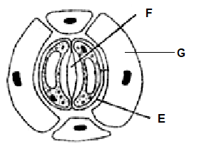

a) Name the parts marked F and G (2 marks)

b) State **two** aspects of cell E that are an adaptation to its function. (2 marks)

c) Describe the changes that would take place in E if the cells were placed in concentrated sugar solution for a long period. (3 marks)

24. Study the diagram below and answer the questions that follow

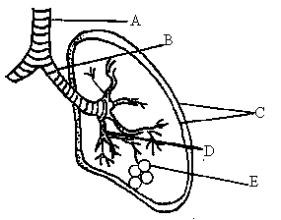

a). Name the parts labelled A, B and C (3 marks)

A,

B

C

b) State the function of the fluid found in between the parts marked C. (1mark)

c) How is the part labelled E adapted to its function. (4 marks)

d) State the significance of rings of cartilage found around the part marked A and B. (1mark)

25.A student found a skull of an animal in the neighborhood of their school. The upper jaw had

4 incissors,2 canines, 6 premolars and 6 premolars and 6 molars

1. Using the information provided write down the dental formula of the animal (1 marks)
2. Give two ways in which incisor differ from a premolar? (2 marks)
3. Amylase is an enzyme in the alimentary canal. identify two juices that contains that enzyme (2 marks)

26.a) Explain **three** ways in which a red blood cell is adapted to its functions. (3mks)

(b) In which form is carbon (IV) oxide transported? (2mks)

28.How is the mammalian heart adapted to its functions? (20mks)