BIOLOGY FORM 2 – END TERM 2 MARKING SCHEME

1. State the importance of the following in a living organism

(a) Locomotion. (2marks)

-Acquire resources (food, water shelter);

- Escape from predators;

-to get mates;

-To escape harmful stimuli;

***Any two*** (2mks)

(b) Respiration (1mark)

To acquire energy for various activities;

1. Name the cell organelles which would be abundant in (2marks)

(a) Sperm cell

Mitochondria

(b) Pancreas.

Golgi bodies

1. State the functions of the following in the heart. (1mk )
2. Sino Atrio Node (SAN)

Regulates the pace at which the heart beats; initiating and maintain contraction of the Heart;

***(Any one***)

(b) Interventricular septum

Prevents mixing of oxygenated and deoxygenated blood;

1. Name two antigens that determine human blood groups. (2 marks)

- Antigen A;

- Antigen B;

- Rhesus factor / Antigen;

1. a) Explain why blood group O is a universal donor. (1 mark)

Lacks antigens to react with the recipient‘s antibodies (to cause agglutination);

b) i) Name the blood vessel that links arterioles to venules. (1 mark)

Capillaries;

ii) What is the adaptive advantage of arteries having a narrower lumen? (1 mark)

To create/sustain higher blood pressure; (which moves the blood to all body parts from the heart)

1. (a) Name the tissues that transport water in plants. (1mk)

Xylem

(b) State why the tissue above is said to be dead. (1mk)

Lacks cytoplasm and organelles;

1. The diameter field of view of a light microscopic is 6.5mm. Plant cells lying across the diameter are 12.Determine the size of one cell in micrometers. (2 marks)

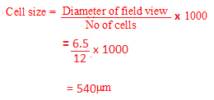

1. State **two** adaptations of the phloem tissue. (2 marks)

* Have cytoplasmic filaments along which food is translocated;
* sieve plate has pores for passage of organic material;
* Have companion cell which have numerous mitochondria to provide energy for tlanslocation;
* Presence of plasmodesmata to communicate between sieve tube elements and companion cells.

1. Name the process that results to formation of tissue fluid. (1mk)

Ultra filtration;

1. What is serum? (1mks)

Serum is blood whose plasma proteins have been removed.

1. The diagram below shows a transverse section of a plant organ.



a) Name the class to which the plant organ was obtained. (1mark)

Monocotyledonae;

b) Give a reason for your answer in (a) above. (1mark)

Vascular bundles scattered/not arranged in a ring; absence of pith; absence of vascular cambium;

12.a) Which component of the blood gives the body immunity? (1 mark)

White blood cells

(b) Distinguish between natural and acquired immunity. (2 marks)

Natural immunity is inherited / transmitted from parents to off springs;

Acquired immunity is acquired after suffering from a disease / through vaccination / vaccination through inoculation / through introducing antibodies. (Rej. Immunisation alone)

13.(a) Define the term excretion (1mk)

Process by which plants get rid of metabolic wastes.

(b) In what state is water excreted in man? (1mks)

Liquid

Water vapour any correct

(c)Why do plants not excrete salts in their excretory products (1mk)

They absorb enough of what they require/ not in excess

14.Under what conditions does a green plant excrete oxygen? (1mks)

When the rate of photosynthesis is greater/ higher than the rate of respiration in plant

leaves which utilize the oxygen release

15.Study the diagram below and answer the questions that follows

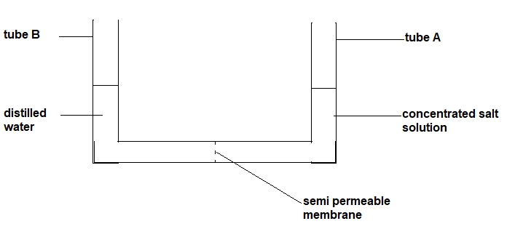

The experimental set up was left for 8 hours

1. Using your biological knowledge, show the level of fluids after 8 hours ( 2 marks)

The level of the fluid in delivery tub A should rise; while in the tube B it should be lower

( any level qualifies for a mark)

1. Which process was being investigated in the experiment? ( 1 mark)

osmosis

16.Study the diagram of excretory system in man and answer the questions that follows



1. Name parts labeled (2 marks)

Q ureter

R urethra

1. What is the function of the part labeled S ? (2 marks)

To collect urine from( both) kidneys ; and temporarily stores it ;( before it is excrete)

NB:Temporarity must be there to qualify for mark.

17.The diagram below shows gaseous exchange in tissues.

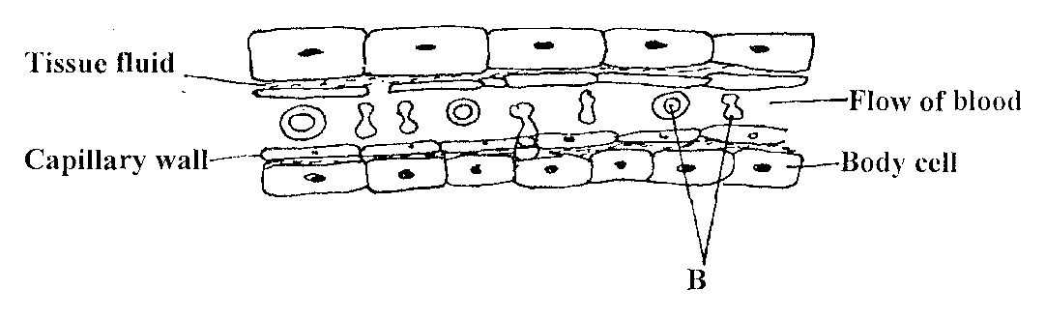

a) Name the gas that diffuses:

i) To the body cells (1mk)

ii) From the body cells(1mk)

b) name cell labeled B(1mk)

c) Which compound dissociates to release the gas named in (a) (i) above?(1mk).

a) i) Oxygen

ii) Carbon IVoxide

b) red blood cell/erythrocytes

c) Oxyhaemoglobin

18.Other than carbon (IV)oxide, name other products of anaerobic respiration in plants(2mks)

. -Ethanol

-Energy / ATP/ 210kJ / heat;

Rej. atp, formula of alcohol.

19. (a) Name **one** structures for gaseous exchange in amphibians. (2mks)

Skin ;Buccal cavity ; lungs; (any two)

(b ) What is the effect of relaxation of diaphragm muscles during breathing in mammals. (3mks)

It decreases the volume of the thoracic cavity; and increases the pressure inside; thus air is forced out of the lungs through the air passage into the atmosphere

20. Sate two ways in which respiratory surfaces adapted to their function? (2mks)

Has thin membrane to reduce distance over which gases diffuse;

Moist to dissolve gases before they diffuse;

Have large surface area to maximize gaseous exchange=

Are well ventilated to allow free movement of gases

Are highly vascularized to transport the diffused gases

21. Study the equation below and then answers the questions that follow.

C6H12O6 L+ Energy

1. Name the process represented by the above equation (1mk)

Anaerobic respiration in animals

1. Identify substance L (1mk)

Lactic acid

1. Where in the cell does the above reaction take place? (1mk)

cytoplasm

1. Name the form in which energy is stored in the body of living organism. (1mk)

Adenosine triphosphate

22. The oxidation of a certain fat is represented by chemical equation shown below.

C57H104O6 + 80 O2 → 57CO2+52H2O + Energy

a) Calculate the respiratory quotient (RQ) of the fat (2marks)

b) What is the significance of RQ? (2marks)

1. RQ =volume of carbon (IV)oxide released

Volume of oxygen released

57

80

=0.7125

b) It gives the type of substrate undergoing respiration;

It gives the type of respiration taking place;

23.The diagram below represents epidermis of a leaf

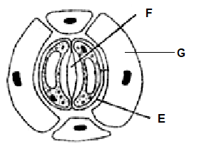

a) Name the parts marked F and G (2 marks)

F – Stomatal opening/stoma;

G – Epidermal cell;

b) State **two** aspects of cell E that are an adaptation to its function. (2 marks)

Thick inelastic inner wall; thin elastic outer wall;

Has chloroplast for photosynthesis;

Its bean shaped to create an aperture between two guard cells

c) Describe the changes that would take place in E if the cells were placed in concentrated sugar solution for a long period. (3 marks)

Water would leave vacuole and cytoplasm by osmosis; They shrunk and cell membrane draws away from the cell wall; the guard cell becomes plasmolysed; stoma is closed;

24. Study the diagram below and answer the questions that follow

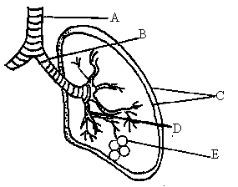

a). Name the parts labelled A, B and C (3 marks)

A,

B

C

b) State the function of the fluid found in between the parts marked C. (1mark)

c) How is the part labelled E adapted to its function. (4 marks)

d) State the significance of rings of cartilage found around the part marked A and B. (1mark)

a) A-Trachea

B-Bronchus; reject bronchi

C-Pleural membranes; reject membrane

D-Bronchiole

b) Reduce friction making the lungs to move freely in the chest cavity

c) Moist to dissolve respiratory gases

Highly supplied with blood capillaries to transport

Enclosed by thin membrane to reduce distance over which diffusion gases move.

Numerous-large surface area to make gaseous exchange efficient increase the rate of gaseous exchange

1. Prevent it from collapsing during breathing

25.A student found a skull of an animal in the neighborhood of their school. The upper jaw had

4 incissors,2 canines, 6 premolars and 6 premolars and 6 molars

1. Using the information provided write down the dental formula of the animal (1 marks)

*i $\frac{2}{2};$ $c\frac{1}{1};$ pm $\frac{3}{3};$ m $\frac{3}{3}$*

1. Give two ways in which incisor differ from a premolar? (2 marks)

incisor has a sharp edge; its top is chisel shaped; it has one root

1. Amylase is an enzyme in the alimentary canal. identify two juices that contains that enzyme (2 marks)

Saliva

Pancreatic juice

26.a) Explain **three** ways in which a red blood cell is adapted to its functions. (3mks)

- Have biconcave disc shape which increases the surface area for exchange of gases by diffusion;

- Have haemoglobin which has high affinity for oxygen; (hence faster transportation of oxygen).

- Lacks nucleus to provide more room for packaging of haemoglobin;

- Have thin plasma membrane that allows faster / rapid diffusion of gases;

- Have carbonic anhydrase which accelerates loading and off-loading of carbon (IV) oxide for faster offloading of carbon (IV) oxide transport. (any three)

(b) In which form is carbon (IV) oxide transported? (2mks)

- Carbamino hemoglobin;

- Carbonic acid;

**ESSAY.**

**28.How is the mammalian heart adapted to its functions?**

* Heart is enclosed in a pericardial membrane/pericardium; that
  + produces a fluid; to lubricate it;
  + the membrane also keeps the heart in position;
  + Prevent heart from overstretching
  + It is covered in a fatty layer; that acts as a shock absorber;
* made up of cardiac muscles; which are interconnected/intercalated hence contract and relax without fatigue or nervous stimulation/myogenic; for continuous pumping of blood throughout the lifespan of the animal;
* the muscles are supplied by nutrients and oxygen; by the coronary arteries; and the coronary veins take away wastes and carbon (IV) oxide;
* has interventricular septum; to separate oxygenated and deoxygenated blood;
* left ventricle has thicker muscles/more muscular; to generate high pressure to pump blood to all body tissues;
* heart has bicuspid; and tricuspid valves; to prevent back flow of blood to left auricle; and right auricle respectively;
* valves have tendinous cords/valve tendons; to prevent them from turning inside out;
* semi lunar valves located at the beginning of major arteries; prevent backflow of blood into the ventricles;
* has sino-artrio node located in the muscles of the right auricle; to initiate heart beat/contractions of heart muscles/cardiac muscles,
* rate of heart beat is controlled by nerves; vagus nerve; slows down heartbeat; while sympathetic nerve; speeds up the heartbeat;

**Max. 20 mks**