**APRIL HOLIDAY ASSIGNMENT 2023**

**BIOLOGY FORM TWO**

1. The diagram below shows the exchange of gases in alveolus

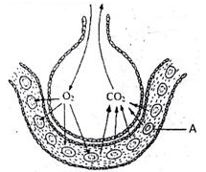

1. State how the alveoli are adapted to their function (3mks)
2. Name the cell labeled A (1mk)
3. State **three** importance of osmosis in plants (3mks)
4. State **two** reasons why the pressure of blood is greater in arteries than in veins.(2mks)

4. The diagram below shows the gaseous exchange system of a locust.

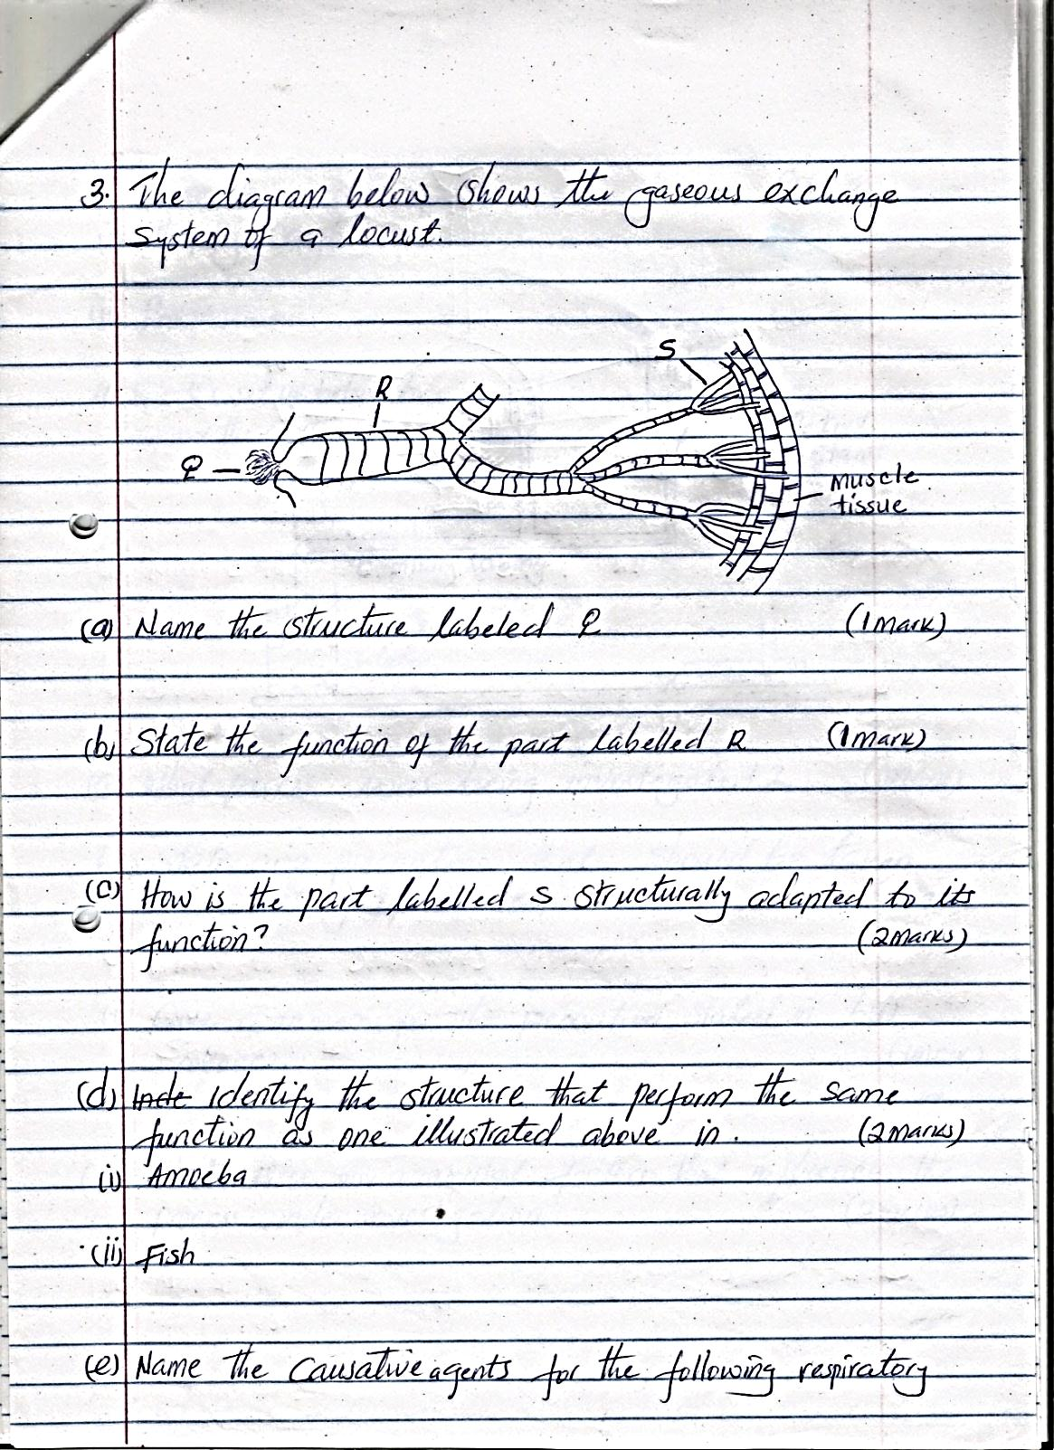

1. Name the structure labeled Q. (1mk)
2. State the function of the part labeled R. (1mk)
3. How is the part labeled S structurally adapted to its function? (2mks)
4. Identify the structure that perform the same function as one illustrated above in. (2mks)

i. Amoeba

ii.Fish

5. Name the causative agents for the following respiratory Diseases. (2mks)

i) Whooping Cough

ii) Pneumonia

6. a) Give reasons why the wall of the left ventricle of heart is thicker than that of the right ventricle. (2mks)

b) Name the blood vessel with the highest concentration of.

i) Glucose. (1mk)

ii) Carbon (IV) oxide (1mk)

7. Explain why inhaling carbon (II) oxide result to death of a person (3mks)

8. Describe the process of absorption of water from the soil to the xylem of the root.(6mks)