BIOLOGY
FORM TWO
MID TERM THREE 2022
NAME ……………………………………………………………….ADM……………CLASS…………
SECTION A
Answer all questions
1.Explain the two main branches of biology (4mks).
………………………………………………………………………………………………………………………………………………………
………………………………………………………………………………………………………………………………………………………
………………………………………………………………………………………………………………………………………………………
………………………………………………………………..……………………………………………………………………………………
………………………………………………………………………………………………………………………………………………………
2.State the role of light in photosynthesis (2mks)
………………………………………………………………..……………………………………………………………………………………
………………………………………………………………………………………………………………………………………………………
………………………………………………………………………………………………………………………………………………………
………………………………………………………………..……………………………………………………………………………………
………………………………………………………………..……………………………………………………………………………………
3.State the functions of the following cell organneles(2mks)
a)Golgi apparatus
………………………………………………………………..……………………………………………………………………………………
………………………………………………………………………………………………………………………………………………………
………………………………………………………………..……………………………………………………………………………………
………………………………………………………………………………………………………………………………………………………
b)Robosomes
………………………………………………………………..……………………………………………………………………………………
………………………………………………………………………………………………………………………………………………………
………………………………………………………………..……………………………………………………………………………………
………………………………………………………………………………………………………………………………………………………
4.What are the three end products of anaerobic respiration in plants(3mk)
………………………………………………………………..……………………………………………………………………………………
………………………………………………………………………………………………………………………………………………………
………………………………………………………………..……………………………………………………………………………………
………………………………………………………………………………………………………………………………………………………
b)State the economic importance of the products named above(2mks)
………………………………………………………………..……………………………………………………………………………………
………………………………………………………………………………………………………………………………………………………
………………………………………………………………..……………………………………………………………………………………
………………………………………………………………………………………………………………………………………………………
5.Below is a diagram representing a longitudinal section of a human tooth

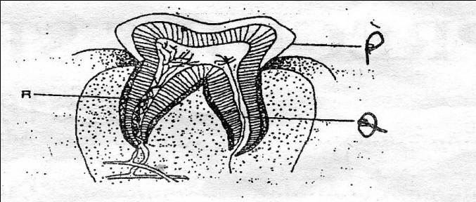

a)Name the type of tooth (2mks)
………………………………………………………………..……………………………………………………………………………………
………………………………………………………………………………………………………………………………………………………
b)Give a reason for your answer in (a) abobe. (1mk)
………………………………………………………………..……………………………………………………………………………………
………………………………………………………………………………………………………………………………………………………
c)Name the structures P,Q, and R (3mks)
P………………………………………………………..……………………………………………………………………………………
Q…………………………………………………………..……………………………………………………………………………………
R…………………………………………………………………………………………………………………………………………………
6.The diagram below represents a transverse section of a plant part

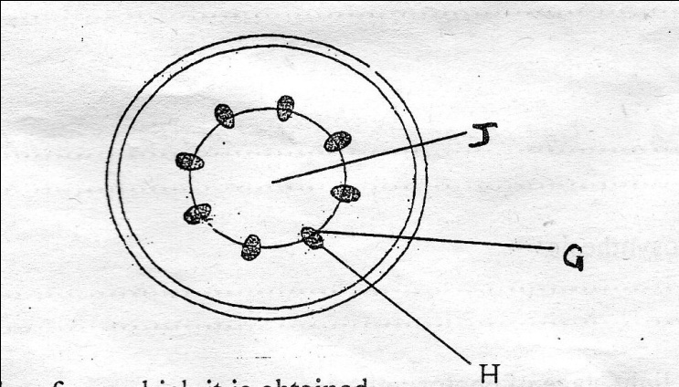

a)Identify the class from which it is obtained (1mk)
………………………………………………………………..……………………………………………………………………………………
b)Name parts G and H (2mks)
G…………………………………………………………..……………………………………………………………………………………
H…………………………………………………………………………………………………………………………………………………
c)Give one role of J (1mk)
………………………………………………………………..……………………………………………………………………………………
………………………………………………………………………………………………………………………………………………………
d)Name the three types of transpiration (3mks)
………………………………………………………………..……………………………………………………………………………………
………………………………………………………………………………………………………………………………………………………
………………………………………………………………………………………………………………………………………………………
e)Name the strengthening material in the xylem vessels (1mk)
………………………………………………………………..……………………………………………………………………………………
7.Below is a dental formulae of a certain organism. Use it to answer the questions that follow
$$I\frac{0}{3} C \frac{0}{1} PM \frac{3}{2} M \frac{3}{3}$$
i)Calculate the total number of teeth in the mouth of the organism (2mks)

ii)Name the organism (1mk)
………………………………………………………………..……………………………………………………………………………………
iii)Identify the mode of nutrition of the organism (1mk)
………………………………………………………………..……………………………………………………………………………………
b)Name the two dental diseases (2mks)
………………………………………………………………………………………………………………………………………………………
………………………………………………………………………………………………………………………………………………………
8.Give a reason why glucose does not normally appear in urine even though it if filtered in mammalian Bowman’s capsule (2mks)
………………………………………………………………………………………………………………………………………………………
………………………………………………………………………………………………………………………………………………………
………………………………………………………………..……………………………………………………………………………………
b)A person was found to pass out large volumes of dilute volumes of dilute urine frequently. Name the:
i)Disease the person was suffering from (1mk)
………………………………………………………………………………………………………………………………………………………
………………………………………………………………………………………………………………………………………………………
ii)Hormone that was deficient
………………………………………………………………………………………………………………………………………………………
………………………………………………………………………………………………………………………………………………………
c)Name the hormone involved in salt balance in the human body (1mk) ………………………………………………………………………………………………………………………………………………………
9.State one use of each of the following excretory products in plants (3mks)
i)Tannin
………………………………………………………………………………………………………………………………………………………
………………………………………………………………………………………………………………………………………………………
ii)Quinine
………………………………………………………………………………………………………………………………………………………
………………………………………………………………………………………………………………………………………………………
iii)Caffeine
………………………………………………………………………………………………………………………………………………………
………………………………………………………………………………………………………………………………………………………
10. The figure below represents a transverse section through the human skin

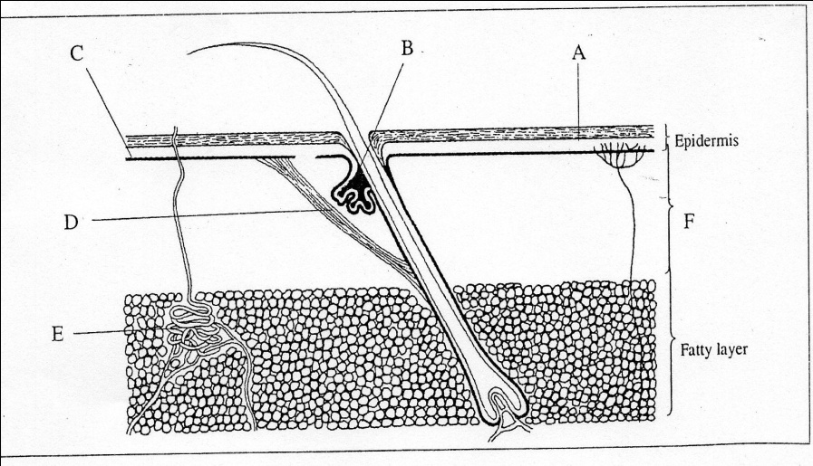
a)Name the structures A to F(6mks)
A…………………………………………………………………………………………………………………………………………………
B…………………………………………………………………………………………………………………………………………………
C…………………………………………………………………………………………………………………………………………………
D…………………………………………………………………………………………………………………………………………………
E…………………………………………………………………………………………………………………………………………………
F…………………………………………………………………………………………………………………………………………………
b)Give two functions of sebum (2mks)
………………………………………………………………………………………………………………………………………………………
………………………………………………………………………………………………………………………………………………………
c)Explain the changes that occur in the skin when it is cold (4mks)
………………………………………………………………………………………………………………………………………………………
………………………………………………………………………………………………………………………………………………………
………………………………………………………………………………………………………………………………………………………
………………………………………………………………………………………………………………………………………………………
………………………………………………………………………………………………………………………………………………………
………………………………………………………………………………………………………………………………………………………
………………………………………………………………………………………………………………………………………………………
………………………………………………………………………………………………………………………………………………………
11.The diagram below shows a vertical section through a mammalian hear

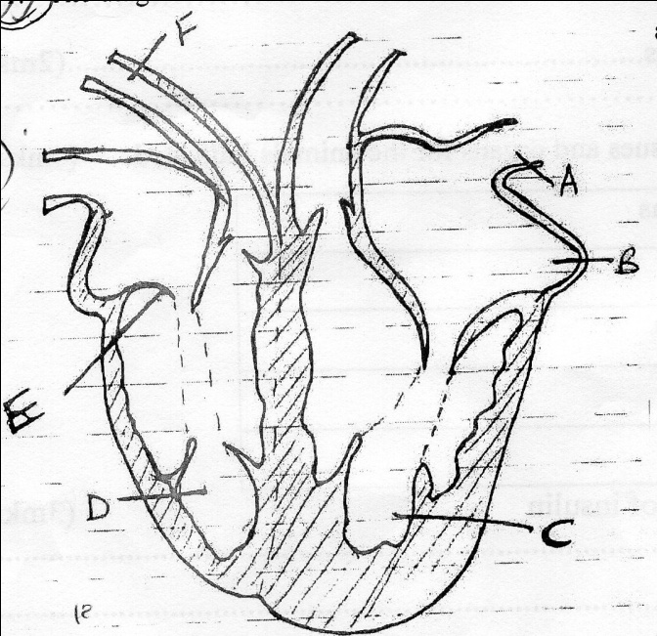

a)Name the parts labeled A,B,E and F (4mks)
A…………………………………………………………………………………………………………………………………………………
B…………………………………………………………………………………………………………………………………………………
E…………………………………………………………………………………………………………………………………………………
F…………………………………………………………………………………………………………………………………………………
b)Use the arrows to show direction in which the blood flows in the heart (2mks)

c)Give a reason why the wall of chamber C is thicker than chamber D (2mks)
………………………………………………………………………………………………………………………………………………………
………………………………………………………………………………………………………………………………………………………

12.Fill in the table below showing reactions of blood type by putting (√) for compatibility and (×)for
Incompatibility (4mks)
DONOR | RECIPIENT
 |  | Ab | Ba | AB | Oab
 | Ab | √ |  | √ | ×
 | Ba |  | √
 | AB | × | ×
 | Oab |  |  | √ | √

b)What are the advantages and disadvantages of having blood group O? (2mks)
………………………………………………………………………………………………………………………………………………………
………………………………………………………………………………………………………………………………………………………
c)What is the advantage of having blood group ABC (2mks)
………………………………………………………………………………………………………………………………………………………
………………………………………………………………………………………………………………………………………………………
13.a)Name the opening to the chamber of the heart of a grasshopper (1mk)……………………………………..
b)Study the diagram below
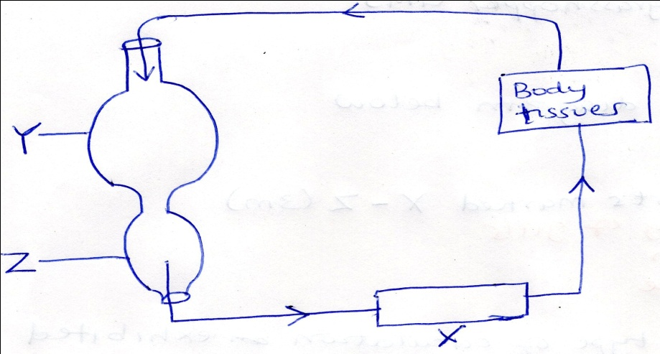
i)Name the parts marked X-Z (3mks)
X……………………………………………………………………………………………….
Y………………………………………………………………………………………………
Z………………………………………………………………………………………………..
c)Identify the type of circulation exhibited above and give an example of an organism with the type of circulation (2mks)………………………………………………………………………………………………………………………….
d)State any two diseases of the kidney (2mks)
………………………………………………………………………………………………………………………………………………………
………………………………………………………………………………………………………………………………………………………

14.The diagram below shows how blood glucose in mammalian body is regulated.
Normal glucose level
Less hormone R secreted hormone Z released
Pancreas secretes hormones
Normal glucose level

R

a)Name hormone R and Z (2mks)
R…………………………………………………………………………………………………………………………………………………
Z…………………………………………………………………………………………………………………………………………………
b)State two ways by which hormone R lowers glucose level in the blood when it rises above 90mg/ 100cm³ (2mks)
………………………………………………………………………………………………………………………………………………………
………………………………………………………………………………………………………………………………………………………
………………………………………………………………………………………………………………………………………………………
15.What is the difference between
i)Homoithers and ectotherms (poikilotherms) (2mks)
……………………………………………………..………………………………………………………………………………………………
………………………………………………………………………………………………………………………………………………………
ii)Vasodilation and vasoconstriction
………………………………………………………………..……………………………………………………………………………………
………………………………………………………………………………………………………………………………………………………
16.State differences between aerobic and anaerobic respiration (5mks)
Aerobic | Anaerobic
b)Study the diagram below and answer the questions that follow
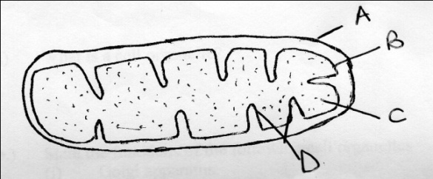
i)Identify the cell organelle (1mk)
……………………………………………………..………………………………………………………………………………………………
ii)What is the function of the cell organelle above (1mk)
……………………………………………………..………………………………………………………………………………………………
……………………………………………………..………………………………………………………………………………………………
iii)Label the parts labeled A to D (4mks)
A………………………………………………..………………………………………………………………………………………………
B………………………………………………..………………………………………………………………………………………………
C………………………………………………..………………………………………………………………………………………………
D………………………………………………..………………………………………………………………………………………………
17.Describe the roles of the liver in homeostasis (10mks)
………………………………………………………………………………………………………………………………………………………
………………………………………………………………………………………………………………………………………………………
………………………………………………………………..……………………………………………………………………………………
………………………………………………………………………………………………………………………………………………………
………………………………………………………………………………………………………………………………………………………
………………………………………………………………………………………………………………………………………………………
………………………………………………………………..……………………………………………………………………………………
………………………………………………………………………………………………………………………………………………………
………………………………………………………………………………………………………………………………………………………
………………………………………………………………………………………………………………………………………………………
………………………………………………………………..……………………………………………………………………………………
………………………………………………………………………………………………………………………………………………………
………………………………………………………………………………………………………………………………………………………
………………………………………………………………………………………………………………………………………………………
………………………………………………………………..……………………………………………………………………………………
………………………………………………………………………………………………………………………………………………………
………………………………………………………………………………………………………………………………………………………
………………………………………………………………………………………………………………………………………………………
………………………………………………………………..……………………………………………………………………………………
………………………………………………………………..……………………………………………………………………………………
………………………………………………………………………………………………………………………………………………………

