Name………………………………………………………………… ADM NO…………………SIGN ……….……date……….…
231
BIOLOGY
FORM 1
2 Hours
END OF TERM 2 EXAMINATION

INSTRUCTIONS TO CANDIDATES
- Write your name and admission Number in the spaces provided above.
- Sign and write date of examination in the spaces provided above.
- Answer ALL questions in the spaces provided.
- All workings must be clearly shown where necessary.

- State the branch of biology that deals with. (3mks)
- Study of Fish.

- Study of external structure of organisms

- Study of tissues.

- State the importance of each of the following in living organisms. (2 marks)
- Respiration

ii) Reproduction

- i) Name the apparatus being used below to collect specimen. (1mk)

ii. Name two organisms that can be collected using the above apparatus above.(2mks)

iii. State two precautions that should be taken during collection of the specimens.(2mks)

- The scientific name of Irish potato is solanum Tuberosum
- Identify two errors that have been made when writing the name (2mks)

(ii) What is the specific name of Irish potato? (1mk)

- Write the kingdoms to which the following organisms belong. (3mks)
Organism | Kingdom
Yeast
Bat
Aloe vera

- (i) The liger is an offspring of a lion and a tiger. Explain why the liger is infertile (1mk)

(ii) Name two members of kingdom Protoctista (2mks)

- (a)What is meant by the term taxonomy? (1mk)

(b)When are two organisms considered to belong to the same species. (2mks)

- Give three reasons why classification necessary? (3mks)

- Name the taxonomic unit
- With fewest members (1mks)
ii) Whose members share most similar characteristics? (1mks)

- If the linear dimension of a dimension of a drawing is 20cm and that of the object is 4cm. What is the magnification of the drawing? Show your working. (3mks)

- State the functions of the following cell structures. (2 marks)
- Sap vacuole.

(b) Nucleolus.

- Name the organelle in a cell that performs the following functions.
a) Forms energy. (1mk)

b) Synthesis of lipids. (1mk)

- i) Julie observed eight onion epidermal cells across the field of view of a light microscope. If the field of view was 4mm in diameter, estimate the average size of the cells in micrometers (1mm= 1000 m). (2marks)

ii) Why is it recommended to keep the stage of the microscope dry? (1 mark)

- In what ways are the properties of a cell membrane affected by
- Temperature; (2mks)

- Concentrated acid .(1mk)

- State the importance of the following when preparing temporary slides.
- Staining. (1mk)

- Cutting thin sections. (1mk)

- Complete the table below concerning specialization of cell. (6mks)
Name | Modification | Function
Muscle cell
 | Long tail – like extension.
 |  | Regulate opening and closing of stomata

- (a) Outline three roles of osmosis in organisms (3mks)

(b) Under what conditions does osmosis take place? (2mks)

- What is the effect of the following factors in the process of diffusion?

- Temperature (2mks)

- Concentration gradient (2mks)

- Surface area to volume ratio (2mks)

- Use the diagram below to answer the questions that follow;

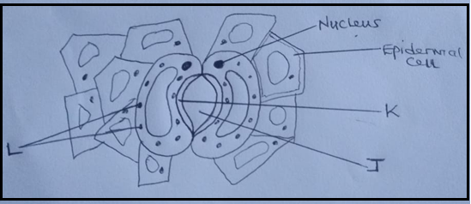
(a)Name the parts labeled J , K and L (3mks)
J
K
L
(b) Which gases pass through the part labeled J? (2mks)

- What differentiates a hypotonic solution from hypertonic solution? (2 marks)

- Form one students set an experiment as shown below.
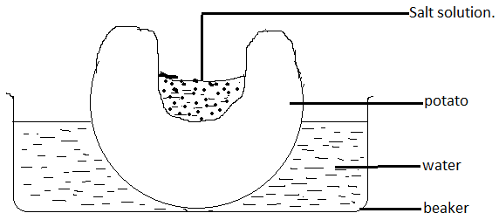
After sometime the students observed that the level of the sugar solution had risen.
- Name the physiological process being investigated. (1mk)
- Account for the rise in level of sugar solution in the experiment. (4mks)

- State the results that the students would obtain if the potato was boiled. Explain. (2mks)

- State three roles of active transport in animals (3mks)

- Distinguish between
- Haemolysis and plasmolysis; (2mks)
Haemolysis | Plasmolysis

- Turgid and crenated cell; (2mks)
Turgid cell | Crenated cell

- How are the leaves of higher plants adapted to their functions? (20mks)

