FORM 1 END TERM 2 –MARKING SCHEME.

- State the branch of biology that deals with. (3mks)
- Study of Fishes.
Ichthiology;
- Study of external structure of organisms
Morphology;
- Study of tissues.
Histology;
- State the importance of each of the following in living organisms. (2 marks)
- Respiration
Respiration: Process whose organism break down food to produce energy.
ii) Reproduction
Reproduction: Give rise to young ones of same ensuring continuity of the group.
- i) Name the apparatus being used below to collect specimen. (1mk)

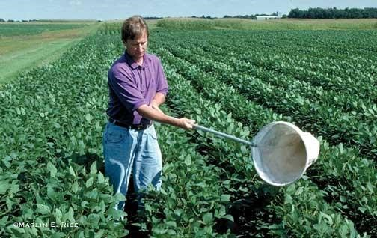

ii. Name two organisms that can be collected using the above apparatus above.(2mks)
Mosquitoes;
Bees;
House fly;
(Any flying insect/ AVP)
iii. State two precautions that should be taken during collection of the specimens.(2mks)
Collect only the number required;
Do not destroy the natural habitat of the organism;
Return live specimen back to the habitat after study;
Do not harm the specimen during capture;

- The scientific name of Irish potato is solanum Tuberosum
- Identify two errors that have been made when writing the name (2mks)
Second name should be in small letter. The names should be
underlined.
(ii) What is the specific name of Irish potato? (1mk)
Tuberosum;
- Write the kingdoms to which the following organisms belong. (3mks)
Organism | Kingdom
Yeast | Fungi
Bat | Animalia
Aloe vera | Plantae;

- (i) The liger is an offspring of a lion and a tiger. Explain why the liger is infertile (1mk)
It is an offspring of two organisms, which belong to different species;
(ii) Name two members of kingdom Protoctista (2mks)
Algae; protozoans acc; specific examples like Plasmodium, Paramecium
- (a)What is meant by the term taxonomy? (1mk)
It is the science of classification;
(b)When are two organisms considered to belong to the same species. (2mks)
When they can freely interbreed; to give rise to viable/fertile offspring;

- Give three reasons why classification necessary? (3mks)
Help in placing living organisms into their correct groups for reference;
Help in understanding evolutionary relationship between different organisms;
Bring together living organisms with similar characteristics while separating those with different features.;
Help in arranging information about living organisms in an orderly manner to avoid chaos and confusion that may arise if this is not done;
- Name the taxonomic unit
- With fewest members (1mks)
Species
ii) Whose members share most similar characteristics? (1mks)
Species
- If the linear dimension of a dimension of a drawing is 20cm and that of the object is 4cm. What is the magnification of the drawing? Show your working. (3mks)
Magnification =drawing dimension ;
Object dimension
=20cm;
4cm
=X5;

- State the functions of the following cell structures. (2 marks)
- Sap vacuole.
Store sugars (in plants)
Contribute to osmotic properties of the cell;

(b) Nucleolus.
Manufacture ribosomes.
- Name the organelle in a cell that performs the following functions.
a) Forms energy. (1mk)
Mitochondrion;
b) Synthesis of lipids. (1mk)
Smooth endoplasmic reticulum.
- i) Julie observed eight onion epidermal cells across the field of view of a light microscope. If the field of view was 4mm in diameter, estimate the average size of the cells in micrometers (1mm= 1000 m). (2marks)

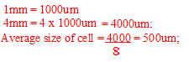
ii) Why is it recommended to keep the stage of the microscope dry? (1 mark)
- To avoid refraction of light;
- To prevent wetting of slide;
(Mark any one)
- In what ways are the properties of a cell membrane affected by
- Temperature; (2mks)
High temperature above optimum denature the proteins in the cell membrane;
- Concentrated acid .(1mk)
It denature the proteins in the cell membrane;
- State the importance of the following when preparing temporary slides.
- Staining. (1mk)
Make structures within the specimen distinct;
- Cutting thin sections. (1mk)
Allow penetration of light;

- Complete the table below concerning specialization of cell. (6mks)
Name | Modification | Function
Muscle cell | Has contractile fibrils; | Transmit impulses for long distances;
Sperm cell; | Long tail – like extension. | Propulsion;
Guard cell; | Bean shaped; | Regulate opening and closing of stomata

- (a) Outline three roles of osmosis in organisms (3mks)

- absorption of water by plant roots/absorption of water in colon in man,
- offer support in herbaceous plants;
- enable feeding in insectivorous plants;
- reabsorption of water in the kidney tubules;
(b) Under what conditions does osmosis take place? (2mks)
- There must be concentration gradient/ difference in water concentration from one part
to another;
- There must be a semi-permeable membrane;separating two fluids of different
concentration.
- What is the effect of the following factors in the process of diffusion?

- Temperature (2mks)

Increase in temperature increases the kinetic energy of diffusing molecules hence faster the rate of diffusion.
- Concentration gradient (2mks)

The higher the diffusion gradient between the two points, the faster the rate of diffusion.

acc. converse
- Surface area to volume ratio (2mks)

The higher /large the surface area to volume ratio, the faster the rate of diffusion,

acc. converse

- Use the diagram below to answer the questions that follow;

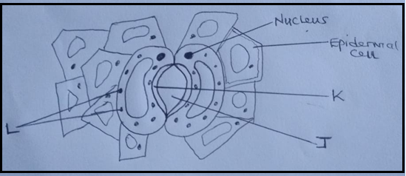
(a)Name the parts labelled J , K and L (3mks)
J Stoma; reject stomata
K thick inner wall
L chloroplasts reject singular
(b) Which gases pass through the part labeled J ? (2mks)
Oxygen gas
Carbon (IV) oxide.
- What differentiates a hypotonic solution from hypertonic solution? (2 marks)
- Solute concentration; hypotonic solution has less solute concentration compared to hypertonic one and/ vice versa.
- Form one students set an experiment as shown below.
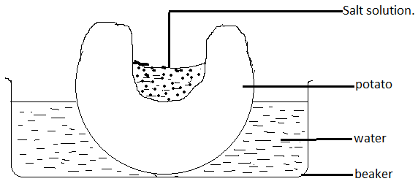
After sometime the students observed that the level of the sugar solution had risen.
- Name the physiological process being investigated. (1mk)
Osmosis;
- Account for the rise in level of sugar solution in the experiment. (4mks)
The water in the beaker was hypotonic to the potato cells; hence the cells gained water by osmosis;
The potato cells were hypotonic to the sugar solution; hence the sugar solution gained water by osmosis;
Acc converse
- State the results that the students would obtain if the potato was boiled. Explain. (2mks)
Sugar crystals would remain the same; boiling kills the protoplasm of the potato cells;

- State three roles of active transport in animals (3mks)
  - Reabsorption of sugars and some salts in the kidney;
  - Absorption of digested food from the alimentary canal into the blood stream;
  - Excretion of waste products from body cells;
  - Accumulation substances into the body to offset osmotic imbalance in arid and saline environment;
- Distinguish between
- Haemolysis and plasmolysis; (2mks)
haemolysis | Plasmolysis
Bursting of the red blood cell; | Process by which a plant cell loses water bby osmosis and the cell membrane shrinks and pull away from the cell wall and the cell become flaccid;

- Turgid and crenated cell; (2mks)
Turgid cell | Crenated cell
A plant cell that has gained water by osmosis and have become rigid/hard; | An animal cell that has lost water by osmosis and shrunk;

- How are the leaves of higher plants adapted to their functions? (20mks)
  - Broad and flattened lamina; to increase surface area; for absorption of light;
  - thin blade; to reduce distance for diffusion of gases and penetration of light ;
  - transparent epidermis and cuticle; to allow light to penetrate to tissues;
  - cuticle layer absent on stomata; to allow for gaseous exchange;
  - one-cell thick epidermal layer; to reduce the distance over which sunlight penetrates;
  - palisade cells have numerous chloroplasts containing chlorophyll; to trap maximum amounts of light energy;
  - have stomata on the epidermis; to allow for gaseous exchange; and control of water loss through transpiration;
  - palisade layer have elongated cells located at right angles to the leaf surface; for maximum absorption of light energy;
  - spongy mesophyll; consists of spherical and loosely-packed cells; to create air spaces; which communicate with the atmosphere through stomata; for purposes of gaseous exchange and control of water loss;
  - veins have conducting tissues: xylem; for movement of water and dissolved mineral salts; phloem; for translocation of manufactured food; Max. 20 mks

