NAME ……………………………………..…… DATE …………………………ADM NO. ……..

INDEX NO. …………….………………….……..….. SIGNATURE ….………..…..………..

231
BIOLOGY
FORM ONE
TIME: 2$\frac{1}{2}$ HOURS

OPENER EXAMINATION TERM 3, 2022
Kenya Certificate of Secondary Education

INSTRUCTIONS TO CANDIDATES: -
  - Write your name, Admission number and class in the spaces provided above.
  - Answer all the questions in the spaces provided
  - Candidates should answer the questions in English.

- State two advantages of using a coverslip when preparing a specimen for observation using the light microscope. (2mks)

- The diagram below is a nucleus.
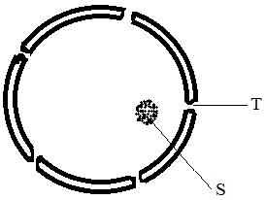
- What is the function of a nucleus? (1mk)

- Name the structure labeled T and S. (2mks)
T-
S –
- State the function of part T. (1mk)

- How are the following specialized cells specialized for their functions?
- Root hair cell. (1mk)

- Nerve cell (1mk)

- Muscle cell. (1mk)

- Define the following terms.
- Organ. (1mk)

- Organ system (1mk)

- Arrange the following from the smallest to the largest (1mk)
Cell, organ, tissue, organ system, organelle, organism;

- State the function of the following tissues. (2mks)
- Parenchyma tissue. (1mk)

- Epithelial tissue (1mk)

- a) What is the purpose of the following during preparation of temporary slide.
- Cutting thin sections. (1mk)

- Using a sharp razor blade (1mk)

- Staining (1mk)

b) Name two commonly used stains. (2mks)

- Name the parts labeled Q, R, S and T in the diagram below. (4mks)

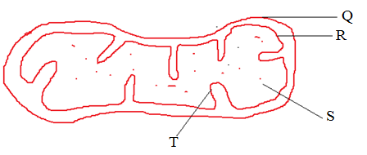

Q- R-

S- T-

- In a class experiment to establish the size of onion cell, a learner observed the following on the microscope field of view.
If the student counted 20 cells across the diameter of the field of view, calculate the size of one cell in micrometers. ( 3mks)

- State the function of the following parts of a microscope.
- Diaphragm. (1mk)

- Mirror. (1mk)

- (a) Explain what is meant by haemolysis. (1mk)

- Three potted plants were dipped in solutions of potassium ions at different concentrations of oxygen. Below is a table showing how potassium ions were absorbed at different percentages of oxygen concentration.

Percentage concentration of oxygen | 3.7 | 15 | 21
Relative absorption of potassium ions | 22 | 96 | 100

- Explain the relationship between oxygen concentration and absorption of potassium ions
(3mks)

- The study of biology enhances international cooperation, as countries work together to solve environmental problems. Name two biology related international conventions that help solve environmental problems. (2 marks)

- Name the field of science that specializes in the study of chemical substances in an organism and the reactions in which they take part. (1mk)

- The specific name of mango tree is Indica and its genus name Mangifera
(i) State one mistake in the way the specific name is written. (1mk)

(ii) Write the name in the correct manner following the rules of the binomial nomenclature. (1mk)

- A scientist discovered a new organism and decided to assign it a scientific name. What rules should be put in consideration while assigning the name? (4mks

- Draw and state the function of the following apparatus: (8mks)

i) Pooter

ii) Sweep net-

iii). Pitfall trap

- Pair of forceps

- Complete the table below (5mks)
Branches of biology | description
Parasitology
 | Study of inheritance and variation
 | Study of cells
Anatomy
 | Study of living organisms in their surroundings;

- a) What is the formula for calculating magnification of a specimen when using a hand lens (1mk)

b.) Draw and label a hand lens (4mks)

- State the importance of the following characteristics of living things (3mks)
- Respiration

- Reproduction

- Locomotion

- Explain the factors that affect the process of diffusion. ( 20 mks)

