BIOLOGY 231
EXAM FORM ONE
OPENER EXAMINATION TERM 3, 2022
MARKING SCHEME
Form 1
- State two advantages of using a coverslip when preparing a specimen for observation using the light microscope. (2mks)
- Hold the specimen in position;
- Protect the specimen from dehydration/ drying up/dust particles;
- Protect the objective lens from staining;
- The diagram below is a nucleus.
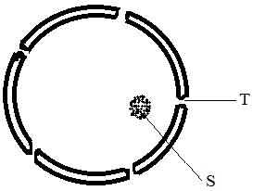
- What is the function of a nucleus? (1mk)
Control all the activities of a cell.
- Name the structure labeled T and S. (2mks)
T- Nuclear pore;
S – Nucleolus;
- State the function of part T. (1mk)
Facilitate movement of materials in and out of the nucleus;

- How are the following specialized cells specialized for their functions?
- Root hair cell. (1mk)
Has an extension which increases the surface area for absorption of water and mineral slats;
- Nerve cell (1mk)
Have extensions called axons and dendrites that facilitate impulse transmission;
- Muscle cell. (1mk)
Contain contractile fibrils that contract and relax bringing about movement;
- Define the following terms.
- Organ. (1mk)
Distinct part of an organism that consists of a group of tissues specialized to perform a specific function;
- Organ system (1mk)
Several organs whose functions are co-ordinated and synchronized to realize an effective function in a living organism.
- Arrange the following from the smallest to the largest (1mk)
Cell, organ, tissue, organ system, organelle, organism;
Organelle, cell, tissue, orgn, organ system, organism;
- State the function of the following tissues. (2mks)
- Parenchyma tissue. (1mk)
Form packaging and storage sites;
- Epithelial tissue (1mk)
Protection of internal and external surfaces;
- a) What is the purpose of the following during preparation of temporary slide.
- Cutting thin sections. (1mk)
Allow light to penetrate/pass through;
- Using a sharp razor blade (1mk)
Prevent distortion of the specimen;
- Staining (1mk)
Make structure within the specimen more distinct;
b) Name two commonly used stains. (2mks)
- Iodine solution; reject iodine alone.
- Eosin safranin;
- Methylene blue;
- Haematoxylene
- Fast green;
- Name the parts labeled Q,R,S and T. (4mks)
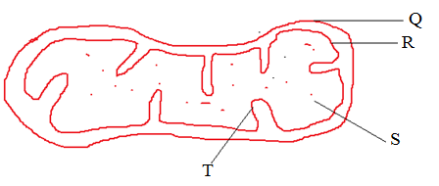
Q- Outer membrane;
R – Inner membrane;
S –matrix
T – Cristae;
- In a class experiment to establish the size of onion cell, a learner observed the following on the microscope field of view.
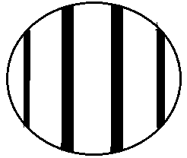
If the student counted 20 cells across the diameter of the field of view, calculate the size of one cell in micrometers. ( 3mks)

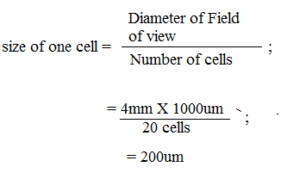

- State the function of the following parts of a microscope.
- Diaphragm. (1mk)
Regulate the amount of light entering the stage;
- Mirror. (1mk)
Reflect light to the stage;

- (a) Explain what is meant by haemolysis (1mk)
Bursting of the red blood cell;

(b) Three potted plants were dipped in solutions of potassium ions at different concentrations of
oxygen. Below is a table showing how potassium ions were absorbed at different percentages of
oxygen concentration.

Percentage concentration of oxygen | 3.7 | 15 | 21
Relative absorption of potassium ions | 22 | 96 | 100

- Explain the relationship between oxygen concentration and absorption of potassium ions
(3mks)

As the concentration of oxygen increases the higher the relative potassium absorption, oxygen is required in respiration; to release energy needed in potassium ion absorption (active transport);

- The study of biology enhances international cooperation, as countries work together to solve environmental problems. Name 2 biology related international conventions that help solve environmental problems. (2 marks)
Kyoto Protocol; Convention on International Trade in Endangered Species.
- Name the field of science that specializes in the study of chemical substances in an organism and the reactions in which they take part. (1mk)
Biochemistry;
- The specific name of mango tree is Indica and its genus name Mangifera
(i) State one mistake in the way the specific name is written. (1mk)
The name Indica should start with small letter I;
(ii) Write the name in the correct manner following the rules of the binomial nomenclature. (1mk)
Mangifera indica;

- A scientist discovered a new organism and decided to assign it a scientific name. What rules should be put in consideration while assigning the name? (4mks

i. The first name should be the generic name and the second name is the specific name (1mk
ii. The generic name should start with a capital letter while the specific name should start with
a small letter
iii. The names should be printed in italics or underlined separately when handwritten (1mk
iv. The names should be in Latin Language or Latinised

- Draw and state the function of the following apparatus: (8mks)

i) Pooter

ii) Sweep net-

iii). Pitfall trap

- Pair of forceps

- Complete the table below (5mks)

Branches of biology | description
Parasitology | Study of parasites
Genetics | Study of inheritance and variation
Cytology; | Study of cells
Anatomy | Study of external structures of organisms;
Ecology; | Study of living organisms in their surroundings;

- a) What is the formula for calculating magnification of a specimen when using a hand lens (1mk)
Magnification = drawing linear length
Actual length of the specimen
b.) draw and label a hand lens (4mks)

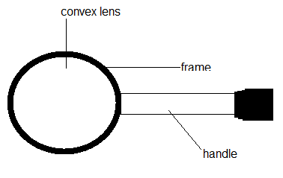

3marks –labelling
1mk- drawing
- State the importance of the following characteristics of living things (3mks)
- Respiration
Production of energy required by the living thigs
- Reproduction
Production of new organisms of the same kind as parents
Prevent extinction of species
Improvement of species especially in sexual reproduction
- Locomotion
Escape unfavourable conditions
Get nutrients/food
Get mates

- Explain the factors that affect the process of diffusion. ( 20 mks)
Concentration gradient; the higher/greater the concentration gradient between two regions; the higher/faster rate of diffusion; and converse.
Size of the molecules; smaller; and lighter molecules; diffuse faster; than larger and heavier molecules which diffuse slowly;
Temperature ; as temperature increases; the rate of diffusion increases; when the temperature is low the rate decreases;
Thickness of the membrane/tissue; in thin membranes/tissue; the rate of diffusion is faster; than in thick membranes(where it’s slow).
Medium in which it is taking place; it is faster in air; since molecules are far apart; than in water and solids; where molecules are closer ;
Surface area to volume ratio; the higher the ratio; the faster the process of diffusion/the shorter the distance covered by diffusing molecules; the lower the ratio; the slow the rate of diffusion;
Surface area; the larger the surface area the faster the rate of diffusion and converse;

