BIOLOGY FORM II EXAM
END OF TERM 2- 2021
TIME: 2 HRS

NAME……………………………………………………CLASS. ……………………………………
ADM. NO. ………………………………………………DATE………………………………………
QUESTIONS
- The diagram below represents a transverse.

Section of a young stem.

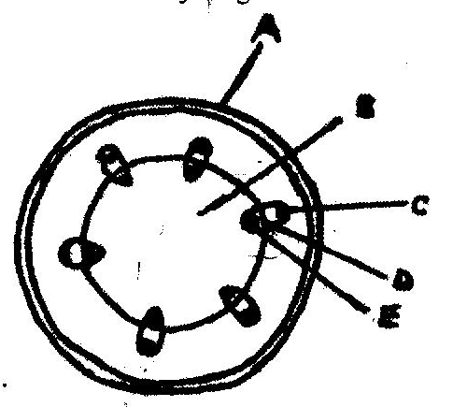

- Name the parts labeled A and B (2mks)

- State functions of the part labeled C, D, E. (3mks)
________________________________________________________________________________________________________________________________________________________
____________________________________________________________________________
- a) Why are people with blood group O universal donors. (2mks)
________________________________________________________________________________________________________________________________________________________
____________________________________________________________________________
b) A person with blood group AB requires blood transfusion. Name blood groups of
the donor. (2mks)
______________________________________________________________________________________________________________________________________________________________
_______________________________________________________________________________

- a) Name the type of circulatory system found in insects (1mk)
___________________________________________________________________________________________________________________________________________________________________

b) Name the blood vessel that transports blood from
- Small intestine to the liver. (1mk)
____________________________________________________________________________________________________________________________________________________________________
- Lungs to the heart. (1mk)

________________________________________________________________________________________________________________________________________________________
c) In what form is oxygen transported from the lungs to the body tissues? (1mk)
________________________________________________________________________________________________________________________________________________________

- Distinguish between natural and acquired immunity. (2mks)
_______________________________________________________________________________________________________________________________________________________________________________________________________________________________________________________________________________________________________________
- State four functions of blood other than transport. (4mk)
________________________________________________________________________________________________________________________________________________________________________________________________________________________________________________________________________________________________________________________________________________________________________________________________________________________________________________________________________

- Name the antigens that determine human blood groups. (2mks)
________________________________________________________________________________________________________________________________________________________

- State structural differences between arteries and veins. (6mks)
________________________________________________________________________________________________________________________________________________________
____________________________________________________________________________________________________________________________________________________________________________________________________________________________________________________________________________________________________________________________________________________________________________________________
- Give reasons for carrying out the following procedure when making temporary slides.
- Making thin sections. (1mk)
________________________________________________________________________________________________________________________________________________________
- Adding water to the sections. (1mk)

______________________________________________________________________________________________________________________________________________________
- Placing coverslip over the plant section. (1mk)

_________________________________________________________________________________________________________________________________________________________
- a) Distinguish between diffusion and osmosis. (2mks)
________________________________________________________________________________________________________________________________________________________
__________________________________________________________________________
b) The diagram below show a red blood cell that was subjected to certain treatment.

At start At end

Account for the shape of the cell. (2mks)

- a) Name the material that strengthens xylem vessels. (1mk)
________________________________________________________________________________________________________________________________________________________
b) Name the tissue that is removed when the bark of the dicotyledonous stem is ringed(1mk)
________________________________________________________________________________________________________________________________________________________
11. a) State what happens during light stage of photosynthesis. (4mks)
________________________________________________________________________________________________________________________________________________________
____________________________________________________________________________
________________________________________________________________________________________________________________________________________________________
____________________________________________________________________________
b). What are the end products light stage. (2mks
________________________________________________________________________________________________________________________________________________________
____________________________________________________________________________
12. State 2 factors affecting enzymatic activities. (4mks
___________________________________________________________________________________________________________________________________________________________________________________________________________________________________________________________________________________________________________________________________________________________________________________________

13. How does the following affect the rate of diffusion:
- Diffusion gradient. (2 mk)
________________________________________________________________________________________________________________________________________________________
____________________________________________________________________________
- Size of the molecules (2 mk)
____________________________________________________________________________________________________________________________________________________________________________________________________________________________________
- Thickness of the membrane. (2 mk)
____________________________________________________________________________________________________________________________________________________________________________________________________________________________________
- Temperature (2mks)
____________________________________________________________________________________________________________________________________________________________________________________________________________________________________
- Surface area to volume ration. (2mks)
____________________________________________________________________________________________________________________________________________________________________________________________________________________________________
14. Explain how the following factors determine the daily energy requirements

- Age (2mks)

__________________________________________________________________________________________________________________________________________________________________________________________________________________________________________________________________________

- Occupation (2mks)
____________________________________________________________________________________________________________________________________________________________________________________________________________________________________________________________________________________________________________

- Sex (2mks)
____________________________________________________________________________________________________________________________________________________________________________________________________________________________________
15. Name the appropriate food substances for each of the following enzymes.
- Ptyalin. (2mks)
______________________________________________________________________________________________________________________________________________________________________________________________________________________________________________________
- Pepsin. (2mks)
______________________________________________________________________________________________________________________________________________________________________________________________________________________________________________________
b). State the two roles of mucus in the stomach. (2mks)
______________________________________________________________________________________________________________________________________________________________________________________________________________________________________________________
16. a) State 3 adaption of xylem to its function. (3mks)

__________________________________________________________________________________________________________________________________________________________________________________________________________________________________________________________________________________________________________________________________________________________________________________________________________________________

b) Describe how 4 environment factors affect the rate of transportation. (8mks)
______________________________________________________________________________________________________________________________________________________________________________________________________________________________________________________
__________________________________________________________________________________________________________________________________________________________________________________________________________________________________________________________________________________________________________________________________________________________________________________________________________________________
__________________________________________________________________________________________________________________________________________________________________________________________________________________________________________________________________________________________________________________________________________________________________________________________________________________________
17.a) State the difference between closed and open circulatory system. (2mk)
______________________________________________________________________________________________________________________________________________________________________________________________________________________________________________________
b).State two ways in which the heart muscles are adapted to their functions. (2mks)
______________________________________________________________________________________________________________________________________________________________________________________________________________________________________________________
18. State the role of the following organelles. (6mks)
- Golgi apparatus
__________________________________________________________________________________________________________________________________________________________________________________________________________________________________________________
- Ribosomes
___________________________________________________________________________________________________________________________________________________________________________________________________________________________________________________
a. Golgi apparatus
__________________________________________________________________________________________________________________________________________________________________________________________________________________________________________________

- Lysosomes
___________________________________________________________________________________________________________________________________________________________________________________________________________________________________________________
- Mitochondrion
___________________________________________________________________________________________________________________________________________________________________________________________________________________________________________________
- Chloroplasts
___________________________________________________________________________________________________________________________________________________________________________________________________________________________________________________
- Centrioles
___________________________________________________________________________________________________________________________________________________________________________________________________________________________________________________

