END TERM 1-2023
BIOLOGY (232)
FORM FOUR (4)
PAPER 2
TIME: 2HRS

Name: ................................................................... Adm No: ...................
School: ................................................................. Class: .......................
Signature: .............................................................. Date: .....................

INSTRUCTIONS TO CANDIDATES
- Write your name, admission number, school and sign in the spaces provided above.
- Answer all the questions in the spaces provided.
- This paper contains two sections A and B. Answer ALL questions in section A. In section B, answer question 6 (Compulsory) and EITHER question 7 or 8.
- Note that all questions in section A carry equal marks.
FOR EXAMINERS USE ONLY
Section | Question | Maximum score | Candidates score
A | 1 | 8
 | 2 | 8
 | 3 | 8
 | 4 | 8
 | 5 | 8
B | 6 | 20
 | 7 | 20
 | 8 | 20
 | Total score | 80

Section A: 40MKS: Answer all the questions
- A cross between red flowered plant and white flowered plant produced plants with pink flowers. Using letter R to represent the gene for red color and W to represent white color;
- Work out a cross between F₁ plants (4mks)

- Give the;
- Phenotypic ratio of F₂ plants (1mk)

………………………………………………………………………………………………….

- Genotypic ratio of F₂ plants (1mk)

…………………………………………………………………………………………………

- Name a characteristic in humans which is controlled by multiple alleles. (1mk)

………………………………………………………………………………………………………

- Which is the biological term used to refer to the condition exhibited by F₁ plants. (1mk)
……………………………………………………………………………………………………..

- The photograph below shows red blood cells that have been put in different solutions. Examine them and answer the questions that follow.
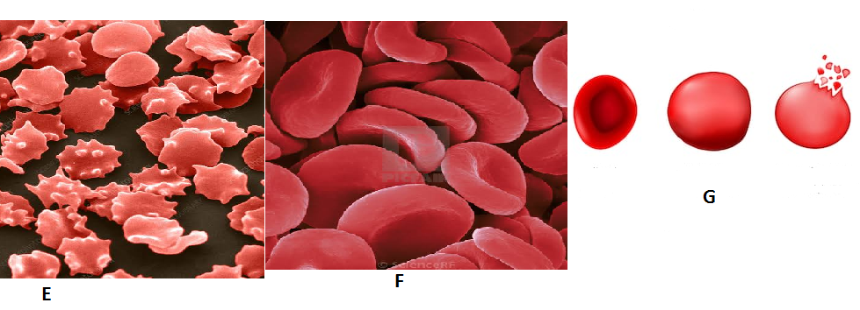
- i)Identify the type of solution in which F was placed. (1mk)
………………………………………………………………………………………………………
ii) State the process which the red blood cells underwent in illustration G. (1mk)

…………………………………………………………………………………………..

- Account for the appearance the red blood cells underwent in illustration E. (3mks)
………………………………………………………………………………………………………
……………………………………………………………………………………………………

- Explain what would happen if plant cells are placed in the solution in which the cells in G were immersed. (3mks)
…………………………………………………………………………………………………………………………………………………….

- The diagram below shows blood circulation in a mammalian tissue.

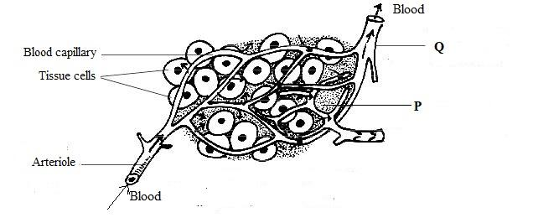
- Name the parts labelled P and Q. (2mks)

P ………………………………………………………………………………………………………

Q……………………………………………………………………………………………
- Name the substances that are:
- Required for respiration that move out of capillaries. (1mk)
………………………………………………………………………………………………………
- Removed from tissue cells as a result of respiration. (1mk)

………………………………………………………………………………………………………

- Explain how substances move from the blood capillaries into the tissue cells. (3mks)

…………………………………………………………………………………………………………………………………………………………
…………………………………………………………………………………………………………………………………………………………

- Name one blood component that is not found in the part labeled P. (1mk)

……………………………………………………………………………………………
- a. The diagram below represents a member of kingdom Animalia.

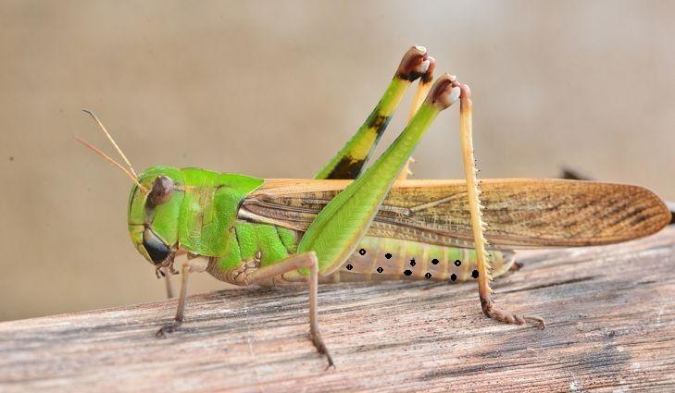
- Name the phylum to which the organism belong. (1mk)

…………………………………………………………………
- Using observable features in the diagram, give three reasons for the answer in 4a (i) above. (3mks)
…………………………………………………………………………………………………………………………………………………….
………………………………………………………………………………………

b. To estimate the population size of crabs in a certain lagoon, traps were laid at random. 400 crabs were caught, marked and released back into the lagoon on the first day. Four days later, traps were laid again at random. Out of the 374 crabs caught the second time, 80 were found to have been marked.
i. Calculate the population size of the crabs in the lagoon. (3mks)
- What is the name given to this method of estimating the population size? (1mk)

……………………………………………………………………………………………………
- An experiment was set up as show below.
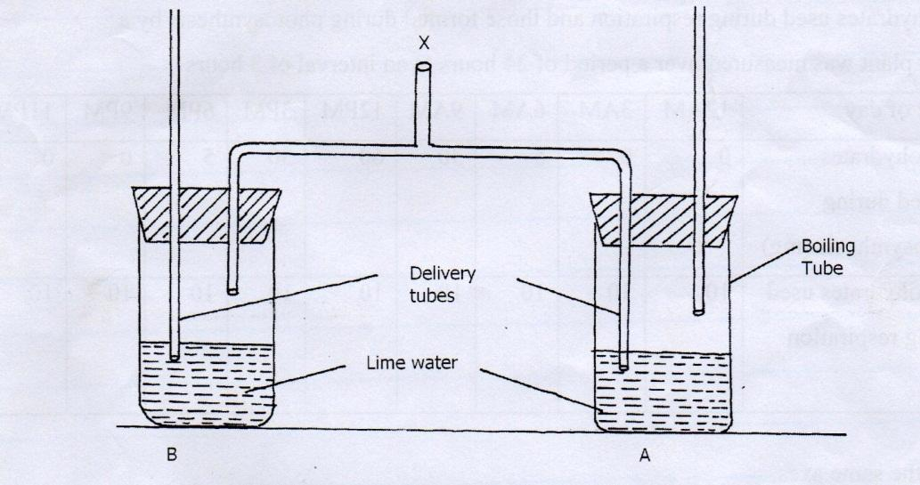

- A student blew air in and out through point X. Using arrows indicate how air gets in and out of the set up. (2mks)
(b) [i] In which of the tube would lime water form white precipitate first. (1mk)
………………………………………………………………………………………………
ii] Give a reason. (1mk)
………………………………………………………………………………………………
(c)What is the effect of lactic acid in the thigh muscle of an athlete after a short fast race? (2mks)
……………………………………………………………………………………………..

(d) Identify the type of muscle in human being where the formation and effect of lactic acid is not felt. (1mk)
………………………………………………………………………………………………………
(e) What is the biological significance of boiling milk. [1mk]
………………………………………………………………………………………

SECTION B: 40 Mks: Answer question 6 (compulsory) and either question 7 or 8.

- An experiment was carried out to investigate the effect of temperature on the rate of reaction catalyzed by an enzyme. The results are shown in the table below.
Temperature ⁰c | Rate of reaction in mg of product per unit time
5 | 0.2
10 | 0.5
15 | 0.8
20 | 1.1
25 | 1.5
30 | 2.1
35 | 3.0
40 | 3.7
45 | 3.4
50 | 2.8
55 | 2.1
60 | 1.1

- On the grid provided draw a graph of rate of reaction against temperature. ( 6marks)

(b) When was the rate of reaction 2.6 mg of product per unit time? ( 2 mks)
………………………………………………………………………………………………………
………………………………………………………………………………………………………
(c) Account for the shape of the graph between
(i) 5⁰ C and 40⁰ C ( 2 mks)
………………………………………………………………………………………………………………………………………………………………………………………………………………
(ii) 45⁰ C and 60⁰C ( 3 mks)
……………………………………………………………………………………………………..
……………………………………………………………………………………………………..
……………………………………………………………………………………………………..
(d) Other than temperature name two ways in which the rate of reaction between 5⁰C and 40⁰C could be increased. (2 mks)
………………………………………………………………………………………………………………………………………………………………………………………………………………
(e) (i) Name one digestive enzymes in the human body which works best in acidic condition ( 1 mk)
……………………………………………………………………………………………………..
(ii) How is the acidic condition for the enzyme named in (e) (i) above attained? ( 2 mks)
………………………………………………………………………………………………………………………………………………………………………………………………………………
(f) The acidic conditions in (e) (ii) above is later neutralized
(i) Where does the neutralization take place? ( 1 mk)

………………………………………………………………………………………………………

(ii) Name the substance responsible for neutralization (1 mk)
………………………………………………………………………………………………………
- Describe:
- How the structure of mammalian heart is adapted to its function. (15mks)
- The process of blood clotting. (5mks)

- a) After a meal of carbohydrate, the glucose level in the blood rose to 150mg/ cm³ . Explain the role of the liver in bringing the sugar level down back to normal. (8mks)

b) Explain six importance of plants excretory products. (12mks)

