TERM 2 2022 OPENER EXAM FORM 2
FORM TWO YEAR 2022
BIOLOGY. 70 MARKS.
TIME 2 HOURS.
NAME………………………………………ADM NO……………CLASS…….
Instructions to candidate.
Answer all questions in the spaces provided

- Distinguish between the following terms: - 4marks
- Magnification and resolution of a microscope

- Mounting and staining of a specimen

- Name the organelle that performs each of the following functions in a cell. 3marks
- Transport of packaged glycoproteins

- Destruction of worn out cell organelles

- Synthesis of proteins

- Given that the diameter of the field of view of a light microscope is 2000um. Calculate the
size of a cell in mm if 10 cells occupy the diameter of the field of view 2marks

- State three physiological processes that are involved in movement of substances a cross the cell membrane 3marks

- The diagram below illustrates the behaviour of red blood cells when placed into two different
solutions X and Y.
Placed in solution
X
Placed in solution
Y
Process A
Process B

(a) Suggest the nature of solutions X and Y. 2marks

X
Y

(b)Name the process A and B.
A
B 2marks
(c) What would happen to normal blood cell if it were placed in an isotonic solution? 2marks

- The diagram below represents a cell organelle
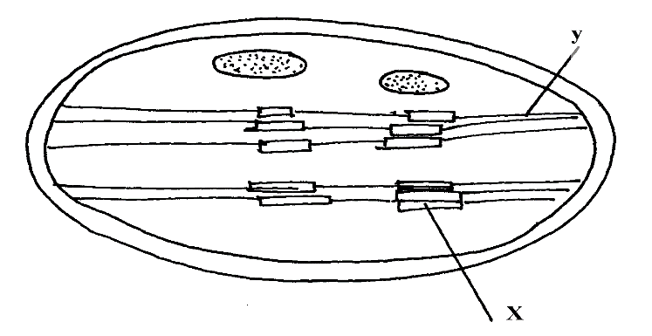

i) Name the part labeled Y 1mark

ii) State the function of the part labeled X 1mark

- Briefly explain the fate of the following products from the light stage of the process of
Photosynthesis: 3 marks
(a) Oxygen atoms

(b) Hydrogen ions

(c) ATP

- Name the diseases caused by deficiency of: 2marks

- Iodine

- Vitamin C

- (a) What is peristalsis? 1 mark

- Explain how the process above is brought about.
2marks

- What are the two functions of bile salts during the process of digestion. 2marks

- The table below shows three enzymes A, B and C and their respective optimum PH.
Enzyme | Optimum PH
A | 6.8
B | 2.0
C | 8.0
(a) (i) Name the most likely region of the alimentary canal of a mammal where enzyme
B would be found. 1 mark

(ii) Give a reason for your answer in (a) (i) above 2marks

- Study the dental formula given below:
I 0 C 0 PM 3 M 2
4 0 3 3
(a) Identify with reasons the mode of feeding of the animals whose dental formula is
given above
Mode 1mark

Reasons 2marks

(b) Calculate the total number of teeth in the mouth of the above animal. Show your working.
2marks.

- (a) Define the term transpiration 2marks

(b) State three types of transpiration 3marks

(c) List three forces that facilitate the transport of water and mineral salts up the stem.
3marks

(d) Name the tissue that is removed when the bark of a dicotyledonous plant is ringed

1 mark
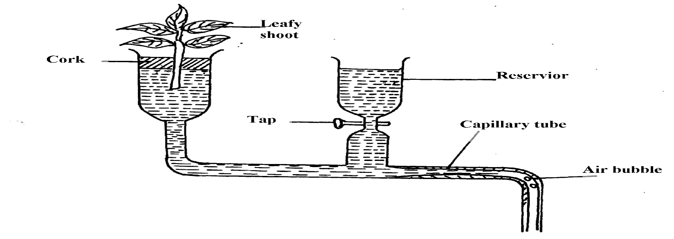
- The figure below represents a diagram of a photometer;

(a) What is the potometer used for? 1 mark

(b) Give two precautions, which should be taken when setting up a potometer 2marks

- Name the blood vessel that nourishes the heart 1 mark

- In which form is oxygen transported in the blood. 1 mark

- (a) State three structural differences between arteries and veins in mammals. 3marks

(b) Name a disease that causes thickening and hardening of arteries 1 mark

- Explain two advantages of closed circulatory system over open circulatory system. (2marks)

- List the components of animal circulatory systems 3 marks

- Give two structural differences between a red blood cell and a white blood cell. 2 marks.

- (a) what is blood clotting? 1 mark

(b)Name a protein, vitamin, and an enzyme involved in blood clotting. 3marks

- (a) What is immunity? 1 mark

(b)Distinguish between natural and acquired immunity 2 marks

- What is the role of vaccination against certain diseases 1 mark?

