NAME ……………………………………..…….ADM NO……………CLASS……………
SCHOOL……………………………………………DATE…………………….
231/3 BIOLOGY
PAPER 3 (PRACTICAL)
1 ¾ HOURS
INSTRUCTIONS TO THE CANDIDATE
- Write your name, admission number and class in the spaces provided.
- Answer all the questions in the spaces provided.
- You are required to spend the first 15 minutes of the 1 ¾ hours allowed for this paper reading the whole paper carefully before commencing your work.
- Candidates should answer the questions in English.

For Examiner’s Use Only
Question | Maximum  Score | Candidate’s  Score
1 | 15
2 | 13
3 | 12
Total Score | 40

- You are provided with a specimen labelled K and solutions labelled P and Q. Cut the specimen into two halves. From one half remove the outer and an inner leaf of the specimen.
- State two observable features of the outer and inner leaves of the specimen.
- outer leaf (2mks)

- Inner leaf (2mks)

- State a function of the inner and outer leaves of the specimen.
- Outer leaf (1mrk)

- Inner leaf (1mrk)

c) Name the type of reproduction exhibited by specimen K (1mrk)

Using the other half of specimen K, remove some of the inner leaves. Cut the leaves along their lengths into nine strips. Each strip should be about 2mm wide. Place three strips into the solution labelled P. Place another three strips into the solution labelled Q and leave the last three strips in a petri dish labelled R. Allow the experimental setups to stand for 10 minutes.
d) Use your fingers to feel the texture of the strips. Record your observations.
(i)Strip in solution P (1mrk)

(i) Strip in solution Q (1mrk)

e) Account for the texture of strips in solution Q (3mrks)

f) Suggest the concentration of solution P in relation to the cell sap in the strips of the specimen (1mrk)
g) Give a reason for your answer in (f) above (1mrk)

h) State the aim of the setup R (1mrk)

2. The diagram below illustrates photographs of plants undergoing a certain process. Study them carefully and answer the questions that follow.
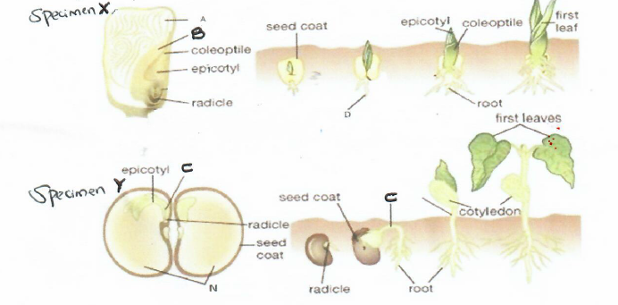

i) Name the process illustrated on the photograph. (1mrk)

ii) State two differences in the way the process occurs as illustrated in X and in Y. (2mrks)

b) i) State two roles of part C in the process illustrated above. (2mrks)

ii) State two external factors that are necessary for the process above to take place. (2mrks)
c) Name the part labeled B and give its function.
Name:
(1mrk)
Function:
(1mrk)

d) Using observable features only, name the classes to which the specimen X and Y belong, giving one reason in each case. (4mrks)
SPECIMEN | CLASS | REASONS
X
Y

3. Study the photographs below of specimen. A, B, C and D and then answer the questions that follows.

a) Name the condition exhibited in A which hinders self- fertilization. (1mrk)

b) Explain how the above condition hinders self-fertilization. (2mrk)

- With reasons give the term given to gynoecium B and C

- B (1mrk)

Reason (1mrk)

- C (1mrk)

Reason (1mrk)

d) i) State the division where plant in photograph D belong and give reason for your answer.
Division (1mrk)

Reason (1mrk)

ii) State the type of nutrition exhibited by specimen D. (1mrk)

iii) Give a reason for your answer in d (ii) above. (1mrk)

iv) Give the function of the structure labelled Y. (1mrk)

