A.C.K NAMBALE DIOCESE EXAMINATIONS
BIOLOGY 231/3
(PRACTICAL)
NOVEMBER 2021- 1^{3/4}HOURS
Name…………………………………………………………… Index Number……………………………
Candidate’s Signature………………………………………………. Date…………………………………

Instructions to Candidates
- Write your name and index number in the spaces provided above.
- Sign and write the date of examination in the spaces provided above.
- Answer all the questions in the spaces provided.
- You are required to spend the first 15 minutes of the 1^{3/4}hours allowed for this paper reading the whole paper carefully before commencing your work.
- Additional pages must not be inserted.
- Candidates should check the question paper to ascertain that al pages are printed as indicated that no questions are missing.
- Candidates should answer the questions in English.

For Examiner’s use only
Question | Maximum score | Candidate’s score
1 | 14
2 | 13
3 | 13
Total | 40

1. (a) You are provided with a straw and calcium hydroxide in a test tube.
- Dip one and a half of the drinking straw into the calcium hydroxide solution.
- Place your mouth at the open end of the drinking straw. Breathe out such as to bubbles gas into the calcium hydroxide solution five times.
- Record your observations. (1mk)

- Explain you observations in a(i) above. (2mks)

- Write an equation of the reaction that occurred in the test tube. (2mks)

- Apart from the chemical substance under investigation, name two other products that were bubbled into the test tube. (2mks)

- Name the parts followed by gases from the lungs until it is exhaled. (2mk)

(b) Examine photograph M below and use it to answer the questions that follows:-
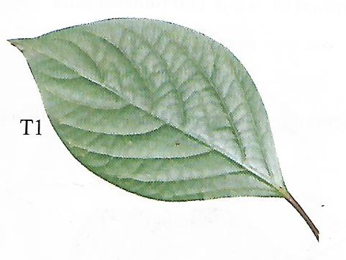

- State three observable features which adapt specimen M to gaseous exchange. (2mks)

(ii) State the sub-division and class to which specimen M belongs;-
Sub-division: (1mk)
Class: (1mk)
2. You are provided with soaked bean seed, Iodine solution, Biuret’s reagent, a scalpel and a hand lens.
By use of a scalpel, carefully cut the bean seed longitudinally such as to separate the two cotyledons.
- By use of a dropper, smear Iodine solution onto the exposed surfaces of the first cotyledon.
- Record your observation. (1mk)

- Account for observation in a(i) above. (1mks)

- By use of a dropper, smear some Biuret’s reagent onto the exposed surface of the second cotyledon.
- Record your observation. (1mk)

- Account for your observation in b(i) above. (1mk)

- Explain how the type of germination in the specimen occurs. (3mks)

- State the role of the following in the germination of a seed.
- Oxygen (1mk)

- Water (2mks)

- Cotyledon (3mks)

3. You are provided with specimen labelled as K and L in a petri-dish. Examine them.
- Identify specimens K and L. (2mks)
K: L:

- (i) Draw and label the anterior parts of specimen K. (4mks)

(ii)State ways by which specimen K is adapted to its functions. (3mks)

- From which parts of the body were specimens K and L obtained?
Specimen K: (1mk)
Specimen L: (1mk)
- Name the bone that articulates with specimen L at the:
- Proximal end (1mk)
- Distal end (1mk)
- Name the type of joint formed by specimen L at the anterior part; (1mk)

