MID TERM SERIES TERM 1-2023
BIOLOGY PAPER 3
FORM 4
MARKING SCHEME

a.

 | Contents inside tubing | Iodine solution  Outside tubing
Before the experiment | Grey/cream | Brown;
After the experiment | Blue-black | Brown;

- Diffusion;
- Iodine ions / particles are smaller in size and hence entered into the visking tubing by diffusion/ along concentration Gradient; through the pores; and reacted with starch solution/ solution L; While extract molecules/ solution L cannot come out since they are too large to diffuse out.
- Lungs; Small intestines
(b)
B Prophase I | Chromosomes have condensed/thickened;  Chromosomes beginning to pair up;
C Metaphase I | Spindle fibers fully formed; homologous chromosomes still associated as bivalents move to the equator of the spindle;

- X(Centromere)
It is the site/ point of attachment of sister chromatids
It is the site for attachment of spindle fibre

Y (Spindle fibre)
Responsible for moving and segregating the chromosomes during nuclear division/ cell division
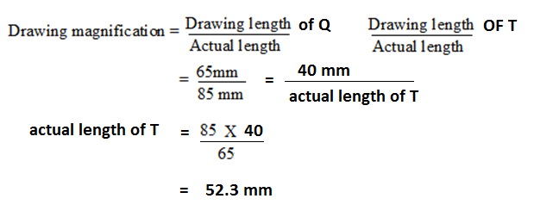

- The abdomen has spiracles; and therefore gaseous exchange continued;

c)

- (a) Animals with wings ................................................................................... go to 2
(b) Animals without wings ................................................................................ go to 3
2 (a) Animals with long limbs ............................................................................ Q
(b) Animals without long limbs ...................................................................... R

3 (a) Animals with four pairs of legs ..................................................................... S
(b) Animals with more than four pairs of legs ............................................... go to 4

4 (a) Animals with long Antenna ..................................................................... U
(b) Animals with short Antenna .................................................................... T

- Brown/ camouflaged to blend with environment;
Hind limbs have spines for protection;
Hind limbs are large enabling the organism to jump;

- (2mks)
Q | R
- Spikes on legs  - Hind less muscular  - Two pairs of wings  -Biting and chewing mouth part | - No spikes on legs  - Hind legs not muscular  - One pair of wings  - Piercing and sucking mouth part

FOOD SUBSTANCE | PROCEDURE | OBSERVATION | CONCLUSION
Starch | To 2cm³ of solution L add drops of iodine√1mk | Colour turns brown /yellow√1 mk | Starch absent1 mk
Reducing sugar | To 2cm³ of solution L ,add benedicts solution and boil√1 mark | Colour changes from blue to green to yellow/orange √1 mk | Reducing sugars present 1mk
proteins | To 2cm³ of solution L add 3 drops of NaOH followed by drops of CuSO₄ and shake√1mk | solution remains blue  √1 mk | Protein absent 1mk
Ascorbic acid  (vitamin c) | To 2cm³ of solution DCPIP add solution L dropwise shaking till in excess √1mk | DCPIP decolourised  √ 1mk | Vitamin C /Ascorbic acid present 1mk
3.

Mark Procedure, observation and conclusion
Food substance must be correctly entered to continue with marking

