231/3
BIOLOGY FORM THREE
Marking scheme
Question 1
(a) Omnivorous; (1mk)
(b) I – Molar; (1mk)
II – Canine; (1mk)

(c) H – Enamel / crown; (1mk)
J – Neck; (1mk)

(d) Teeth II has flat top / ridged while tooth IV has chisel shaped top. (1mk)

(e) Cutting / biting (1mk)

(f) i2 c3 pm2 m3 x 2 = 32 (1mk)
2 3 2 3

(g) Used more for chewing / has greater contact with food particles; // is flat broad ridged / cusped holds food remains;

Question 2
(a) (i)
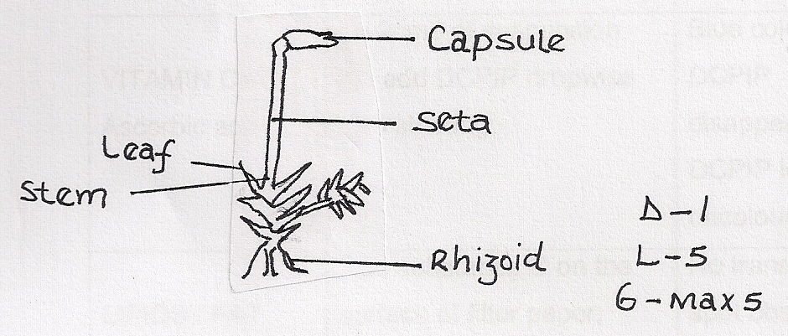
(ii) mg = Drawing length = 20mm
Objects length 10mm

= x 2;

- (i) Plantae;
  - Bryophyta;
  - Presence of;
Rhizoids;
Male and female branches

- - Leaves – photosynthesis
    - Capsule – spore producing
    - Rhizoids – anchorage, absorption of water and mineral salts.
    - Green contains chlorophyll for photosynthesis;

- Sporulation

- Green hence carry out photosynthesis / autotrophic
Question 3
Test - tube | OBSERVATIONS | CONCLUSION
A | Blue black/blue /black/bluish black; | Starch present;
B | Blue black/blue /black/bluish black; | Starch present;
C | Blue black/blue /black/bluish black; | Starch present;
6/2 = 3 marks
(b)
Test - tube | OBSERVATIONS | CONCLUSION
A | Blue black/blue /black/ dark blue /  bluish black; | Starch present;
B | No colour change /brown/yellow colour / colour of iodine; | Starch present;
C | Blue black/blue /black/bluish black; | Starch present;
6 marks
(c) Control experiment

(d) (i) Distase / enzyme /starch digesting enzyme/ ptyalin / saliva enzyme /salivary enzyme; (1mark)
(ii) Because it is converted / digested / changed starch / can be denatured by boiling / acts within a range of temperature between 35 ⁰C – 38₀C / optimum temperature; only 1 (1 mark)

(e) Mouth / duodenum / ileum;

NB (f) tied to table (b)
- B – Starch absent / No colour change /colour of iodine remains because starch has been digested / converted / hydrolysed / broken down into glucose / maltose / simple sugar; (1mark)

C - Starch present because boiling denatured enzyme /L₂ ; thus starch not broken down / not digested / not acted upon;

