CHOGORIA-MURUGI PRE-MOCK EXAM- 2023
Name…………………………………….………………..……Adm No……...................
Index Number.......…………………………….......... Date………………........
231/3
BIOLOGY
(Practical)
Paper 3
Time: 1 ¾ hours

Instructions to Candidates
- Write your name, Admission number and your other details in the spaces provided above.
- Spend the first 15 minutes of the time allocated to read through the question paper before commencing your work
- Answer ALL the questions in the spaces provided.
- For Examiner's Use Only
Question | Maximum Score | Candidate’s Score
1 | 14
2 | 13
3 | 13
Total Score | 40

1. You are provided with Irish potato tuber labeled specimen K, use it to answer questions that follow.
Cut out two cubes whose sides measure 1cm from the Irish potato provided
Label three test-tubes as, A, B and C and put them into the test-tube rack.
A ) Crush one cube to obtain a paste and add about 15 cm³ of distilled water to the paste to form a solution and then carry out the following procedure;
i) Use a measuring cylinder to pour 10 cm³ of potato extract solution into test-tube A.

ii) Use the measuring cylinder to transfer 5 cm³ of potato solution extract from test-tube A to test- tube B.

iii) Use the measuring cylinder to add 5 cm³ of distilled water to test-tube B. Place a stopper in test-tube B and shake it.

iv) Remove the stopper. Use the measuring cylinder to transfer 5 cm³ of the liquid in test- tube B to test-tube C.

v) Use the measuring cylinder to add 5 cm³ of distilled water to test-tube C. Place a stopper in test-tube C and shake it. Using a measuring cylinder reduce the volume of solution C to 5 cm³.
a) Table below shows the percentage concentration of the potato extract solution.

test-tube | percentage concentration of potato extract solution
A | 100.00
B
C

Complete the table above by calculating and writing in the percentage concentration of potato extract solutions in test-tube B and C. (2mks)

b ) Using a measuring cylinder pour 1 cm³ to each of hydrogen peroxide to the contents in test tube A to C and make the observations (3mks)

Test tube | Observations
A

B
C

( i) What was the aim of the investigation above (1mk)
……………………………………………………………………………………………………………
……………………………………………………………………………………………………………
(ii) Write the word equation for the reactions taking place in the test tubes (1mk)
……………………………………………………………………………………………………………
……………………………………………………………………………………………………………
(iii) What will be the expected observation if the irish potato was replaced with a piece of mammalian liver (1mk)
……………………………………………………………………………………………………………
……………………………………………………………………………………………………………

(iv) Explain your answer in c (iii) above (2mk)
……………………………………………………………………………………………………………
……………………………………………………………………………………………………………
……………………………………………………………………………………………………………
(B) Crush the remaining cube to obtain the paste. Use the reagents provided to and carry out food test on the extract. (4mks)

TEST | PROCEDURE | OBSERVATIONS | CONCLUSION

2. Study the photographs below and answer the questions that follow.
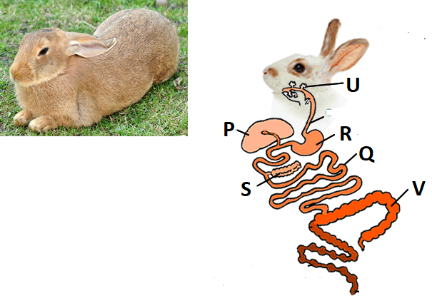
- With observable reasons identify the class of the specimen in the photograph.
- Class…………………………………………………………………………..(1mk)
- Reasons (2mks)
…………………………………………………………………………...……….
……………………………………………………………………………………
- (i) Name the structures labeled (4mks)
P …………………………………………………………………………………………...
Q …………………………………………………………………………………………...
R …………………………………………………………………………………………...
S …………………………………………………………………………………………..
- State the function of the parts labeled (2mks)
U …………………………………………………………………………………………...
V …………………………………………………………………………………………...

- Study the photographs below depicting plants growing in different habitats.
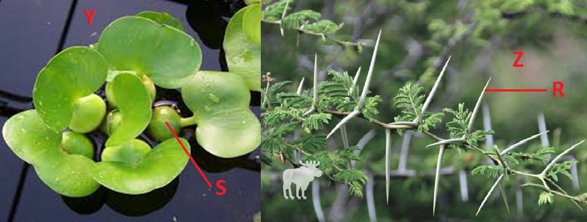
- Identify the habitats in which they are found (2mks)
Y …………………………………………………………………………………………...
Z …………………………………………………………………………………………...
- State the significance of the following structures found in the specimens shown above (2mks)
R …………………………………………………………………………………………...
S …………………………………………………………………………………………...
3. Below are photographs of two specimens, J and K. Both of them belong to the same phylum and class. Observe them carefully before you answer the questions that follow.
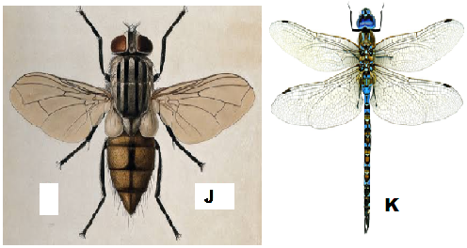
- Name the class to which J and K belong and support your answer with two reasons.
Class 1mk
…………………………………………………………………………………………………………….
Reasons 2mks
……………………………………………………………………………………………………………
……………………………………………………………………………………………………………
……………………………………………………………………………………………………………
- Suggest why the transport fluid in J and K has no haemoglobin. 2mks
……………………………………………………………………………………………………………
……………………………………………………………………………………………………………
……………………………………………………………………………………………………………
- The actual length of specimen K is 8cm, given that both J and K are under the same magnification, determine the actual length of J 3mks
……………………………………………………………………………………………………………
……………………………………………………………………………………………………………
……………………………………………………………………………………………………………
……………………………………………………………………………………………………………
- Below is a diagram showing the life cycle of specimen J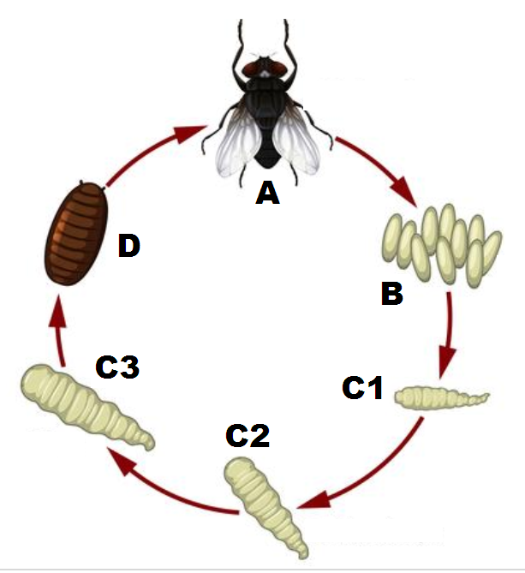
- Identify the stage labeled D. 1mk
………………………….………………………………………………………………………………….
- Name the hormone responsible for the change from D to A. 1mk
………………………………………………...………………………………………………...................
- Explain the differences in the change from C2 to C3 and from C3 to D. 2mks
C2 to C3
……………………………………………………………………………………………………………..
……………………………………………………………………………………………………………..
C3 to D
…………………………………………………………………………………………………………….
…………………………………………………………………………………………………………….
- State the importance of the process illustrated above in the life cycle of the organism (1mk)
......................................................................................................................................................................
......................................................................................................................................................................
.....................................................................................................................................................................
THE END

