NAME:………………………………………………… INDEX NO:……………………
SCHOOL:……………………………………………… DATE: .........................................
231/2
BIOLOGY
PAPER 2 (THEORY)
DECEMBER, 2021
2 HOURS

INSTRUCTIONS TO CANDIDATES
- Write your name and Index Number in the spaces provided above.
- This paper consists of two sections. Section A and section B. Answer ALL questions in section A in the spaces provided. In section B answer question 6 (compulsory) and either question 7 or 8 in the spaces provided after question 8
For Examiners use only.
Section | Question | Maximum score | Candidates score
A | 1 | 5
 | 2 | 2
 | 3 | 5
 | 4 | 4
 | 5 | 8
 | 6 | 7
 | 7 | 13
 | 8 | 20
 | 9 | 20
 | 10 | 20
 | Total score | 80
This paper consists of 8 printed pages. Candidates should check the question paper to ascertain that all pages are printed as indicated and that no questions are missing.
SECTION A
- When testing a variegated leaf for starch, the following procedure is important
- The leaf is boiled in water
- The leaf is then boiled in methylated spirit
- The leaf is taken back to the hot water
- The leaf is spread on a white tile and irrigated with iodine solution.
- Why is the leaf boiled in hot water? (1mk)
…………………………………………………………………………………………………………………………………………………....
- Why is the leaf boiled in methylated spirit? (1mk)
…………………………………………………………………………………………………………………………………………………….
- Explain why the leaf is dipped in in hot water. (1mk)
……………………………………………………………………………………………………………………………………………………
- Explain the observation made when the leaf is irrigated with iodine solution. (2mks)
…………………………………………………………………………………………………………………………………………………………………………………………………………………………………………………………………………………………………………..
- What is a variegated leaf? (1mk)
……………………………………………………………………………………………………………………………………………………..
- What is to destarch the leaf? (2mks)
………………………………………………………………………………………………………………………………………………………………………………………………………………………………..

- The diagram below represents the lower jaw of a mammals.

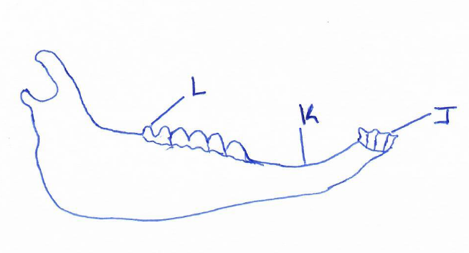

- Name the mode of nutrition of the mammal whose jaws is shown above. (1mk)
……………………………………………………………………………………………………………………………………………………………………………………..

- State one structural and one functional differences between the teeth labeled J and L. (2mks)
……………………………………………………………………………………………………………………………………………………………………………………..

  - Name the toothless gap labeled K. (1mk)
……………………………………………………………………………………………………………………………………………………………………
  - State the function of the gap. (1mk)
………………………………………………………………………………………………………………………………………………………………………………………………………………………………………………………..
- Name the substance that is responsible for hardening of the teeth. (1mk)
……………………………………………………………………………………………………………………………………………………………………………………..
- Distinguish between the terms homodont and hererodent. (2mks)
……………………………………………………………………………………………………………………………………………………………………………………..

- The diagram below shows the gaseous exchange system of a locust.
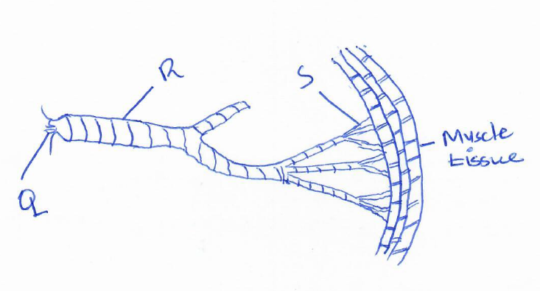
- Name the structure labeled Q. (1mk)
………………………………………………………………………………………………………………………………………………………………………..……………………..
- State the function of the part labeled R. (1mk)
…………………………………………………………………………………………………………………………………………………………………………………..…………..
- How is the part labeled S structurally adapted to its function? (2mks)
…………………………………………………………………………………………………………………………………………………………………………………………..…..
- Identify the structure that perform the same function as one illustrated above in. (2mks)
  - Amoeba
…………………………………………………………………………………................................................................................................................................
  - Fish
……………………………………………………………………………………………………………………………………………………………………
- Name the causative agents for the following respiratory.
Diseases. (2mks)
- Whooping Cough.
………………………………………………………………………………………………………………………………………………………………………………
- Pneumonia.
………………………………………………………………………………………………………………………………………………………………………………

- When pure breeding black guinea pigs were crossed with pure breeding white guinea pigs the offspring had a coat with black and white patches.
- Using letter G to represent the gene for black coat colour and letter H for white colour, workout the genotypic ratio of F_{2.} (5mks)

- State the phenotypic ratio of F₂ generation. (1mk)
…………………………………………………………………………………………………………………………………………………………………………………..
- Name the term used when two alleles in heterozygous state are fully expressed phenotypically in an organism. (1mk)
……………………………………………………………………………………….
…………………………………………………………………………………………
- Give an example of a trait in human beings where the condition whose term is named in (c) above expresses it. (1mk)
…………………………………………………………………………………………………………………………………………………………………………………..…

- The diagram below shows an embryo sac.
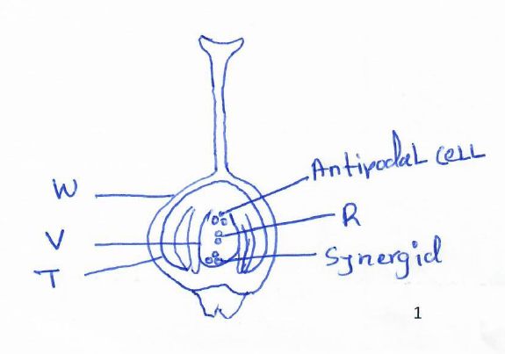
- Name the structures labeled D and E. (2mks)
………………………………………………………………………………………………………………………………………………………………………………………………………………………………………………………………………………………………
- On the diagram label the integuments. (1mk)

- On the diagram, mark using letter X the point at which the pollen tube enters the embryo sac. (1mk)

- What is the function of the pollen tube? (2mks)
…………………………………………………………………………………………………………………………………………………………………………………..…………..
………………………………………………………………………………………………
- State two factors that hinders self-pollination in flowering plants. (2mks).
…………………………………………………………………………………………………………………………………………………………………………………..…………..
…………………………………………………………………………………………………………………………………………………………………………………..…………..
SECTION B (40 MARKS)
Answer question 6 (compulsory) and any other one question from this section.
- 1cm³ of catalase solution was added to equal volumes of hydrogen peroxide solutions at different pH values. The time taken to collect 10cm³ of oxygen was measured. The results were as follows.

pH solution | Time taken to collect gas (minutes)
5.5 | 30
6.0 | 20
6.5 | 12
7.0 | 8
7.5 | 5
8.0 | 9
8.5 | 15
9.0 | 25

- Plot a graph of time against pH of solution. (6mks)
- Account for the rate of reaction at:
- pH. 7.5 (2mks)
……………………………………………………………………………………………………………………………………………………………………
- pH. 5.5 (2mks)
……………………………………………………………………………………………………………………………………………………………………..
- pH. 9.0 (2mks)
……………………………………………………………………………………………………………………………………………………………………
- Write a word equation for the reaction above. (1mk)
…………………………………………………………………………………………………………………………………………………………………………………..…
- What is the importance of the reaction you have given in c above? (1mk)
…………………………………………………………………………………………………………………………………………………………………………………..…
- Name an organ in the human body where the above reaction takes place. (1mk)
- Other than the factor being investigated above name four other factors that affect the rate of enzyme controlled reaction. (4mks)
…………………………………………………………………………………………………………………………………………………………………………………………………………………………………………………………………………………………………………………………………………………………………………………………………………………………………………………………………......

- Describe the functions of a mammalian skin. (20mks)

- Describe the process of double fertilization in a flowering plant. (20mks)

