Name …………………………………………….…………………………………………Index Number…………………………..
Adm.no……… ……………

231/ 2
BIOLOGY

Paper 2
Time-2 hours
MOMALICHE 1 CYCLE 10
INSTRUCTIONS TO CANDIDATES:
- Write your name and admission number in the spaces provided.

- Answer all the questions in this paper in the spaces provided.

- Answer questions 1-6 (compulsory) and either question 7 or 8.

For Examiner’s Use Only:
QUESTIONS | MAXIMUM SCORE | CANDIDATE’S SCORE
1 | 8
2 | 8
3 | 8
4 | 8
5 | 8
6 | 20
7 or 8 | 20

1a) Arrange the following structures in ascending order (2mks)
Chromosomes; Alleles; Genes; Chromatid; DNA

………………………………………………………………………………………………………………..

b) The letters below represents nitrogenous organic bases,
CCG; ATT; CGA; TAG
i)What term is given to each group (1mk)

………………………………………………………………………………………………………………..

ii) Give two functions of the three bases (2mks)

………………………………………………………………………………………………………………..

………………………………………………………………………………………………………………..

c) Study the diagram below on chromosomes and answer the questions that follow

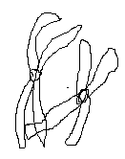

i)Identify the type of cell division (1mk)

………………………………………………………………………………………………………………..
ii)Name the stage of cell division illustrated by the above diagram (1mk)

………………………………………………………………………………………………………………..
iii) Describe what has occurred in the above chromosomes (1mks)

………………………………………………………………………………………………………………..

2. The diagram below is of a bean seedling placed horizontally in normal light condition
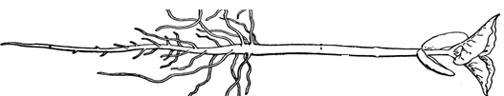

a)What is the expected observation after five days (2mks)

………………………………………………………………………………………………………………..

………………………………………………………………………………………………………………..

b)Name two responses exhibited by above seedling after 5 days (2mks)

………………………………………………………………………………………………………………..

………………………………………………………………………………………………………………..

c)Name the chemical substances responsible for inducing observation in (b) above
(1mk)
………………………………………………………………………………………………………………..
d) Name the structure in which the chemical substance in (c) above is conducted in the seedling (1mk)

………………………………………………………………………………………………………………..
e) Explain two survival values of Phototropism in plants (2mk)

………………………………………………………………………………………………………………..

………………………………………………………………………………………………………………..

3. Describe how each of the following cells are adapted to their functions
a)Root hair cells (4mks)
………………………………………………………………………………………………………………..

………………………………………………………………………………………………………………..

………………………………………………………………………………………………………………..

………………………………………………………………………………………………………………..
b) Sperm cells (4mks)

………………………………………………………………………………………………………………..

………………………………………………………………………………………………………………..

………………………………………………………………………………………………………………..

………………………………………………………………………………………………………………..

4. a i)What are sex linked genes (1mk)

………………………………………………………………………………………………………………..

………………………………………………………………………………………………………………..
ii) Give one reason why most sex linked genes are located on X chromosome
(1mk)
………………………………………………………………………………………………………………..

b) A red- green color blindness is a sex linked trait controlled by a sex linked recessive allele (d). A normally sighted woman whose father was color blind marries color blind man.
I)Draw a genetic cross diagram and show phenotypic ratio of their children (5mks)
………………………………………………………………………………………………………………..

………………………………………………………………………………………………………………..

………………………………………………………………………………………………………………..

………………………………………………………………………………………………………………..

………………………………………………………………………………………………………………..

………………………………………………………………………………………………………………..

II) Calculate the probability that their son will be color blind (1mk)

………………………………………………………………………………………………………………..

5. The chart below is a summary of blood clotting mechanism in humans
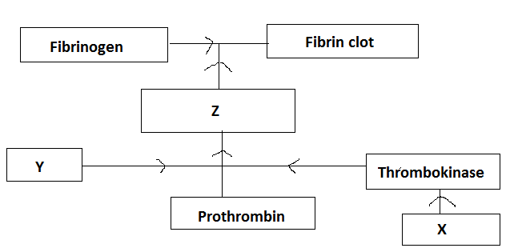
a)Name
i) the blood components represented by X (1mk)

………………………………………………………………………………………………………………

ii) Metal ion represented by Y (1mk)

………………………………………………………………………………………………………………

iii)What is the role played by metal ion in (ii) above (1mk)

………………………………………………………………………………………………………………

b)Name the site where vitamin K is formed in human body (1mk)

………………………………………………………………………………………………………………

c)Explain why an injured person loses more blood during hot weather when injured
(3mks)

………………………………………………………………………………………………………………

………………………………………………………………………………………………………………

………………………………………………………………………………………………………………
d) Name one way in which white blood cells defend the body against harmful microorganisms (1mk)

………………………………………………………………………………………………………………

SECTION B( 40 MARKS)
Answer questions 6 (compulsory) and either questions 7 or 8 in the spaces provided questions 8

6) An experiment was carried out using yeast at various temperatures starting at 15 degrees centigrade by immersing boiling tube with glucose yeast mixture in a water bath and results were tabulated as follows

Temperature(⁰C) | 15 | 20 | 25 | 30 | 35 | 40 | 45 | 50 | 55 | 60 | 65
Number of bubbles in every 2 minutes | 0 | 1 | 4 | 9 | 18 | 28 | 26 | 20 | 15 | 10 | 0

a)Using suitable scale plot a graph of number of bubbles every 2 minutes against temperature (6mks)

b) from the graph determine the rate of bubble production at 27 ⁰C (2mks)

………………………………………………………………………………………………………………

c) At what temperature was rate of bubbling at maximum (1mk)

………………………………………………………………………………………………………………
d)Name metabolic process taking place in the boiling tube with Glucose- Yeast mixture

(1mk)
………………………………………………………………………………………………………………

e)Explain why there was decline in rate of bubbling if temperatures was reduced from 65 ⁰C to 45 ⁰C (3mks)

………………………………………………………………………………………………………………

………………………………………………………………………………………………………………

………………………………………………………………………………………………………………

f) State one importance of this process to animals (1mk)

………………………………………………………………………………………………………………

………………………………………………………………………………………………………………
h) State the economic importance of the above process in Agriculture (3mks)

………………………………………………………………………………………………………………

………………………………………………………………………………………………………………

………………………………………………………………………………………………………………
g)Draw well diagram of a yeast cell (3mks)

7. Describe the role of the kidney in the following homeostatic processes
a) Osmoregulation (10mks)
b) Selective reabsorption of sodium ions (10mks)

8. Explain the factors that affect the following processes in living organisms
a)Diffusion (10mks)

b)Active transport (10mks)

………………………………………………………………………………………………………………

………………………………………………………………………………………………………………

………………………………………………………………………………………………………………

………………………………………………………………………………………………………………

………………………………………………………………………………………………………………

………………………………………………………………………………………………………………

………………………………………………………………………………………………………………

………………………………………………………………………………………………………………

………………………………………………………………………………………………………………

………………………………………………………………………………………………………………

………………………………………………………………………………………………………………

………………………………………………………………………………………………………………

………………………………………………………………………………………………………………

………………………………………………………………………………………………………………

………………………………………………………………………………………………………………

………………………………………………………………………………………………………………

………………………………………………………………………………………………………………

………………………………………………………………………………………………………………

………………………………………………………………………………………………………………

………………………………………………………………………………………………………………

………………………………………………………………………………………………………………

………………………………………………………………………………………………………………

………………………………………………………………………………………………………………

………………………………………………………………………………………………………………

………………………………………………………………………………………………………………

………………………………………………………………………………………………………………

………………………………………………………………………………………………………………

………………………………………………………………………………………………………………

………………………………………………………………………………………………………………

………………………………………………………………………………………………………………

………………………………………………………………………………………………………………

………………………………………………………………………………………………………………

………………………………………………………………………………………………………………

………………………………………………………………………………………………………………

………………………………………………………………………………………………………………

………………………………………………………………………………………………………………

………………………………………………………………………………………………………………

………………………………………………………………………………………………………………

………………………………………………………………………………………………………………

………………………………………………………………………………………………………………

………………………………………………………………………………………………………………

………………………………………………………………………………………………………………

………………………………………………………………………………………………………………

………………………………………………………………………………………………………………

………………………………………………………………………………………………………………

………………………………………………………………………………………………………………

………………………………………………………………………………………………………………

………………………………………………………………………………………………………………

………………………………………………………………………………………………………………

