NAME…………………………...……………………………..… ADM NO……..………CLASS……..……..
231/2
BIOLOGY
PAPER 2
(THEORY)
DECEMBER, 2021
TIME: 2 HOURS

LANET JOINT EXAMINATION
Kenya Certificate of Secondary Education (K.C.S.E)

INSTRUCTIONS TO CANDIDATES
- Write your name and Index Number in the spaces provided above.
- This paper consists of two sections. Section A and section B.
- Answer ALL questions in section A in the spaces provided. In section B answer question 6 (compulsory) and either question 7 or 8 in the spaces provided after question 8
- This paper consists of 8 Printed pages. Candidates should check the question paper to ensure that all the papers are printed as indicated and no questions are missing.

For Examiners use only.
Section | Question | Maximum score | Candidates score
A | 1 | 8
 | 2 | 8
 | 3 | 8
 | 4 | 8
 | 5 | 8
B | 6 | 20
 | 7 | 20
 | 8 | 20
 | Total score | 80

This paper consists of 6 printed pages.
Candidates should check the question paper to ensure that all pages are printed as indicated
and no questions are missing

- The diagram below shows experiment that was carried out by form one students.

Starch + diastase
Starch + diastase + HCL

TEST TUBE B
TEST TUBE A

Both test tubes were placed in a hot water bath maintained at 37⁰c for 30 minutes.
- What was the aim of the experiment (1 mk)

- If the contents of the two test tubes were tested for starch.
State observation that was made and give reasons for the observation made. (1 mk)

- Name the enzyme that completes the digestion of starch in small intestines (1 mk)

- State two ways through which mechanical digestion is achieved (2 mks)

- In a family where the father is blood group A and the mother blood group B, one of their children had blood group O.
- State the genotypes of the parents (2 mks)

Father …………………………………………………………………………………….
Mother ……………………………………………………………………………………

- Work out genotypes of their children using genetic cross (3 mks)

- i). Which children can receive blood from all other member of the family (1 mk)

ii). Give reason for your answer in (i) above (1 mk)

- What is multiple allelism? (1 mk)

- The figure below shows an experimental set up to demonstrate transportation in plants.
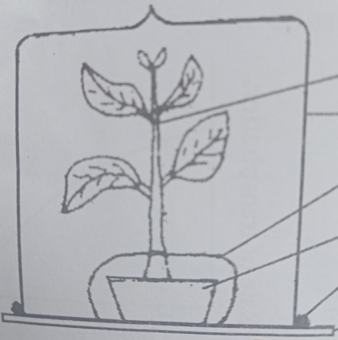
Plant

Polythen bag

Pot with watered soil

Vaseline

Glass plate

- Give reason for the following
- Smearing Vaseline between the glass plate and the bell jar (1 mk)

- Why polythne bag is wrapped around the pot and tied at the base of the plant (1 mk)

- i). What will be observed in this experiment? (1 mk)

ii). How do you test for the identity of the substance observed in b(i) above (2 mks)

- Describe the setup of the control for this experiment (2 mks)

- State two factors which affect the results of this experiment (2 mks)

- The diagram below shows plant gametes.
A
B
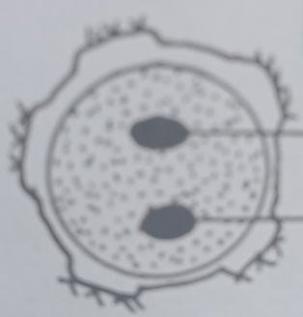
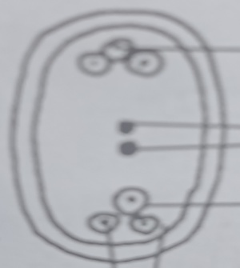
P
Y
X
Z

Egg

Synerds

- Identify structures A and B (2 mks)
A ……………………………………………………..
B ……………………………………………………
- Name the parts labeled Y and P (2 mks)

- What is the fate of the structure labeled X (1 mk)

- Which structure on diagram B fuses with one of male nucleus to form triploid nucleus (1 mk)

- What is double fertilization (2 mks)

5. The diagram below shows behavior of animal cell when present in solution of different concentration.
Process Y
Y
X
Solution P
Process Z
Soluti on X

- Name solution X and P

- Name process Y and Z (2 mks)

- Explain what will happen to a plant cell when subjected to solution X (2 mks)

- Give importance of osmosis to a plant cell. (2 mks)

SECTION B
In this section attempt question 6 (compulsory) and either questions 7 or 8
- An experiment was done to investigate population growth of four beetles (tribolium confusum).16g and 64g of maize flour was placed in two equal boxes K and L respectively. Equal number of beetles was added in the boxes. Both boxes were kept under the same environmental condition. Beetles were counted at certain intervals and results tabulated as shown below.
Number of days after introduction of bettles | Approximate number of individuals present in K and L
 | K | L
0 | 20 | 20
5 | 20 | 20
40 | 200 | 300
60 | 550 | 800
80 | 560 | 1300
100 | 650 | 1750
120 | 640 | 1600
135 | 650 | 1900
150 | 645 | 1500

- Using the results in the table above draw two graphs on the same axes. Plot approximate number of individual present on y-axis (7 mks)

- What was the approximate number of individuals present in the two boxes on the 90th day? (2 mks)

- Number in K ……………………………………………

- Number in L ……………………………………………

- On what day was population difference:- (2 mks)
- Greatest

- Lowest

- Account for the shape of the two graphs between 1st and 100th day (2 mks)

- Explain the shapes of the graph K between 80th and 150th day (2 mks)

- Differentiate between intraspecific and interspecific competition (2 mks)

- Name three methods of population estimation (3 mks)

- Explain how the skin is adapted to its functions (20 mks)
………………………………………………………………………………………………………………………………………………………………………………………………………………………………………………………………………………………………………………………………………………………………………………………………………………………………………………………………………………………………………………………………………………………………………………………………………………………………………………………………………………………………………………………………………………………………………………………………………………………………………………………………………………………………………………………………………………………………………………………………………………………………………………………………………………………………………...
……………………………………………………………………………………………………………………………………………………………………………………………………………………………………………………………………………………………………………………………………………………………………………………………………………………………………………………………………………………………………………………………………………………
………………………………………………………………………………………………………………………………………………………………………………………………………………………………………………………………………………………………………………………………………………………………………………………………………………………………………………………………………………………………………………………………………………………………………………………………………………………………………………………………………………………………………………………………………………………………………………………………………………………………………………………………………………………………………………………………………………………………………………………………………………………………………………………………………………………………………...
……………………………………………………………………………………………………………………………………………………………………………………………………………………………………………………………………………………………………………………………………………………………………………………………………………………………………………………………………………………………………………………………………………………………………………………………………………………………………………………………………………………………………………………………………………………………………………………………………………………………………………………………………………………………………………………………………………………………………………………………………………………………………………………………………………………………………………………………………………………………………………………………………………………………………………………………………………………………………………………………………………………………………………………………………………………………………………………………………………………………………………………………………………………………………………………………………………………………………………………………...
……………………………………………………………………………………………………………………………………………………………………………………………………………………………………………………………………………………………………………………………………………………………………………………………………………………………………………………………………………………………………………………………………………………………………………………………………………………………………………………………………………………………………………………………………………………………………………………………………………………………………………………………………………………………………………………………………………………………………………………………………………………………………………………………………………………………………………………………………………………………………………………………………………………………………………………………………………………………………………………………………………………………………………………………………………………………………………………………………………………………………………………………………………………………………………………………………………………………………………………………...
………………………………………………………………………………………………………………………………………………………………………………………………………………………………………………………………………………………………………………………………………………………………………………………………………………………………………………………………………………………………………………………………………………………………………………………………………………………………………………………………………………………………………………………………………………………………………………………………………………………………………………………………………………………………………………………………………………………………………………………………………………………………………………………………………………………………………………………………………………………………………………………………………………………………………………………………………………………………………………………

- a) What is organic evolution (1 mk)
…………………………………………………………………………………………………………………………………………………………………………………………………………………………………………………………………………………………………………………………………………………………………………………………………………………………………………………………………………………………………………………………………………………………………..
- Giving examples, describe differences between homologous and analogous structures (4 mks)
………………………………………………………………………………...................................................................................................................................................................................................................
..............................................................................................................................................................................................................................................................................................................................………………………………………………………………………………...........................................................................................................................................................................................................................................................................................................................................................................................................................................................................................................................................................................
........................................................................................................................................................................................................................................................................................................................................................................................................................................................................................................................................................................................................................................................................................

- Describe how natural selection brings about the adaptation of a species to its environment (15 mks)

………………………………………………………………………………………………………………………………………………………………………………………………………………………………………………………………………………………………………………………………………………………………………………………………………………………………………………………………………………………………………………………………………………………………………………………………………………………………………………………………………………………………………………………………………………………………………………………………………………………………………………………………………………………………………………………………………………………………………………………………………………………………………………………………………………………………………...
……………………………………………………………………………………………………………………………………………………………………………………………………………………………………………………………………………………………………………………………………………………………………………………………………………………………………………………………………………………………………………………………………………………………………………………………………………………………………………………………………………………………………………………………………………………………………………………………………………………………………………………………………………………………………………………………………………………………………………………………………………………………………………………………………………………………………………………………………………………………………………………………………………………………………………………………………………………………………………………………………………………………………………………………………………………………………………………………………………………………………………………………………………………………………………………………………………………………………………………………...
…………………………………………………………………………………………………………………………………………………………………………………………………………………………………………………………………………………………………………………………………………………………………………………………………………………………………………………………………………………………………………………………………………………………………………………………………………………………………………………………………………………………………………………………………………………………………………………………………………………………………………………………………………………………………………………………………………………………………………………………………………………………………………………………………………………………………………………………………………………………………………………………………………………...
………………………………………………………………………………………………………………………………………………………………………………………………………………………………………………………………………………………………………………………………………………………………………………………………………………………………………………………………………………………………………………………………………………………………………………………………………………………………………………………………………………………………………………………………………………………………………………………………………………………………………………………………………………………………………………………………………………………………………………………………………………………………………………………………………………………………………………………………………………………………………………………………………………………………………………………………………………………………………………………………………………………………………………………………………………………………………………………………………………………………………………………………………………………………………………………………………………………………………………………………………………………………………………………………………………………………………………………………………………………………………………………….…………………………

