231/2
BIOLOGY MARKING SCHEME
PAPER 2 (THEORY)
DECEMBER, 2021
SECTION A
- When testing a variegated leaf for starch, the following procedure is important
- The leaf is boiled in water
- The leaf is then boiled in methylated spirit
- The leaf is taken back to the hot water
- The leaf is spread on a white tile and irrigated with iodine solution.
- Why is the leaf boiled in hot water? (1mk)
To kill the protopiasm/ to open up the starch grains.
- Why is the leaf boiled in methylated spirit? (1mk)
To remove the chlorophyll/ discolour the leaf.
- Explain why the leaf is dipped in in hot water. (1mk)
To soften the leaf which was hardened by methylated spirit and remove any traces of ethanol.
- Explain the observation made when the leaf is irrigated with iodine solution. (2mks)
There is formation of blue/black patches; other areas remained brown (colour of iodine); blue/black confirmed presence of starch; brown absence of starch.
- What is a variegated leaf? (1mk)
A leaf which has some chlorophyll patches while other parts do not have chlorophyll.
- What is to destarch the leaf? (2mks)
To remove starch from the leaf by keeping it in darkness for 48 hours.

- The diagram below represents the lower jaw of a mammals.

- Name the mode of nutrition of the mammal whose jaws is shown above. (1mk)
Herbivorous
- State one structural and one functional differences between the teeth labeled J and L. (2mks)
Structural- tooth J is narrow/ sharp/chisel like while tooth L is broad/ridged.
Functional- tooth J is used for cutting and biting while tooth L is used for grinding food.

  - Name the toothless gap labeled K. (1mk)
Diastena
  - State the function of the gap. (1mk)
To allow manipulation of food by tongue, separating chewed and newly cut vegetation.
- Name the substance that is responsible for hardening of the teeth. (1mk)
Calcium Phosphate
- Distinguish between the terms homodont and hererodent. (2mks)
Homodont- organisms having same/ similar kind/ type of teeth, hence same function.
Heterodont- organisms having different type/ kind of teeth hence different function.
- The diagram below shows the gaseous exchange system of a locust.
- Name the structure labeled Q. (1mk)
Spiracle.
- State the function of the part labeled R. (1mk)
R is the trachea which is air tubes that penetrates the body space carrier oxygen to and carbon (iv) oxide away from tracheoles.
- How is the part labeled S structurally adapted to its function? (2mks)
Thin walled to reduce the diffusing, molecules. Since it lacks spiral bands of chitin to make the surface permanent to respiratory gases. Moist to dissolve respiratory gases.
- Identify the structure that perform the same function as one illustrated above in. (2mks)
  - Amoeba cell membrane
  - Fish- gill filament
- Name the causative agents for the following respiratory.
Diseases. (2mks)
- Whooping Cough. Bordetella pertussis
- Pneumonia. Streptococcus Pneumonia.

- When pure breeding black guinea pigs were crossed with pure breeding white guinea pigs the offspring had a coat with black and white patches.
- Using letter G to represent the gene for black coat colour and letter H for white colour, workout the genotypic ratio of F_{2.} (5mks)
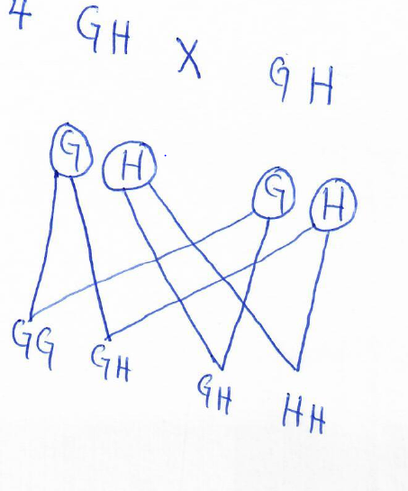
Genotypic ratio 1GG:2GH:1HH;
- State the phenotypic ratio of F₂ generation. (1mk)
Phenotypic ratio 1 black guinea ; 2 black guinea and white; 1 white
…………………………………………………………………………………………………………………………………………………………………………………..
- Name the term used when two alleles in heterozygous state are fully expressed phenotypically in an organism. (1mk)
Co-dominance
- Give an example of a trait in human beings where the condition whose term is named in (c) above expresses it. (1mk)
Blood group AB

- The diagram below shows an embryo sac.
- Name the structures labeled D and E. (2mks)
D-polar nuclei; reject nucleus.
E- egg cell/ovam.
- On the diagram label the integuments. (1mk)
- On the diagram, mark using letter X the point at which the pollen tube enters the embryo sac. (1mk)

- What is the function of the pollen tube? (2mks)
Dissolves the tissue of the stigma, style and ovary as it grows through them; forms a pathway for the male gametes nuclei to reach the embryo sac.

- State two factors that hinders self-pollination in flowering plants. (2mks).
-Protandry;
-Protogyny;
-Self-sterility;
-Heterostyly;

SECTION B (40 MARKS)
Answer question 6 (compulsory) and any other one question from this section.
- 1cm³ of catalase solution was added to equal volumes of hydrogen peroxide solutions at different pH values. The time taken to collect 10cm³ of oxygen was measured. The results were as follows.
- Plot a graph of time against pH of solution. (6mks)
- Account for the rate of reaction at:
- pH. 7.5 (2mks)
Reaction proceeds at maximum rate; optimum pH for enzyme;
- pH. 5.5 (2mks)
Reaction proceeds at low rate; enzyme denatured;
- pH. 9.0 (2mks)
Reaction proceeds at a low rate; enzyme denatured.
- Write a word equation for the reaction above. (1mk)
Hydrogen peroxide water oxgyen
- What is the importance of the reaction you have given in c above? (1mk)
Convert toxic of metabolism/ hydrogen peroxide into harmless nontoxic substances;
- Name an organ in the human body where the above reaction takes place. (1mk)
Liver
- Other than the factor being investigated above name four other factors that affect the rate of enzyme controlled reaction. (4mks)
Temperature;
Enzyme inhibitors;
Enzyme concentration;
Substrate concentration;
Enzyme cofactor and coenzymes.
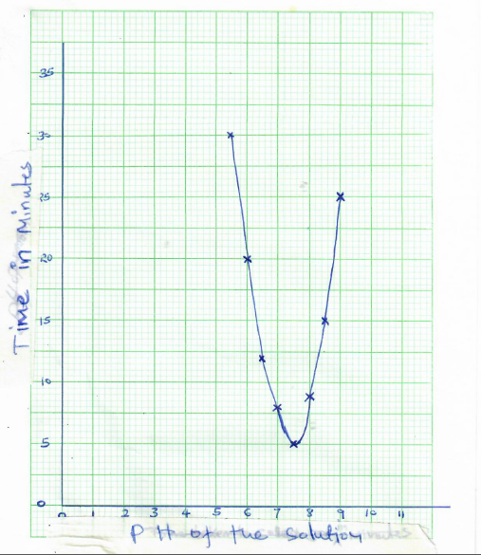

- Describe the functions of a mammalian skin. (20mks)
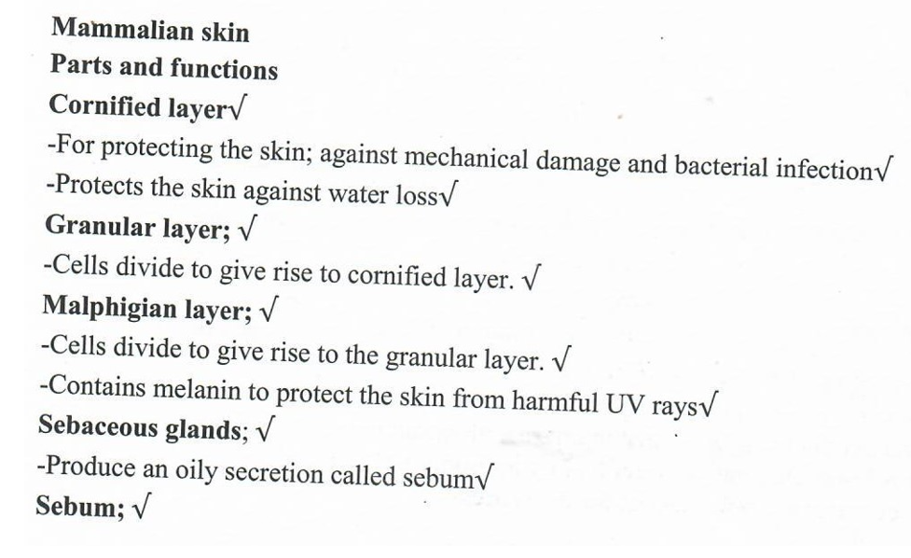
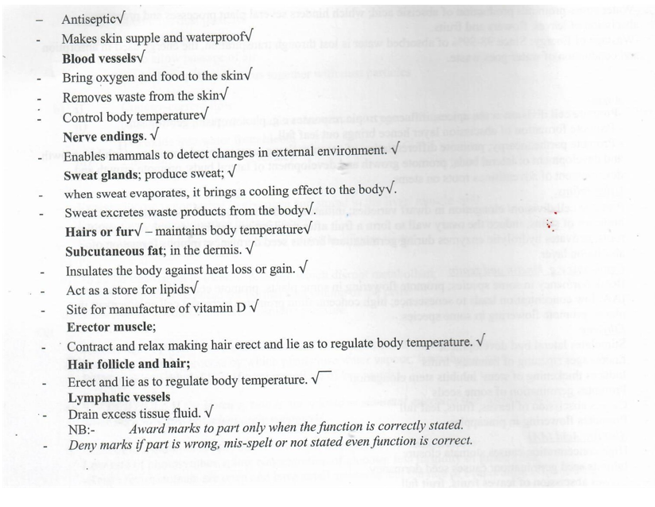

- Describe the process of double fertilization in a flowering plant. (20mks)
