**F4 BIOLOGY THEORY (MARKING SCHEME)**

**231/2**

**Paper 2**

1. Cross between F1 plants (4mks)

Parental phenotype (F1) Pink flowers Pink flowers

Parental genotype (F1) RW X RW

Gametes

Fusion

F2 offspring genotype RR RW RW WW

1. Red: Pink: White

1 : 2 : 1 (1mk)

RR: RW: WW

1 : 2 : 1 (1mk)

1. ABO blood group system. (1mk)
2. Incomplete dominance. (1mk)
3. a) i)Identify the type of solution in which F was placed. (1mk)

F – isotonic to cytoplasm of the cells;

ii) State the process which the red blood cells underwent in illustration G. (1mk)

Haemolysis;

b. Account for the appearance the red blood cells underwent in illustration E. (3mks)

E – The cells were placed in a hypertonic solution to their cytoplasm; they therefore lost water by osmosis; shrunk and became crenated;

1. Explain what would happen if plant cells are placed in the solution in which the cells in G were immersed. (3mks)

G – The cells would gain water; by osmosis; swell and become turgid;

1. **a) P** – Tissue fluid; **Q –** Venule. (2mks)

b.)

1. Oxygen; Glucose. (1mk)
2. Carbon (IV) oxide; Water. (1mk)
3. Blood entering through arteriole has a higher pressure than the blood leaving through venule; the pressure build up within the capillaries and force water and small molecules in blood out through capillary wall to form tissue fluid; (in a process called ultrafiltration); nutrients and oxygen in tissue fluid move into tissue cells by diffusion. (3mks)

d. ) Blood cells; (e.g. red, white blood cells and platelets); Plasma proteins; (e.g. fibrinogen).

1. a.
2. Arthropoda; Rej: Arthropod, arthropoda and wrong spelling e.g. Anthropoda. (1mk)
3. Has spiracles

Has jointed appendages

Has segmented body

Body is divided into head, thorax and abdomen. (3mks)

b.

i. Calculate the population size of the crabs in the lagoon. (3mks)

P = FM x SC;

MR

= 400 x 374;

80

= 1,870 crabs

1. Capture-recapture method. (1mk)

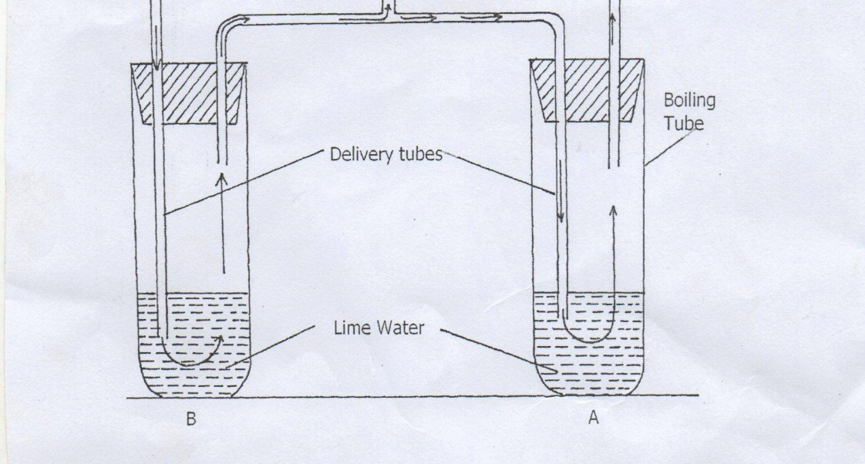

(b) [i] In which of the tube would lime water form white precipitate first. [1mk]

A

ii] Give a reason. [1mk]

Exhaled air has more carbon (IV) dioxide; than inhaled air

(c) What is the effect of lactic acid in the thigh muscle of an athlete after a short fast race? [2mks]

Poisonous if it accumulates; causes muscle cramps/fatigue;

(d) Identify the type of muscle in human being where the formation and effect of lactic acid is not felt [1mk]

Cardiac muscle;

(e) What is the biological significance of boiling milk. [1mk]

-Kill microorganisms (lactobacillus) bacteria ;

–High temperature denatures bacteria enzymes /stops anaerobic respiration;

**SECTION B: 40MKS: Answer question 6 (compulsory) and either question 7 or 8.**

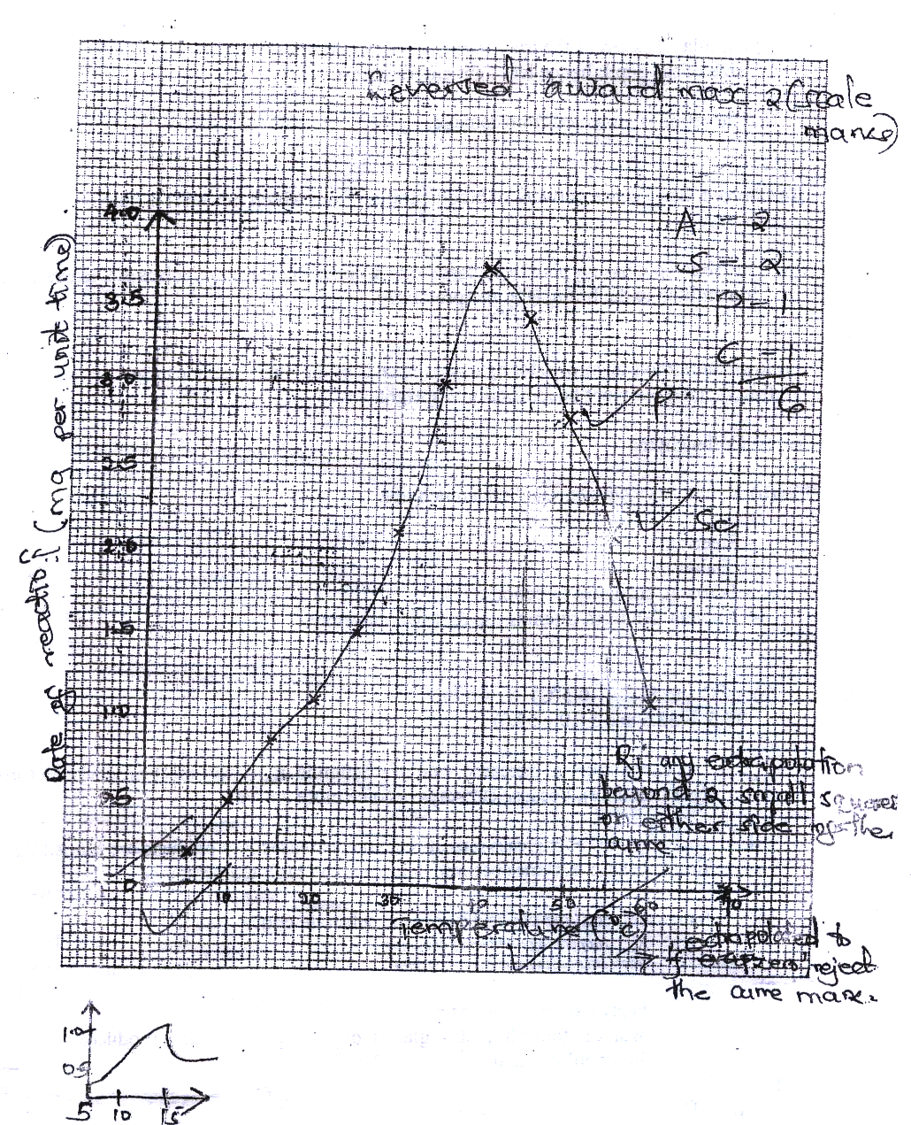

(b) When was the rate of reaction 2.6 mg of product per unit time? ( 2 mks)

330C and 51.5 ( ± 0.50C)

(32.5 - 33.5 and 51.0 – 52.0)

(c) Account for the shape of the graph between

(i) 50 C and 400 C ( 2 mks)

As temperature is increased rate of reaction is increased/ more products are formed (per unit time)

;because enzymes become more active;

(ii) 450 C and 600C ( 3 mks)

As temperatures increases rate of reaction decreases less products are formed (unit per time) ; because enzymes become denatured by high temperatures;

(d) Other than temperature name two ways in which the rate of reaction between 50C and 400C could be increased ( 2 mks)

Increase in enzyme concentration and substance concentration

Rj. Increasing number of enzymes

(e) (i) Name one digestive enzymes in the human body which works best in acidic condition ( 1 mk Pepsin, remain/ chymosin

(ii) How is the acidic condition for the enzyme named in (e) (i) above attained? ( 2 mks)

Wall of stomach/ gastric gland/ oxyntic/ parietal/ cell produce Hydrochloric

(f) The acidic conditions in (e) (ii) above is later neutralized

(i) Where does the neutralization take place? ( 1 mk)

Duodenum;

(ii) Name the substance responsible for neutralization ( 1 mk)

Bile juice/ acc any correct salt e.g. NaHCO3

Acc: Bile

1. **a) Structural adaptations of a mammalian heart to its function. (15mks)**

* It is enclosed by a tough fibrous pericardium membrane which give it mechanical support and prevent it from overstretching.
* It is surrounded by pericardial fluid secreted and enclosed by the pericardial that lubricates it as it pumps blood.
* The outer part of membrane is covered by layer of fat that acts as a shock absorber.
* Cardiac muscle of the heart is myogenic/generates its own rhythmic contraction without nervous stimulation and does not fatigue.
* The heart muscle is supplied by coronary artery with nutrients and oxygen.
* It’s also served by the coronary vein that removes the metabolic wastes.
* It composes of sinoartrial node (SAN) **(Rej: SAN without full name)** that initiates the heartbeat hence serves as the pacemaker.
* The heart muscle is interconnected by intercalated discs that enhance rhythmic contraction of the muscle through conduction of contraction wave.
* The inter-ventricular septum contain special purkinje muscles; which slows down the transmission of impulse; by the action of vagus nerve so that the ventricles contracts after atria.
* The heart is divided into two halves separated by a tough membrane called septum; so that oxygenated blood does not mix with deoxygenated blood.
* The heart is made up of four chambers; Atria are thin walled to pump blood over shorter distances; while the ventricles are thicker walled to pump blood over longer distances; the left ventricle is thickest walled to pump blood all over the body.
* Has valves that ensure unidirectional flow of blood; tricuspid valve prevent back flow of back flow of blood into right atrium; bicuspid valve prevent back flow of blood to left atrium; and semilunar valves prevent back flow of blood to the ventricles; during diastole.
* Has tendons that support the atrioventricular valves and prevent them from turning inside out due to pressure during ventricular contractions.

1. **The process of blood clotting. (5mks)**

* When the blood vessels are injured the blood platelets are exposed to air; and disintegrate/rapture and release thromboplastin;
* Thromboplastin in presence of vitamin K and calcium ions stimulate conversion of prothrombin into thrombin; (by neutralizing anticlotting factor heparin).
* Thrombin activates conversion of soluble fibrinogen to insoluble fibrin.
* Fibrin forms a meshwork of fibers that trap (red) blood cells that form a blood clot (plug) and prevent further bleeding.

1. a)After a meal of carbohydrate, the glucose level in the blood rose to 150mg/ cm3 .Explain the role of the liver in bringing the sugar level down back to normal. (8mks)

The pancreas detects; and is stimulated to secrete insulin hormone; which is released into the blood and is transported to the liver; where it stimulates the liver to;

* convert excess glucose to glycogen for storage;
* inhibit conversion of glycogen into glucose;
* increase oxidation of glucose to release energy;
* convert excess glucose into fat;

b)Explain six importance’s of plants excretory products. (12mks)

Tannins; - treatment of leather;

- decoration of pots;

Caffeine – mild stimulant/increases mental activity and reduces fatigue;

Quinine – treatment of malaria;

Cannabis – manufacture of narcotic drugs;/insecticides;/ cigarettes;

Rubber; - make shoes;/ chewing gum;

Colchicine; - breeding research and in cancer therapy;

Gum Arabica; - in food processing industries and printing industries;

Papain – meat tenderizer;

Khat; - mild stimulant; (any 6)