NAMBALE DIOCESE MARKING SCHEME
Confidential Nov/Dec. 2021
Biology paper 2 231/2
1) a) i) Non – disjunction;
ii) Down’s syndrome;
Klinefelter’s syndrome;
Turner’s syndrome; (mark 1st two)
iii) Sickle cell aneamia;
b) DNA RNA
Is a double strand Is a single strand;
Has base thymine Has base uracil;
Only present in nucleus Present in both nucleus and cytoplasm;
Has deoxyribosugar Has ribose sugar,
(mark 1st 3)
c) Sudden/abrupt/spontaneous, change in the genetic makeup of an organism (that are capable of being
inherited).

2. a) A- Root hair; B- Cortex; C- Endodermis; D- xylem;
b) Absorption of water containing mineral ions;
c) Consists of along tubes that are continuous from the roots to the leaves;
Has thick lignified wall to provide support/mechanical support to prevent it from collapsing;
Has narrow lumen to increase capillarity;
3. a) An electrical charges which is conducted/transmitted along a nerve fibre/ an electrical charge arising
from changed in ionic concentration across the surface membrane of an axon/dendrite/Dendron;
b) Diagram
c) Acetylcholine/Noradrenaline;
d) Produces/releases(Cellular) energy for the reconstitution of a cetylcholine/noradrenaline, which are
used for the transmission of impulses across a synapse;
e) Sodium(Na+), Potassium (K+), Chloride (Cl-); (any mark 1st two)
ii) At 60⁰C digestion takes long; since most enzymes have been denatured (by the high temperature);
b) Pepsinogen;- to prevent the digestion of the cells that produce it;
c) pH;/
Presence or absence of enzyme inhibitors;
Substrate concentration;
Presence of co-factors;
5. a) Curve X; It starts with a lower population than Y, the herbivore;
b) Number of predators decreased due to increased completion for food as a result of decrease in the
number of prey;
c) i) Prey – predator relationship/predation
ii) It maintains the number of prey and predators at the carrying capacity of the habitat/state of balance.
d) The number of herbivores will increase (due to reduced predation);
The amount of vegetation will decrease (due increased number of herbivore Primary productivity
will decrease/lead to soil erosion);
Because of increased competition there will be shortage of food for the herbivores.
The number of herbivores will decrease due to death or migration;
(Mark any two correct answers)
a) Graph.
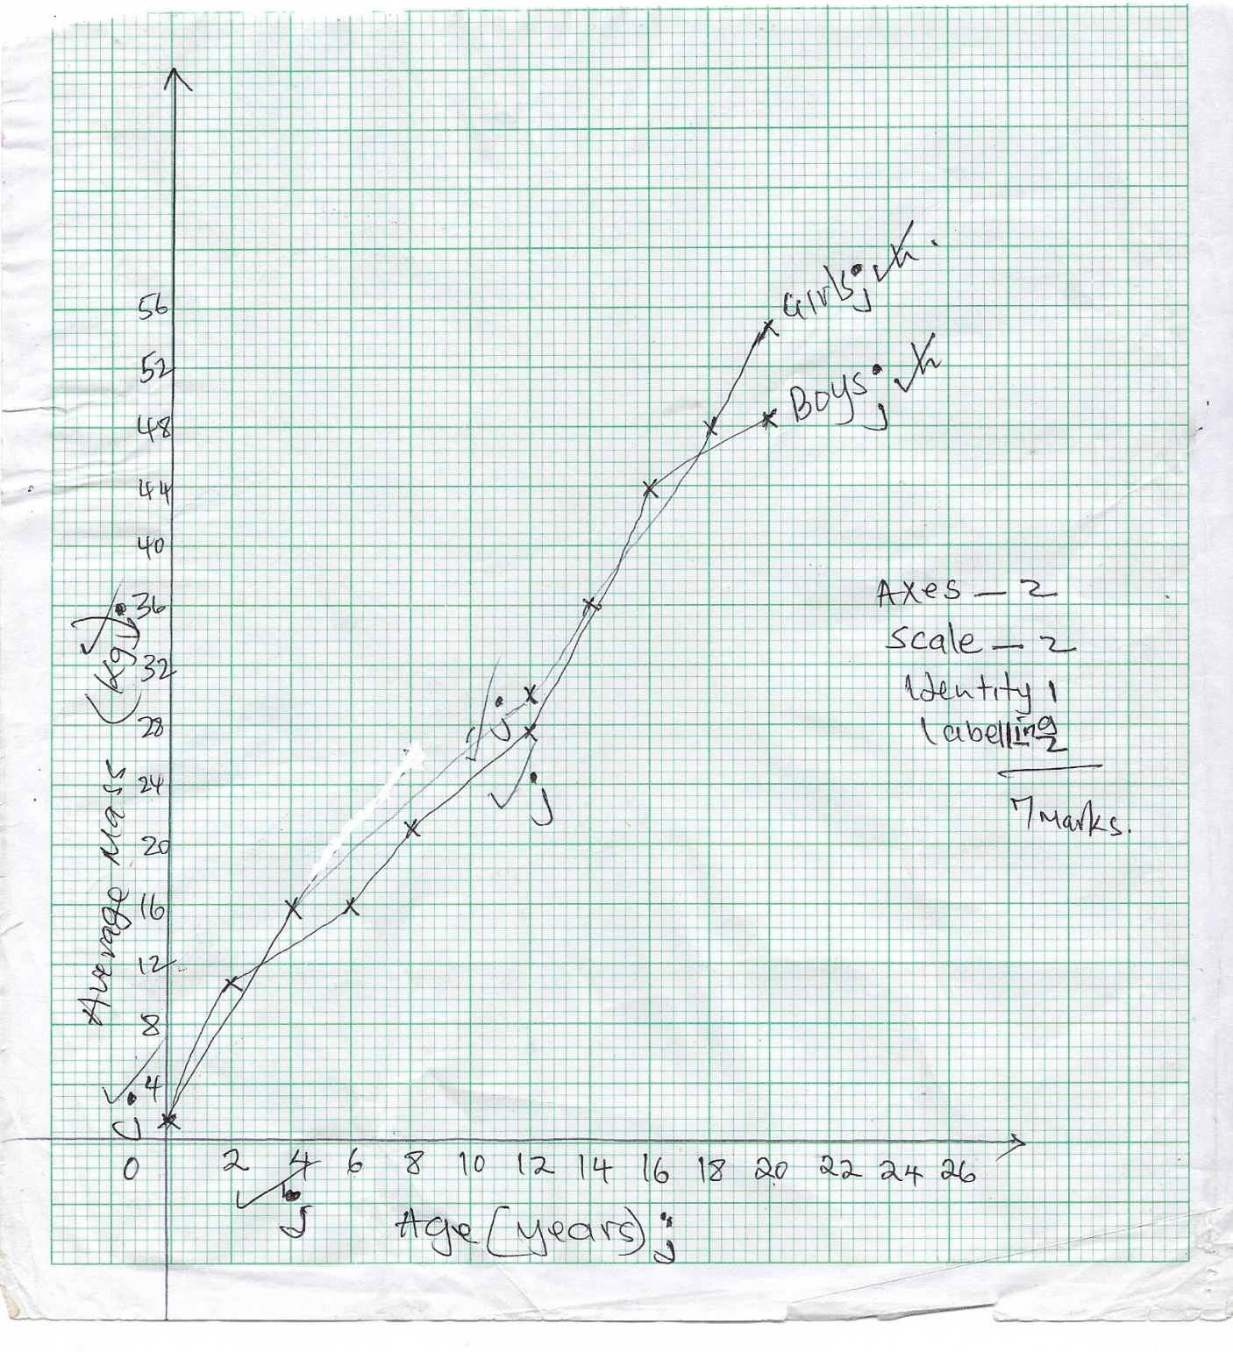
b)(i) (26+-.5)kg;
(ii) Girls 15 years – 39
Girls 13 years – 33
6 ÷ 2 = 3.0kg/year;

c) Girls grow faster at adolescence. There is an increase in the size of their hips and breasts.
d) Girls generally grow faster than boys. Boys grow slowly compared to girls but later, after
puberty, the grow more steadily.
e) Girls above 10 years begin to menstruate. They need more iron to replace the blood lost during
menstruation.
f) Genetic composition;
Sex of the child;
State of health;
Emotional status;
Climatic condition
g) Height of the body;
Volume of the body;
7. a) Control and maintenance of a constant internal environment of living organisms;
b) Regulation of blood glucose level.
Excess glucose is converted to glycogen by the liver cells under the influence of insulin hormone
secreted by the pancreas. While the hormone glucagon produced by the pancreas stimulates liver cells
to convert stored glycongen into glucose; when there is less glucose in blood than normal.
Deamination
The liver cells breakdown excess amino acids to form ammonia. Ammonia combines with Carbon (IV)
Oxide to form urea. Ammonia is formed from the amino group. The carbon skeleton is then converted
to glucose that is then used by cells in respiration.
Detoxification;
Ammonia from the process, of deamination is converted into less toxic urea in the liver. Bacterial
toxins,hydrogen peroxide, alcohol and drugs are converted into less toxic substances by the liver cells.
Regulation of plasma proteins;
The liver produces fibrinogen and prothrombin(which are involved in blood clotting) and most of the
proteins found in blood. Albumin and some globulins and also produced by the liver. Globulins act as
antibodies. Albumin contributes to the maintenance of the osmotic pressure of blood Non-essential
amino acids are also synthesized by the liver.
Storage of fat soluble vitamins A, B, E and K.
Storage of Iron;
Iron is released from the breakdown of worn out erythrocytes is stored in the liver. Iron is stored in form
of a compound called Ferritin.
Heat storage;
Various metabolic processes that take place in the liver releases energy. This energy is distributed by
blood to other parts of the body, hence contribute to maintenance of a constant body temperature.
In activation of hormones and drugs
Hormones and dugs after performing their function are chemically modified to inactive compounds in the
liver. These by-products are got rid of through the kidney and faeces via bile.
Storage of blood;
The large size and high capacity for contraction and expansion of the veins in the liver enable it to hold
and store a lot of blood. It regulates the volume of blood in the general circulation depending on the body
needs.
Regulation of fat metabolism
Fats stored in different parts of the body are mobilized and taken to the liver, when carbohydrates are in
short supply. The fats are oxidized to release energy or are modified by the liver cells before
they are sent to the tissues for oxidation to release energy.;
7. Adaptations of xerophytes to their habitats
Some have thick/fleshy/succulent stems/leaves to store water;
Some have leaves with thick waxy cuticle to reduce water loss by transpiration;
Some have needle like leaves/leaves are reduced to spines to reduce the surface area through which water
is lost during transpiration;
Some have deep; widespread roots that also water deep in the ground in order to reach water;
Some have leaves which are covered with hair or scales that trap a layer of still moist air close to the
surfaces of their leaves in order to reduce transpiration.
Some have superficial roots that provide a large surface area for maximum absorption of water after
light/short showers;
Some have rerrenting underground organs like bulbs/corm that store food/water,
Some have shallow extensive fibrous root system to absorb water near the surface;
Some have short life cycles to maximize the use of the short rainy season to grow and mature;
Some role their leaves in dry weather to reduce the surface area exposed to the external environment so as
to reduce transpiration;
Some produce seed which are resistant to desiccation and remain dormant yet are viable for long period of
time;
Some have reversed, stomata rhythm ie. Open at night and close during day time to minimize transpiration
During hot weather/daytime;
Stomata are mainly located on the lower of stomata that come into direct contact with sunlight in order to
minimize transpiration.
Some have shiny/glossy leaf surfaces to reflect away light in order to reduce the leaf temperature hence
reducing rate of transpiration.

