NAME:……………………………………… INDEX NO. ……………….…

SIGNATURE: …………………...... DATE: ...........................................

231/2
BIOLOGY
THEORY
PAPER 2
DECEMBER, 2021
Time: 2 Hours

LANJET JOINT EVALUATION EXAMINATION
Kenya Certificate of Secondary Education (K.C.S.E)
231/2
Biology
Paper 2
DECEMBER, 2021

MARKING SCHEME

- The diagram below shows experiment that was carried out by form one students.

Starch + diastase
Starch + diastase + HCL

TEST TUBE B
TEST TUBE A

Both test tubes were placed in a hot water bath maintained at 37⁰c for 30 minutes.
- What was the aim of the experiment (1 mk)
To investigate the effect of pH on enzyme diastase
- If the contents of the two test tubes were tested for starch.
State observation that was made and give reasons for the observation made. (1 mk)
Test tube A
Observation: color of iodine solution will retain.
Reason: Enzyme diastases digest starch into maltose
Test tube B
Observation: blue –black color
Reason: Enzyme diastase cannot digest starch in acidic medium.
- Name the enzyme that completes the digestion of starch in small intestines (1 mk)
Pancreatic lipase
- State two ways through which mechanical digestion is achieved (2 mks)
Peristalsis
Chewing/mastication
- In a family where the father is blood group A and the mother blood group B, one of their children had blood group O.
- State the genotypes of the parents (2 mks)
Father - AO
Mother – BO

- Work out genotypes of their children using genetic cross (3 mks)
FATHER
MOTHER
AO
BO
A
O
O
B
AB
AO
BO
OO
Parental genotype

- i). Which children can receive blood from all other member of the family (1 mk)
Child with blood group AB
ii). Give reason for your answer in (i) above (1 mk)
Blood group AB has no antibodies to react with antigens
- What is multiple allelism?
Condition whereby a gene controlling a certain trait exists with three alleles e.g ABO blood group.

- The figure below shows an experimental set up to demonstrate transportation in plants.
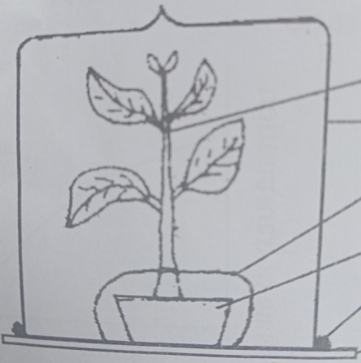
Plant

Polythen bag

Pot with watered soil

Vaseline

Glass plate

- Give reason for the following
- Smearing Vaseline between the glass plate and the bell jar (1 mk)
To prevent escape of respired moisture.

- Why polythne bag is wrapped around the pot and tied at the base of the plant (1 mk)
To prevent the water loss from the soil through evaporation.

- i). what will be observed in this experiment? (1 mk)
Water droplets are formed inside the bell jar.

ii). How do you test for the identity of the substance observed in b(i) above (2 mks)
Putting anhydrous cobalt (III) chloride paper on inside the bell jar. If the paper turns pink that means the substance is water.

- Describe the set up of the control for this experiment (2 mks)
The same setup but with a plant whose leaves have been removed.

- State two factors which affect the results of this experiment (2 mks)
Temperature
Light intensity

- The diagram below shows plant gametes.
A
B
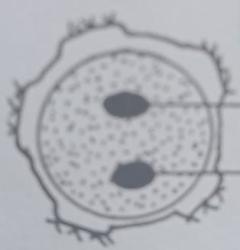
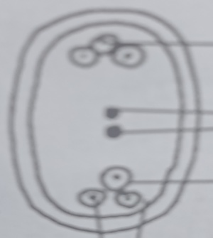
P
Y
X
Z

Egg

- Identify structures A and B (2 mk)
- Mature pollen grains
- Mature embryo sac
- Name the parts labeled Y and P (2 mks)
Y – Generative nucleus
P – Antipodal cells
- What is the fate of the structure labeled X (1 mk)
It disintegrates in the ovule giving way for entry of the male nuclei.
- Which structure on diagram B fuses with one of male nucleus to form triploid nucleus (1 mk)
Structure Z (polar nuclei)
- What is double fertilization (2 mks)
This is whereby one of the male nuclei fuses with egg cell nucleus to form a diploid zygote which develops into an embryo while other male nucleus fuse with polar nuclei to form a tripoid nucleus.
5. The diagram below shows behavior of animal cell when present in solution of different concentration.
Process Y
Y
X
Solution P
Process Z
Soluti on X

- Name solution X and P
Solution X- hypotonic
Solution P- hypertonic
- Name process Y and Z (2 mks)
Process Y – haemolysis
Process Z – creanation
- Explain what will happen to a plant cell when subjected to solution X (2 mks)
Plant cell will take in water by osmosis and become turgid, it does not bust because the wall resist any further expansion of the cell. (wall pressure).
- Give importance of osmosis to a plant cell. (2 mks)
Absorption of water from the soil
Support by increasing cell turgor
Opening and closing of the stomata
Feeding of insectiviors plants
Movement of water from one cell to another

SECTION B
In this section attempt question 6 (compulsory) and either questions 7 or 8
- An experiment was done to investigate population growth of lour beetles (tribolium confusum).16g and 64g of maize flour was placed in two equal boxes K and L respectively. Equal number of beetles was added in the boxes. Both boxes were kept under the same environmental condition. Beetles were counted at certain intervals and results tabulated as shown below.
Number of days after introduction of bettles | Approximate number of individuals present in K and L
 | K | L
0 | 20 | 20
5 | 20 | 20
40 | 200 | 300
60 | 550 | 800
80 | 560 | 1300
100 | 650 | 1750
120 | 640 | 1600
135 | 650 | 1900
150 | 645 | 1500

- Using the results in the table above draw two graphs on the same axes. Plot approximate number of individual present on y-axis (7 mks)

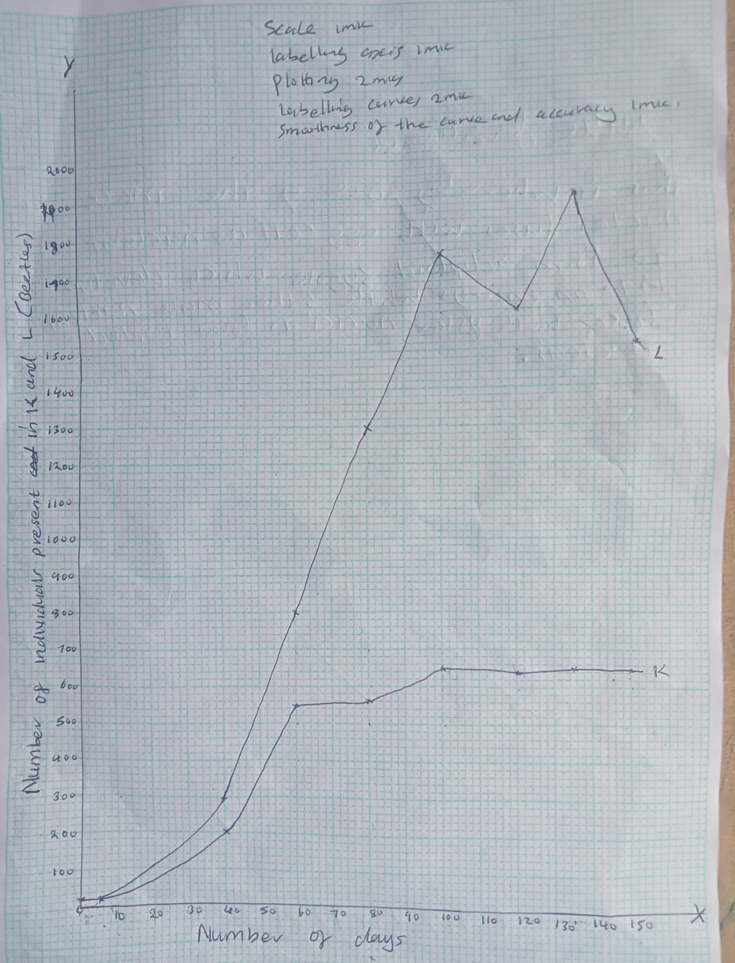

- What were the approximate number of individuals present in the two boxes on the 90th day? (2 mks)
- Number in K -580 individuals
- Number in L – 1520 individuals
- On what day was population difference:- (2 mks)
- Greatest – day 135
- Lowest – day 40
- Account for the shape of the two graphs between 1st and 100th day (2 mks)
There is increase in the number of individuals in both graphs due to enough food.
- Explain the shapes of the graph K between 80th and 150th day (2 mks)
At 80th population increased upto a 100th day and it then started decreasing due to limited food supply.
- Differentiate between intraspecific and interspecific competition (2 mks)
Intraspecific competition is competition between individuals of the same species while interspecific competition is competition between individuals of different species.
- Name three methods of population estimation
Quadrat method
line transect
Belt transect
Head count
Capture - recapture method

- Explain how the skin is adapted to its functions (20 mks)
- The skin is made up of epidermis and dermis.
The epidermis is made up of three layers.
- The outermost layer, called cornified layer is made up of dead cells, which form a tough layer that protects the skin against mechanical damage, bacterial infection and water loss through evaporation.
- The middle granular layer is made up of living cells, which give rise to the cornified layer.
- The innermost malphigian layer consists of actively dividing cells that form new epidermal cells, which replace those that are gradually sloughed off from the top layers.
- The malphigian layer contains melanin granules, which function as a screen against ultraviolet rays from the sun and synthesis vitamin D.
The dermis contains the following components.
- Sebaceous glands which produce an oily secretion called sebum that gives hair its water repelling property keeps the epidermis supple and prevents it from drying. Sebum also has antiseptic properties against some bacteria.
- Blood vessels that supply food and oxygen and remove metabolic wastes from skin tissues.
- The blood vessels of the skin vasodilate when temperature is high increasing blood flow near the skin surface thus enhancing heat loss by radiation and convention.
- The blood vessels vasoconstrict when temperature is low to conserve body heat.
- Hairs stand erect when temperature is low to trap a layer of air, which prevents heat loss.
- When temperature is high the hairs lie close to the skin surface, enhancing heat loss.
- The hair follicles are innervated by sensory neurons which respond to movements of the hair thus increasing the sensitivity of the skin.
- Sensory nerve ending and sensory receptors make the skin to be sensitive to stimuli like heat, cold, pain, pressure and touch.
- Sensory glands which produce sweat that evaporates carrying latent heat of vaporization thus reducing body temperature.
- Under cold conditions little or no sweat is produced thus conserving heat.
- Sweat contains water, salts and urea hence the skin acts as an excretory organ as well.
- The subcutaneous fat layer acts as an insulating layer against heat loss and as a fuel storage.
- a) What is organic evolution (1 mk)
Gradual change of living organisms from simple life forms to complex forms over a long period of time. √
- Giving examples, describe differences between homologous and analogous structures (4 mks)
Homologous structures are structures that have same embryonic origin but have been modified (in the course of evolution) to perfume different functions; while analogous structures are structures of different embryonic origin that become modified (in the course of evolution) to perform similar functions. √

- Describe how natural selection brings about the adaptation of a species to its environment (15 mks)
Organism in the same environment are always competing for resources ;(such as food, mates, shelter e.t.c) as well as enduring the harshness of environment;√ this is called struggle for existence;√
Those organisms that are best adapted survive to reproductive age; √ and give rise to off springs of same kind; √ the less adapted die young and do not pass their characteristics ; √ this is called survival of the fittest; √ if the favorable x-tics possessed by the “fittest” organism are genetic, they are passed onto the offspring; √this leads to a natural occurrence of variation within a species; √ which are transmitted to successive generations; √ consequently there is a gradual change in the x-tics of the species making it adapted to its environment; √ accumulation of small variation over a long period of time lead to emergence of new forms of life/speciation; √ which if suited and well adapted survive and reproduce ; √ and if not suited are eliminated by nature; √ there nature selects those organisms with better adaptations; √ while ensuring the elimination of those not able to adapt to the changing environment; √

