NAME …………………………………..……………ADM ………………CLASS……………
KENYA CERTIFICATE OF SECONDARY EDUCATION
FORM 4 BIOLOGY
PAPER 1 MOCK 2021
ANSWER ALL QUESTIONS
2 HOURS
1. Differentiate nutrition in plants from that in animals. (2 marks)

2. State and explain three modes of feeding in animals. (3 marks)

3. Name two properties of disaccharides. (2 marks)

4. Explain three adaptations of arteries to their function. (3 marks)

5. Explain what happens during photolysis? (3 marks)

6. An experiment was set up as shown.
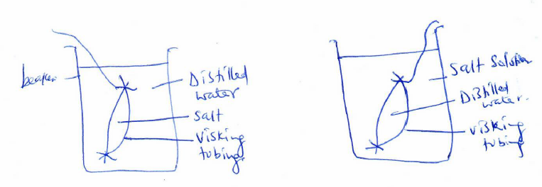
a) State and explain what happened to visking tubings in both M and N. (4 marks)
b) What does visiting tubing correspond to in a living organism? (1 mark)

7. State three digestive enzymes present in pancreatic juice. (3 marks)

8. Colour blindness is a condition carried by a recessive gene on X-chromosome. A colour blind man married a homozygous normal woman. One of their daughters married a normal man. Using letter c for colour blindness,
a) Work out the outcome of the daughter's marriage. (4 marks)

b) Why is colour blindness more common in men than women? (2 marks)

9. The figure below shows the iris of a mammalian eye.
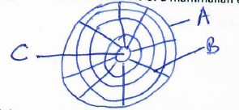
a) Label the parts A, B and C. (3 marks)
A-
B-
C-

b) State three adaptations of the iris to its function. (3 marks)
10. The diagram below shows a stem twining round a support.
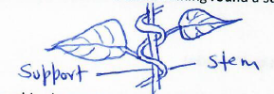

a) Explain how this phenomenon occurs (3 marks)

b) Explain three biological significance of this phenomenon. (3 marks)

11. The base sequence on a DNA strand was as follows;
A --- T --- A --- A ---- C ---- G --- G ---- T ---- A
i) Write the sequence on the other strand. (1 mark)

ii) Write the base sequence on RNA strand replicated from the DNA. (1 mark)

12. Explain four adaptations of hydrophytes to their habitat. (4 marks)

13. a) List three differences between the nervous system and the endocrine system. (3 marks)

b) Name two transmitter substances found in the synapse. (2 marks)
14. Explain four roles of water in seed germination. (4 marks)

15. a) Name two plant cells where you would expect to have numerous mitochondria. (2 marks)

b) State one role of nucleolus. (1 mark)

16. Explain three adaptations of the sperm cell to its function. (3 marks)

17. The diagram below shows arrangements of bones on human forelimb.

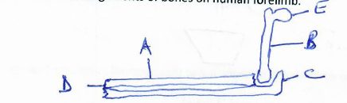
i) Name bones A and B. (2 marks)
A-
B-

ii) State two roles of the structure labelled C (2 marks)

iii) Name the part that articulates with bone labelled B at part E. (1 mark)

iv) Name the type of joint forms at the part labelled D. (1 mark)
18. a) State two special properties of the cardiac muscles found in mammalian heart. (2 marks)

b) Name three organ systems in human body where smooth muscles are found. (3 marks)

19. State three unique characteristics of members of the class Crustacea. (3 marks)

20. Industrial wastes may contain metabolic pollutants. State how such pollutants may indirectly reach and accumulate in the human body if the wastes were dumped into rivers. (3marks)

21. State three biotic factors that affect distribution of living organisms in an ecosystem. (3marks)

