BIOLOGY PAPER 1 MOCK 2021
MARKING SCHEME

1. Plants make own food,(autotrophic); while animals take ready-made food,(heterotrophic);

2. Carnivorous-feed on flesh;
Herbivorous- feed on vegetation/plants;
Omnivorous-feed on both flesh and vegetation;

3. -soluble in water;
-sweet tasting;
-crystalline;

4. -Have narrow lumen to maintain high blood pressure;
-Have a thick elastic wall to help blood flow;
-Have no valves so blood flow is not inhibited;

5. Water molecule; is split by light energy; into hydrogen ions and oxygen gas;

6. a) M- decreased in size;
-distilled water is hypotonic; so water molecules mover into salt solution by osmosis;
N- Decreased in size;
-Salt solution is hypertonic; so water molecules moved out of tubing by osmosis;

b) cell membrane;

7. Pancreatic amylase;
Pancreatic lipase;
Trypsin;

8.a)
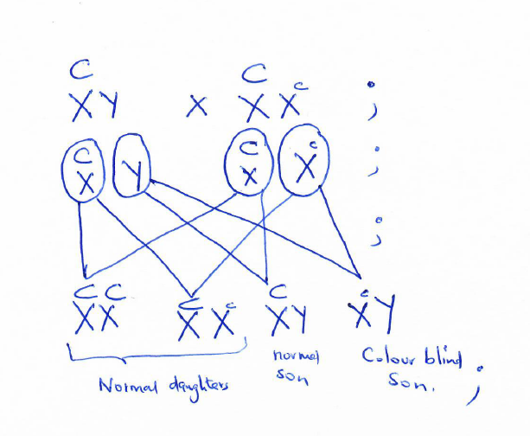

b) All men with the gene are colour blind; women with one gene are normal but carriers;

9.a). A- Circular muscle;
B- Radial muscle;
C -pupil;

b) -pigmented to absorb light controlling amount entering;
-has radial and circular muscles to control size of pupil controlling amount of light entering eye;
- it gives the eye colour;

10.a)Auxin; moves away from point of touch; causing faster growth on other side; resulting in coiling growth;

b) -expose leaves to light for photosynthesis;
-expose flowers to agents of pollination;
-expose fruits and seeds to agents of dispersal;

11.i)T --- A ---- T----T ---- G ---- C ---- C ---- A ---- T;
ii ) U ----A --- U ---- U ---- G ---- C ---- C --- A ---- U;

12. -Roots with no root hairs to reduce absorption;
-Numerous stomata on upper surface of leaves to increase transpiration;
-Large air spaces to increase buoyancy;
-Large leaves to increase surface area exposed for transpiration increase;

13. a)
Nervous | Endocrine
Nerve impulse evoke response | Chemical evoke a response;
Transmitted through neurones; | Transmitted through blood;
Response is rapid | Response is slow;
Effect short lived | Effect is long lasting;

b) Noradrenaline;
Acetylcholine;

14. - Activate germination enzymes;
- Hydrolyses stored food;
-Transport food to embryo;
- Dilute germination inhibitors;
- Soften the seed coat;

15.a) - Root hair cells;
-Companion cell;
-cells in meristematic tissue;
b) Formation of ribosomes;

16. -Has acrosome containing lytic enzymes that digest egg membrane;
-Has a long tail for swimming to the ovum;
-Has numerous mitochondria to provide energy for swimming to the ovum;
- It's streamlined in shape for minimum resistance to movement;

17. i) A- radius;
B- Humerus;

ii) Attachment of triceps muscle;
Prevent overstretching of the arm;

iii) Glenoid cavity;
iv) Glinding joint;

18. a)- They are myogenic;
-Contract and relax continuously without fatigue;

b) - Digestive system;
-Reproductive system;
-Circulatory system;

19.- Have a carapace;
-Have two pairs of antennae;
-Have five pairs of legs;

20. Pollutants are absorbed by aquatic plants; which are eaten by primary consumers e.g. fish; man accumulates the pollutants by eating fish regularly;
21. Competition;
Predation;
Parasitism;
Saprophytism;
Symbiosis;

