NAMBALE ACK DIOSECE TERM 2 2021
JOINT EVALUATION EXAMINATION
MARKING SCHEME
1. Below is an image of a biological vector. Use it to answer questions that follow.
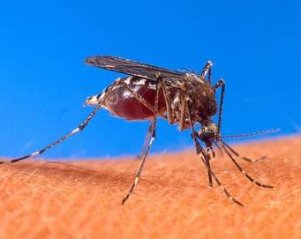
(a) Identify the parasite transmitted into human blood by the organism. (1 mark)
Plasmodium species//Plasmodium vivax//Plasmodium malariae//Plasmodium ovale//Plasmodium falciparum
(b) Name the blood cells that are destroyed by the parasite in (a) above. (1 mark)
Red blood cells//Erythrocytes.
(c) State one biological method used to eradicate the larvae of this organisms. (1 mark)
Fish feeding on the larvae;
2.

3 . a) Monocotyledonae; (1mark)
b) Vascular bundles are randomly scattered within the cortex; (1mark)

4. A- Stomata;
B –Lenticels;
C- Cuticle; 3marks

5. The diagram below shows an experiment set up using a seedling enclosed in a desk box with a hole on one side at the beginning of the experiment and after five days of growth.

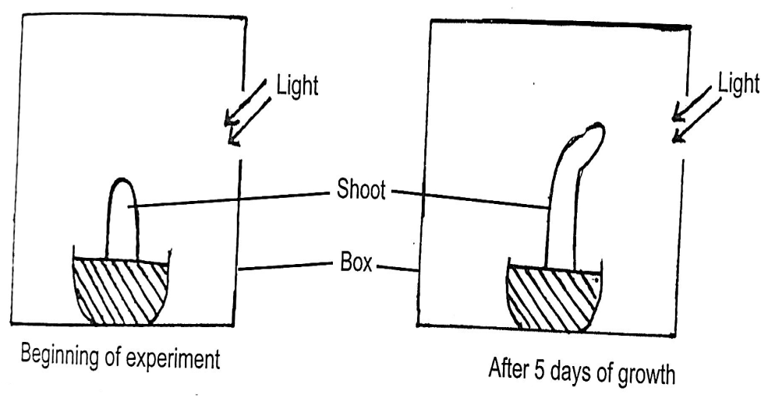

(a) What type of response is shown by the above shoot? (1 mark)
Positive phototropism; Rej. Phototropism alone

(b) State two observable changes which took place in the seedling after five days of growth. (2 marks)
i) Shoot tip/ apex curved towards the source of light; Rej shoot tip
bent;
ii) Shoot increased in height;
(c) Account for the observable changes in (b) above. (2 marks)
Auxins are sensitive to light; auxins migrated to the non-illuminated
side; higher concentration of auxins at the non-illuminate side
promotes cell division hence cell elongation ; thus rapid growth ;
shoot increased in height due to primary growth / rapid mitotic cell
division of meristemic cells present in the shoot apex; OWTTE

6. a (i) To enhance capillarity of water up the stem 1mark
(ii) To allow continuous flow of materials 1mark

7. (i) Neisseria gonorrhea; 1mark
(ii) Entamoeba histolytica ; 1mark

8. a) A group of living organisms that can freely or naturally interbreed to give rise to fertile and viable offspring 1mark

b) The resultant offspring, the mule is infertile 1mark

9. a) - Optimum temperature
- Oxygen 2marks

b) - To activate enzyme involved in germination or breaking dormancy
- it is a reactant in hydrolysis of food
- act as a solvent/transport medium
- softens the hard testa /seed coat max 2marks

10. Excess amino acids are deaminated/ the amino group is removed from an amino acid. The amino acid ${(NH}_{2}$) is converted into ammonia. The ammonia combines with Carbon (IV) Oxide (in the ornithine cycle which is a series of reactions) resulting in the formation of urea. The carboxyl group is converted to glucose for respiration/glycogen for storage 4mks

11. (a) Ornithology;
(b) Biochemistry;
12. (a) (i) Lungs; (ii) Diaphragm;
(b) Explain The rubber balloon would be inflated as air is sucked in;
13. (a) RQ = $\frac{Volume of CO2 produced}{Volume of O2 consumed}$; = $\frac{102}{145}$ = 0.7;
(b) Lipid; Has an RQ of 0.7;
14. (a) DNA; It has the base Thymine;
DNA | RNA
Double stranded | Single stranded;
Has Thymine base | Has base Uracil;
Has deoxyribose sugar | Has ribose sugar;
(b)

15. (a) Peristalsis;
(b)Rhythmic contraction and relaxation of circular and longitudinal muscles on the walls of the alimentary canal push the food downwards;
16. (a) Insulin; (b) Diabetes mellitus;
17. Self sterility; Protandry and protogyny; Hermaphrodite;
18. (a) (i) Dicotyledonous stem;
(ii) Presence of pith; lack of root hairs;
(b) Translocation;
19. (a) Structures that in the course of time ceased to function and thus became reduced in size;
(b) Appendix; Coccyx/ tail; body hair;
20. 1 mm= 1000ᶣm 4 mm= 4000ᶣm Average size = $\frac{4000}{8}$; = 500ᶣm;
21. State the use of the following plant waste products to humans. (2 marks)
(i) Papain - meat tenderizer; (ii) Colchicine - to induce polyploidy in plants;
22. (a) Oxygen; (b) Hydrogen peroxide water + Oxygen; rej chemical equations
23. (a) light penetration in water; (2marks)
(b) Light intensity
24. (a) the ovum has a short lifespan of about 24 hours; to enable proper implantation; (1mark)
(b) one male gamete nucleus fuses with the functional egg cell; to form a diploid zygote; the other male nucleus fuses with both polar nuclei to form a triploid nucleus(primary endosperm nucleus); (2mks)
25.(a) M- Acetabulum; articulates with the head of femur forming ball and socket joint.
N- Obturator foramen; has connective tissues to reduce the weight of the pelvic girdle check spellings. (2marks)
(b) X is made of cartilage Can expand to allow widening of the female pelvic girdle; (1mark)
26. Use the illustration below to answer questions that follow.
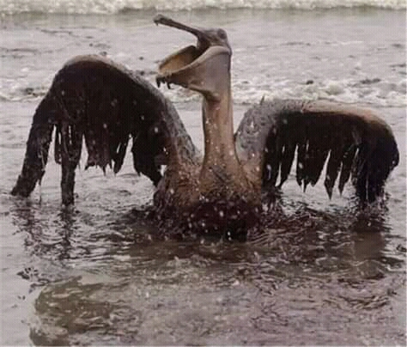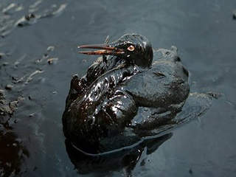
(a) Identify the type of pollution that has such an effect. (1 mark)
Water pollution;
(b) State two effects of the type of pollution identified in (a) above to the organism. (2 marks)
Oil soaks the feathers hindering locomotion;
Birds remove oil using their beaks swallowing some of the oil causing poisoning;
27. a) A factor that influence photosynthesis but is not at its optimum // in short supply
b) i) Light intensity
ii) Temperature
Acc carbon (iv) oxide concentration

- Study the food web below and answer te questions that follow.
- Write down a food chain whose all consumers are arthropods. (1mark)
Detritus/algae Caddis fly larva Water scorpion

- What would be the short term effects on the habitat if all trout fish were eliminated?
- Tadpole larva will slightly increase.
- Detritus plant will decrease (2marks)

- The diagram below represents a stage in the development of human foetus

. a) A – Has umbilical vein and artery to supply foetus with nutrients and removal of waste
products; √
B – Protects embryo from shock/regulate temp. of developing embryo/ suspends and supports
embryo;
b) Foetus head is turned towards the cervix; √

30. Salt exerts osmotic pressure on the cells of grass; Water is drawn from the cells by osmosis; the cells loose turgidity/become flaccid; further water loss dehydrates cells ;( hence kills the plant) max 2 marks.

31. (a) An enzyme (in red blood cells) that speeds up the reaction between water and carbon (IV) oxide; to form carbonic acid;
(b) – It combines with carbon (IV) oxide to form carbaminohaemoglobin which is transported to the lungs;
- It combines with hydrogen ions from dissociation of carbonic acid (hence acting as a buffer);

