NAME: ____________________________________ ADM NO: ___________
DATE: CANDIDATE’S SIGN:
CLASS

231/3
BIOLOGY
PAPER 3
PRACTICAL
JUNE/JULY, 2021
TIME: 1 ¾ HOURS

MOKASA 1 JOINT EVALUATION EXAMINATIONS
Kenya Certificate of Secondary Education
231/3
BIOLOGY
PAPER 3
PRACTICAL
JUNE/JULY, 2021
TIME: 1 ¾ HOURS

INSTRUCTIONS TO CANDIDATES

- Write your Name,Class and Adm No. in the spaces provided above
- Answer ALL the questions in the spaces provided
FOR EXAMINERS USE ONLY
QUESTION | MAXIMUM SCORE | CANDIDATES SCORE
1
2
3
TOTAL | 40

- You are provided with specimen X (Soaked maize grain), Specimen K, Benedict’s solution, Iodine solution, Pestle and mortar, scalpel and distilled water.
- Name the type of fruit represented in X above (1mk)
………………………………………………………………………………………………
ii) Give one reason for the above identity (1mk)
……………………………………………………………………………………………………………………………………………………………………………………………………
- Crush the specimen X using pestle and mortar and dissolve in 4cm³ of distilled water. Divide the mixture into two equal portions and use them to carry out the following food test. Record your observations in the table below: (6marks)

Food Test | Procedure | Observation | Conclusion
Starch
Reducing sugars

iv) Account for the observations made in the above table in relation to starch and reducing sugar. (3mks)
……………………………………………………………………………………………………………………………………………………………………………………………………………………………………………………………………………………………………………………………………………………………………………………………………………………………………………………………………………………………………………………………………………………
v) Identify the type of placentation in the specimen K above (1mk)
……………………………………………………………………………………………………………………………………………………………………………………………………………………
(b) Describe how the above placentation was formed (2mks)
……………………………………………………………………………………………………………………………………………………………………………………………………………………………………………………………………………………………………………………………………………………………………………………………………………………………………………………………………………………………………………………………………………………
(c) Using a scalpel, make a transverse section of specimen K. Draw the section of and label its parts (3mks)

2. Using the pictures of animals provided below, complete the construction of the dichotomous key by filling the blank spaces. (13 marks)

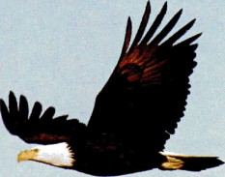 Eagle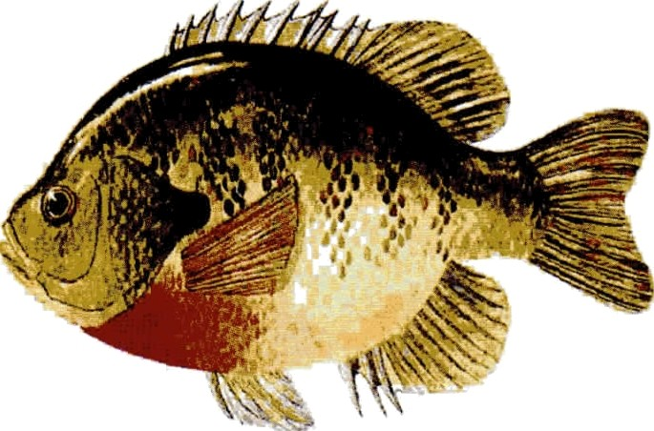 Fish 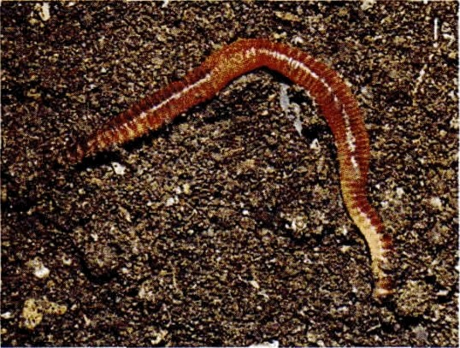
Earthworm

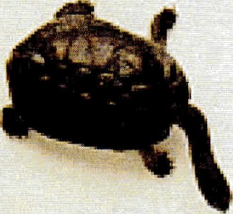
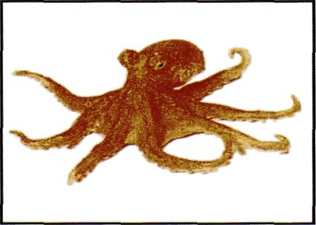
Tortoise

Octopus

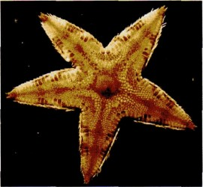
Starfish

Spider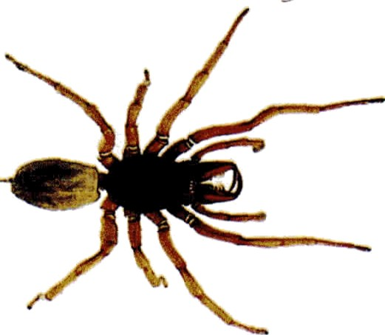 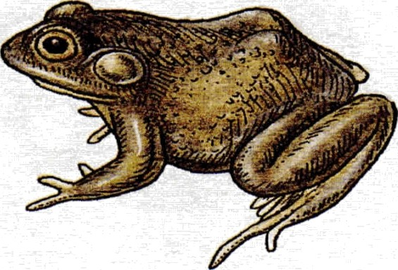
Frog

1a Animals with backbone……………………………………………………….Go to 2
b Animals without backbone …………………………………………………
2 a Animals with wings………………………………………………………….
b Animals without wings………………………………………………………
3a Animals which live in water all the time…………………………………....
b Animals which live in water for some time………………………………….
4a Animals with scales………………………………………………………….
b Animals without scales………………………………………………………
5a Animals with legs……………………………………………………………
b Animals without legs………………………………………………………… Go to 7
6a Animals with six legs……………………………………………………….. Butterfly
b Animals with eight legs……………………………………………………..
7a Animals with a shell………………………………………………………..Snail
b Animals without a shell……………………………………………………..
8a Animals with jelly-like body…………………………………………………
b Animals without a jelly-like body…………………………………………….
9a Animals with a segmented body……………………………………………….
b Animals without segmented body…………………………………………….. Octopus

3.You are provided with starch solution, Iodine solution, Visking tubing, stirring road, 2 pieces of thread, measuring cylinder and a beaker. Tie one end of the visking tubing and pour about 2mls of iodine solution into it. Tie the other end making sure no iodine solution leaks and place the visking tubing into starch solution in the beaker. Leave the set up for about 30 minutes and note the observations
- Account for the observations made after 30 minutes (3mks) ………………………………………………………………………………………………………………………………………………………………………………………………………………………………………………………………………………………………………………………………………………………………………………………………………………
- Give the role of the physiological process investigated above in:
- Reproduction (1mk) ………………………………………………………………………………………………………………………………………………………………
- Respiration (1mk) ………………………………………………………………………………………………………………………………………………………………
iv) Name two parts in the alimentary canal where starch is digested (2mks) ……………………………………………………………………………………………………………………………………………………………………
v) Identify one hormone and one digestive enzyme that stimulates digestion of starch in the parts identified in (iv) above (2mks)
…………………………………………………………………………………………………………………………………………………………………… (vi) What deficiency disease results when an individual lacks starch in their diet? (1mk)
…………………………………………………………………………………

