PRE-MOCK 1 2021
BIOLOGY PAPER 1
TIME: 2 HOURS
Name: …………………………………………………. Class: ………… Index. No. ……………
School: ………………..………………………………… Date……..………Sign:…………..

231/1
BIOLOGY
PAPER 1 (THEORY)
TIME: 2HOURS.
JULY/AUGUST2021

INSTRUCTIONS TO CANDIDATES
- Write your name, school and index number in the space provided above.
- Sign and write the date of the examination in the space provided.
- Answer all the questions in the spaces provided.

FOR EXAMINERS USE ONLY

QUESTION | MAXIMUM  SCORE | CANDIDATES  SCORE
1-30 | 80

- a. Name the external feature which is common in birds, fish and reptiles (1mk)
…………………………………………………………………………………………………
b. State two characteristics of fungi (2mks)
…………………………………………………………………………………………………………………………………………………………………………………………………….

- State the functions of the following parts of a light microscope (2mks)
- Objective lens ………………………………………………………………………………………………………………………………………………………………………………………………
- Diaphragm ………………………………………………………………………………………………………………………………………………………………………………………………
- a. Define the term seed dormancy
…………………………………………………………………………………………………………………………………………………………………………………..

b.The diagram below represents a stage during germination of a seed

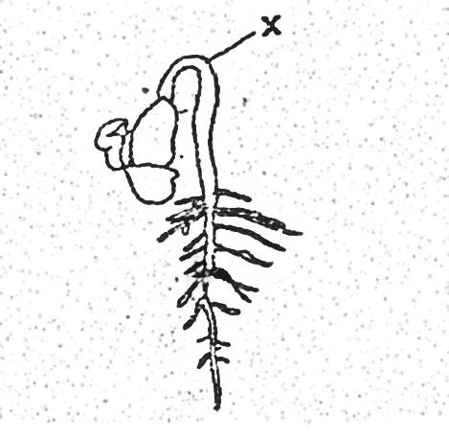

- a. State two causes of chromosomal mutations (2mks)
……………………………………………………………………………………………………………………………………………………………………………………………………
b.Distinguish between continuous variation and discontinuous variations (2mks)
……………………………………………………………………………………………………………………………………………………………………………………………………

- The diagram below shows a section through a plant organ
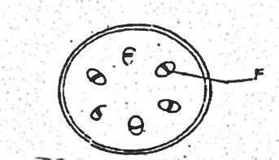

- i. Name the class of the plant which the section was obtained (1mk)
…………………………………………………………………………………………………………………………………………………………………………………..
ii. Give a reason for your answer in (a) (i) above (1mk)
…………………………………………………………………………………………………………………………………………………………………………
- State the functions of the part labeled F (1mk)

- State the function of the following cell organelles \
- Ribosome (1mk)
……………………………………………………………………………………………..

- Lysosomes (1mk)
…………………………………………………………………………………………….
- a. Pregnancies continues if the ovary of an expectant mother is removed after 4 months explain (2mks)
……………………………………………………………………………………………………………………………………………………………………………………………………
b.What is the role of the testes in the mammalian reproductive systems (2mks)
……………………………………………………………………………………………………………………………………………………………………………………………………

- In an experiment the shoot tip of a young tomato plant was decapitated as shown in the diagram below
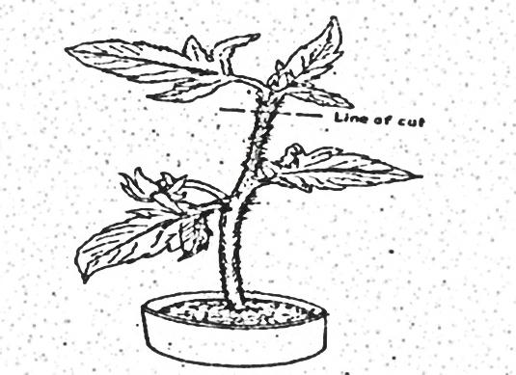

- State the expected results after 2 weeks (1mk)
……………………………………………………………………………………………………….
- Give a reason for your answer in (a) above (2mks)
……………………………………………………………………………………………………….

- a. Distinguish between diffusion and active transport (2mks)
…………………………………………………………………………………………………………………………………………………………………………………………………….

b.State one role that is played by osmosis in (2mks)
i.Plants …………………………………………………………………………………………….

ii. Animals .…………………………………………………………………………………

- a. Name the gaseous exchange surface in insects (1mk)
………………………………………………………………………………………………

b.How is the surface named in (a) above suited to its function (2mks)
……………………………………………………………………………………………………………………………………………………………………………………………………

- Explain why plants do not require specialized excretory organs (2mks)
………………………………………………………………………………………………………………………………………………………………………………………………………………………………………………………………………………………………………………………………………………………………………………………………………….

- Explain how the following factors affect the rate of photosynthesis
- Concentration of carbon (iv) oxide (1mk)
………………………………………………………………………………………………
- Light intensity (1mk)
………………………………………………………………………………………………

- Explain what happens in human when concentration of glucose in the blood decreases below the normal level (4mks)
………………………………………………………………………………………………………………………………………………………………………………………………………………………………………………………………………………………………………………………………………………………………………………………………………….
- Explain how the carnassial teeth of a dog are adapted to their function (2mks)
……………………………………………………………………………………………………………………………………………………………………………………………………..

- a. State three structural differences between arteries and veins in mammals (2mks)
……………………………………………………………………………………………………………………………………………………………………………………………………
b.Name a disease that causes thickening and hardening of arteries (1mk)
………………………………………………………………………………………………..

- from the equation given below, calculate the respiratory quotient (RQ)
2C₅₁H₉₈O₆+145O₂ 102CO₂ + 98H₂O +Energy

Show your working (2mks)

b.Identify the substrate respired in the above equation (1mk)

- a. What is fertilization (1mk)
…………………………………………………………………………………………………………………………………………………………………………………………………….
b.Explain how double fertilization takes place in plants (2mks)

…………………………………………………………………………………………………………………………………………………………………………………………………...

- In an experiment, the pituitary gland of a rat was removed
- state the effect this will have on the quantity of urine produced by the rat (1mk)
………………………………………………………………………………………………………………………………………………………………………………………………
- The diagram below show part of a food relationship in an ecosystem
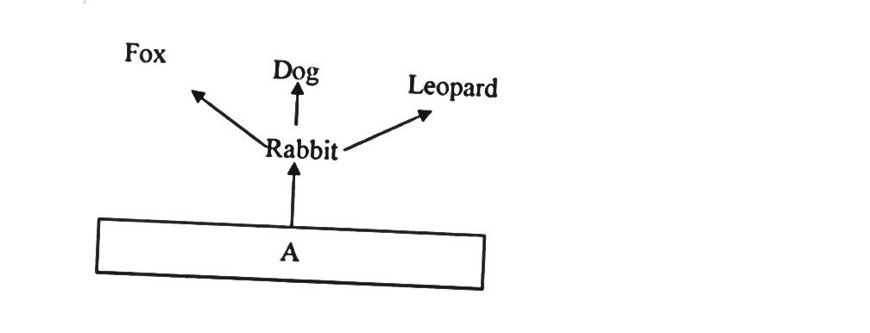

- Name the food relationship shown in the diagram (1mk)
…………………………………………………………………………………

- Name the trophic level occupied by organism A (1mk)
………………………………………………………………………………………

- What is the main source of energy in the ecosystem shown in the diagram above (1mk)
........................................................................................................................................................................................................................................................................................

- Other than transport. State two other function of mammalian blood (2mks)

- Below is a nucleic acid stand
A G U C A C G

- name the nucleic acid (1mk)
……………………………………………………………………………………………

- give a reason for your answer in (a) above (1mk)
………………………………………………………………………………………………

- Name two structures of gaseous exchange in aquatic plants (2mks)
……………………………………………………………………………………………………………………………………………………………………………………

- What is the significance of chiasma formation during meiotic cell division (1mk)\
……………………………………………………………………………………………………………………………………………………………………………………………………

- Define the term evolution (1mk)
…………………………………………………………………………………………

b.Give two evidence of organic evolution (2mks)
……………………………………………………………………………………………………………………………………………………………………………………

- Identify the stage of cell division below (1mk)
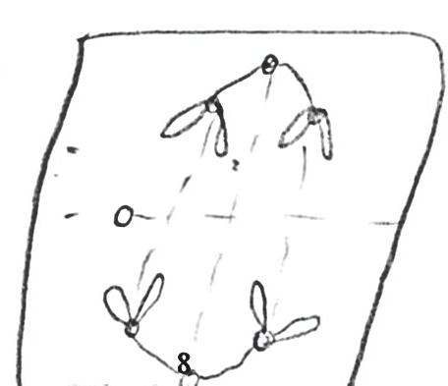

- State two characteristics of cells found at the apical meristems (2mks)
..........................................................................................................................................................................................................................................................................................................................
- The diagram below represents a mature fruit of a certain plant
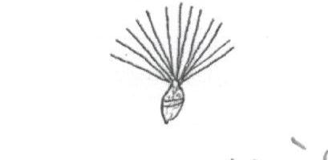

- State the agent dispersal for the fruit ……………………………………………………… .(1mk)

- Give a reason for your answer in (a) above ………………………………………………… (1mk)

- State two other characteristics of fruit and seed dispersal by the agent named in (a) above (2mks)
..........................................................................................................................................................................................................................................................................................................................
- Explain how the following adaptations will reduce the rate of transpiration (2mks)
    - Sunken stomata

    - Leaf folding

- Name the disease caused by each of the following microorganism (2mks)
- Plasmodium falciparum ……………………………………………………………….

- Entamoeba histolytica ………………………………………………………

- State two properties of monosaccharaides (2mks)
……………………………………………………………………………………………………………………………………………………………………………………………………

