NAME........................................................................................CLASS...............ADM………….
231/1
BIOLOGY
PAPER 1
JULY 2021
TIME: 2 HOURS

MOKASA EXAMINATION
(Kenya Certificate of Secondary Education)
BIOLOGY THEORY
Instructions
- Write your name, class and admission number in the space provided above.
- Write the date of the examination and sign in the space provided above.
- Answer all the questions in the spaces provided.
- You may be penalized for wrong spelling especially technical terms.

For Examiner’s Use Only
Question | Maximum Score | Candidate’s Score
1-29 | 80

This paper consists of 12 printed pages. Candidates should check the question paper to ascertain that all the pages are printed as indicated and no questions are missing

1. (a) State the contents of lysosomes. (1 mark)
………………………………………………………………………………………………………
(b) State the functions of the contents named in (a) above. (2 marks)
………………………………………………………………………………………………………
………………………………………………………………………………………………………
2. What is cell specialization? (1mark)
………………………………………………………………………………………………………………………………………………………………………………………………………………………………………………………………………………………………………………………………………………………………………………………………………………………………
3. It was found that during germination of bean seeds, 9.2 cm³ of carbon IV Oxide was produced while 9.0 cm³ of oxygen was used up.
(a) (i) Calculate the respiratory quotient of the reaction:- (2 marks)
……………………………………………………………………………………………………….……………………………………………………………………………………………………….…………………………………………………………………………
(ii) Identify the substrate being metabolized. (1mark)
……………………………………………………………………………………………………….……………………………………………………………………………………
(b) In which part of the cell does glycolysis occur? (1 mark)
…………………………………………………………………………………………………..
4. How is the tracheal system adapted to its function (3marks)
……………………………………………………………………………………………………………………………………………………………………………………………………………………………………………………………………………………………………………………………………………………………………………………………………………….
5. Name two sites where gaseous exchange takes place in terrestrial plants. (2marks)
………………………………………………………………………………………………………………………………………………………………………………………………………………………………………………………………………………………………………
6. The experiment illustrated below was set up to investigate a certain physiological process using a raw potato tuber
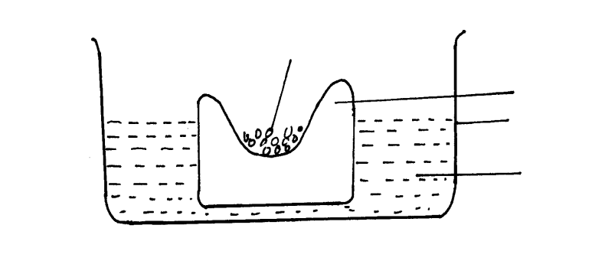
Raw potato tuber
Trough
Distilled water

Concentrated glucose solution

  - Suggest a possible physiological process that was being investigated. (1 mark)

………………………………………………………………………………………

  - Explain the results obtained in the above experiment after a few hours (3 marks)
………………………………………………………………………………………………………………………………………………………………………………………………………………………………………………………………………………………………………………………………………………………………………………………………………………………………………………………
  - State the observations that would have been made if the experiment was repeated using boiled potato. (2 marks) ………………………………………………………………………………………………………………………………………………………………………………………………………………………………………………………………………
7. State the end products of anaerobic respiration in: - (2marks)
(a)Animals
…………………………………………………………………………………………………..
(b) Plants
…………………………………………………………………………………………………….
8. State two properties of the cell membrane (2marks)
……………………………………………………………………………………………………..
…………………………………………………………………………………………………….
9. State two guidelines that should be followed when typing of scientific names (2marks)
………………………………………………………………………………………………………………………………………………………………………………………………………………
10. State two roles of luteinising hormones in female reproduction. (2marks)
………………………………………………………………………………………………………………………………………………………………………………………………………………
11. The diagram below shows a cross section of a plant stem.
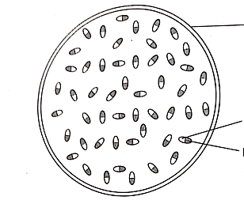
Z
Y
X

(i) State the class of the plant from which the organ was obtained (1 mark)
………………………………………………………………………………………………………
(ii) Name the parts labeled X Y and Z (3 marks)
X …………………………………………………………………………………………

Y ………………………………………………………………………………………...

Z ………………………………………………………………………………………...

12. What are the causative agents for the following sexually transmitted diseases? (2marks)
(i) Gonorrhoea
……………………………………………………………………………………………………
(ii)Syphilis
…………………………………………………………………………………………………….
13. (a) What is meant by the following terms as used in ecology : (2marks)
(i) Population
………………………………………………………………………………………………………………………………………………………………………………………………………………………………………………………………………………………………………………………………………………………………………………………………………………………………
(ii) Carrying capacity
……………………………………………………………………………………………………………………………………………………………………………………………………………………………………………………………………………………………………………………………………………………………………………………………………………………………..
(b) During an ecological visit to maasai mara students were able to see antelopes, lions, vultures, and pastoralists grazing their cattle. Construct a food chain with four consumer levels ending with the vulture to illustrate the energy flow in the ecosystem. (2marks)

14. Give three reasons why plants have not evolved complex excretory organs. (3marks)
………………………………………………………………………………………………………………………………………………………………………………………………………………………………………………………………………………………………………………………………………………………………………………………………………………………………………………………………………………………………………………………………………
15. State one adaptation of the xylem vessels to its functions. (1marks)
………………………………………………………………………………………………………
16. State three factors that increases the rate of diffusion. (3 marks)
………………………………………………………………………………………………………………………………………………………………………………………………………………………………………………………………………………………………………………………
17 The diagram below represents a certain plant,study it and answer the questions that follow
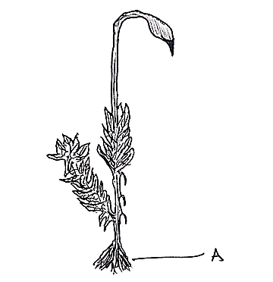
- (i)Name the division to which the plant belongs (1marks)
………………………………………………………………………………………

(ii)The plant only survives in wet areas. Give a reason (1marks)
……………………………………………………………………………………………………………………………………………………………………………………
- What is the function of part labeled A (1marks)
……………………………………………………………………………………………..
18. Give the roles of each of the following important excretory products in plants (3marks)
(i) Quinine
……………………………………………………………………………………………………………………………………………………………………………………………………………..
(ii)Colchicine
………………………………………………………………………………………………………………………………………………………………………………………………………………
(iii) Papain
………………………………………………………………………………………………………………………………………………………………………………………………………………
19. During a medical examination, a patient presented with the following symptoms, passing of large amounts of urine which when tested contained a lot of glucose.
(i)What hormone was deficient in the patient (1mark)
………………………………………………………………………………………………………
(ii) What disease was the patient suffering from (1mark)
……………………………………………………………………………………………………..

20. State three characteristic features used to classify members of phylum Arthropoda (3marks)
……………………………………………………………………………………………………………………………………………………………………………………………………………………………………………………………………………………………………………………..
21. The graph below shows the effect of substrate concentration on the rate of enzyme reaction.
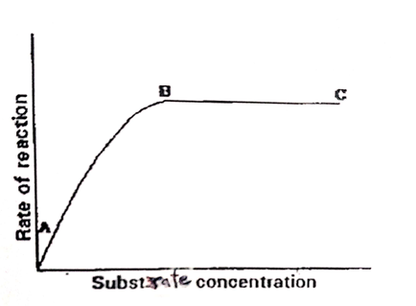
(a) Account for the shape of the graph between A and B (2marks)
....................................................................................................................................................................................................................................................................................................................................................................................................................................................................................
(b) How can the rate of reaction be increased after point B? (1mark)
............................................................................................................................................................
(c) State one other factor that affects the rate of enzyme reaction. (1mark)
............................................................................................................................................................
22. The diagram below shows stage during cell division.
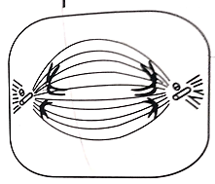
- Identify the stage of cell division in the diagram above (1 mark)
…………………………………………………………………………………………………
(ii) Give a reason for your answer in (i) above (1mark)
……………………………………………………………………………………………………
(b) How are the spongy mesophyll cells adapted to their functions? (1mark)
……………………………………………………………………………………………………
23. Name one cofactor and one co-enzyme required for a blood clotting process to be normal.
- Co-factor - ………………………………………………… (1mark)

- co-enzyme - …………………………………………………. (1mark)

24. Define the following terms; (2 marks)
- Taxonomy
…………………………………………………………………………………………………………..………………………………………………………………………………………………………….…………………………………………………………

- Binomial nomenclature
…………………………………………………………………………………………………………..…………………………………………………………………………
25. In what ways do emotions affect the rate of breathing in humans (2marks)
……………………………………………………………………………………………………………………………………………………………………………………………………..
26 (i) Define the term predation (1 mark)
………………………………………………………………………………………………………………………………………………………………………………………………………………………………………………………………………………………………………
(ii)State three behavioral adaptations displayed by the prey to minimize predation (3mks)
........................................................................................................................................................................................................................................................................................................................................................................................................................................................................................................................................................................................................................
27. Differentiate between the following terms:- (2marks)
(i) Hypogynous flower and epigenous flower
………………………………………………………………………………………………………………………………………………………………………………………………………………………………………………………………………………………………………………………………………………………………………………………………………..
(ii) Gamopetalous corolla and polypetalous corolla
…………………………………………………………………………………………………………………………………………………………………………………………………………………………………………………………………………………………………………………………………………………………………………………………………………
28. Study the following chemical equation and answer the questions that follow
Product Y
Process x
C₁₂H₂₂O₁₁ ₊ H₂O + C₆H₁₂ O₆

(ii) Identify process x and the enzyme that catalyses’ the process (2mark)
.......................................................................................................................................
(ii) Product Y (1mark)
…………………………………………………………………………………….......

29. Study the diagram below and answer the questions that follow. 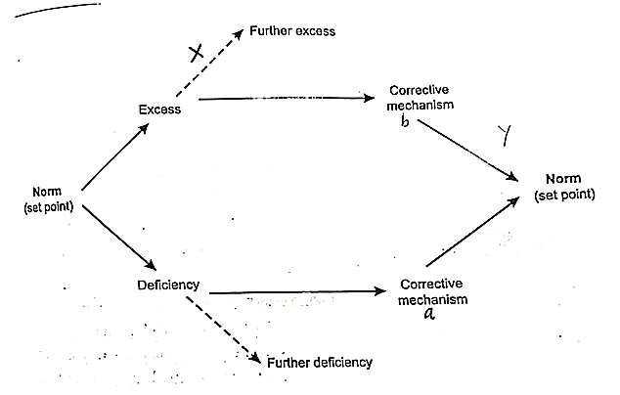
a) Name the mechanism labeled X (1mark)
………………………………………………………………………………………………
- If the above diagram represented temperature regulation.
(i) State the corrective mechanisms carried out at a (1marks)
………………………………………………………………………………………………
(ii) State the condition that may result from the further excess (1mark)
………………………………………………………………………………………………

