MARKING SCHEME
FORM 1 BIOLOGY
TERM 2 2022 OPENER EXAM FORM 1
TIME: 2 HOURS

Answer all the questions in the spaces provided.

1. With reference to the term Biology, state the meaning of the following:- (2 mks)
(i) bios – life

(ii) logos – knowledge

2. State the two major branches of Biology and give their meaning. (4 mks)
(i) Botany - Branch of biology that deals with study of plants.

(ii) Zoology - Branch of biology which deals with study of animals.

3. Complete the table below by giving the meaning of the terms: (5 mks)
Branch of Biology | Meaning
Microbiology | Study of microscopic organisms
Anatomy | Study of structure of living organisms
Physiology | Study of body functions
Entomology | Study of insects
Cytology | Study of cells

4. Outline four benefits of study of biology. (4 mks)
(i) Solving environmental problems
(ii) Career subject
(iii) Acquire scientific skills
(iv) Promotes cooperation in solving common problems
(pertinent and emerging problems)

5. With reference to characteristics of living organisms complete the table below. (8 mks)

Characteristic | Definition/Meaning
Reproduction | Process by which living things give use to new individuals of their own.
Movement | Change in position of whole or part of an organism
Excretion | Removal of metabolic wastes from body of an organism.
Nutrition | Process by which living organisms acquire & utilize nutrients
Respiration | Chemical breakdown of food to release energy
Growth and development | Growth-Permanent increase in size of an organism  Development – Permanent increase in complexity of an organism
Gaseous exchanges | Process of movement of respiratory gases across a respiratory surface.
Irritability (Responsiveness) | Ability of organism to detect and respond to change in environment

6. State the importance of the following in living organisms. (6 mks)
(i) Reproduction – Increase in population
- Sustains species

(ii) Movement – Get resource from environment
- Escape harmful stimuli
- Reach out mates for reproduction

(iii) Excretion – Prevents accumulation of metabolic waste to toxic level which would
harm the organism.

7. Explain how plants and animals differ with reference to the following characteristics. (10 mks)
NB: Marks are linked in each characteristic.

Movement | Plants | Animals
(i) Nutrition | Are antotrophic  Manufacture their food for water & CO₂ | - Are heterotrophic.  - Feed on complex food materials from plants and animals
(ii) Irritability | - Show response  - No specific receptors | - Rapid response to stimulus  - Have specific reception
(iii) Growth | - Growth takes place at meristemetic tissue only. | - Growth occurs all over the body uniformly.
(iv) Excretion | - Lack specialized excretory organs | - Have highly developed excretory organs.
(v) Movement | Occurs only in parts | - Both locomotory and parts movement.

8. Explain how the following apparatus are used in collection and observation of specimens.
(6 mks)
(i) A pooter – Sucking small animals from surfaces.
(ii) A bait trap – Attract and trap small animals eg rats.
(iii) A pit fall trap – Catching crawling animals.
(iv) A fish net – Trapping small water animals eg fish.
(v) A sweep net – Catching flying insects.
(vi) Pair of forceps – Picking up small crawling animals.
9. (a) Define the following terms: (2 mks)
(i) Taxonomy – Science of classification
(ii) Taxonomic units – Group into which organisms are placed in classification.

(iii) Outline the seven taxonomic units of classification from the largest to the smallest.
(7 mks)
(a) Kingdom
(b) Phylum
(c) Class
(d) Order
(e) Family
(f) Genus
(g) Species

(b) Complete the table below kingdoms should be in the order of simplest to most complex
organisms. (10 mks)
 | Kingdom | Example of organism
(i) | Monera | Bacteria
(ii) | Protoctista | Algae, amoeba, paramecium
(iii) | Fungi | Moulds, yeast, mushrooms, puffballs etc
(iv) | Plantae | Maize, beans
(v) | Animalia | Man, bees, lion

10. (a) Identify the organisms shown in the photographs. (3 mks)

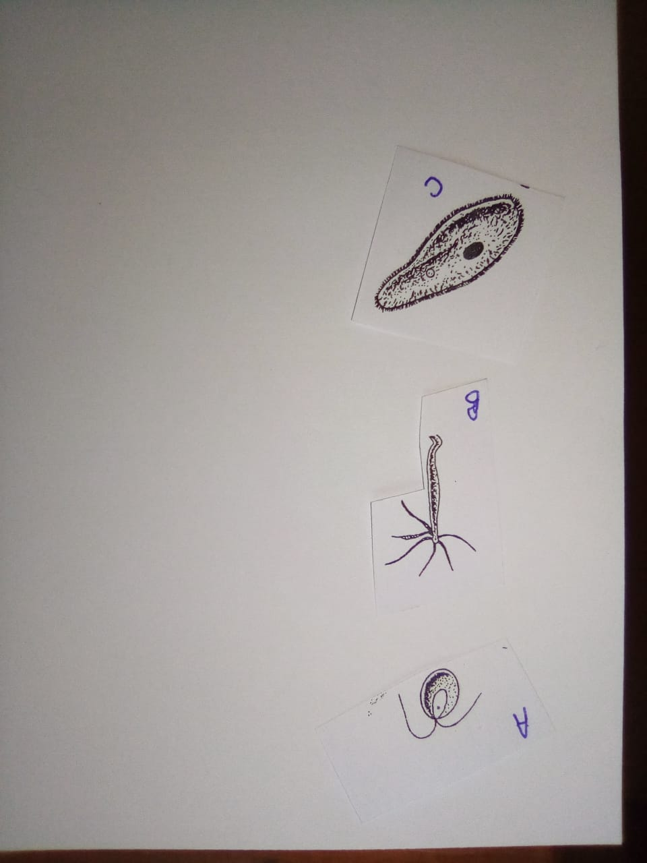

A – Clamydomonas
B – Hydra
C – Paramecium
(b) If fish in diagram A is the drawing of object B, calculate the drawing magnification. (2 mks)

Magnification = $\frac{length of image}{length of object}$ = $\frac{86cm }{43cm}$ = X2

