F3 BIOLOGY MARKING SCHEME
- State two functions of centrioles in an animal cell. (2mks)
- Takes part in cell division/forms spindle fibres
- Formation of cilio and flagella

- Name two classes of phylum arthropoda that have a cephalothorax. (2mks)
- Arachnida
- Crustacean
- Other than having common characteristics state the main features of a species. (2mks)
- Ability to interbreed freely
- Ability to produce a fertile/viable offspring.

- The diagram below represents a transverse section of a plant organ.

- From which plant organ was the section obtained. (1mk)
- Dicotyledonous root
- Give two reasons for your answer in (a) above. (2mks)
- Presence of root hairs
- The xylem is centrally place and star shaped with the phloem in the arms of the xylem.
- Name the parts labeled. (3mks)
J epidermis
K Phloem
L Xylem
- Absorption of water and mineral salts from the soil to the root.
- Name the class from which this section was obtained. (1mk)
- Dicotyledonae

- The diagram below shows an organelle that is found in most cells. Study it and answer questions that follow.

- Name the organelle. (1mk)
- Mitochondrion
- State the function of the organelle named in (a) above. (1mk)
- Provides site for respiration.

- Give the full name of the major chemical compound that is found in the organelle. (1mk)
- Adenosine Triphosphate

- Identify the gas that is required in order to form the compound you have stated in (c ) above. (1mk)
- Oxygen

- Give the name of the structures labeled H and give their function. (2mks)
- H – cristae – provide a large surface area for attachment of respiratory enzymes.

- In which cells between spermatozoon or ova could you expert to find a higher number of the above organelle. (1mk)
- Sperm
ii. Give a reason for your answer in f (i) above. (1mk)
- A sperm requires numerous mitochondria to form side for respiration to provide energy for propulsion to the oviduct for fertilization.

- Name the gaseous exchange structure in the following organisms. (4mks)
a. i. Amoeba
- Cell membrane
ii. Grasshopper
- Tracheole
iii. frog
- Skin
- Buccal cavity Mark any two
- Lungs
b. The diagram below illustrates the structure of a gill from a bony fish.

- Name the parts labeled (3mks)
A – Gill filament
B – Gill bar
C – Gill raker
- State the function of the part labeled C. (1mk)
- It is teeth-like and pointed to trap and filter solid particles from reaching the delicate gill filament.

- How is part B adapted to its functions? (2mks)
- It is long and curved to increase the surface area for attachment of gill rakers and filaments.

- During a biological practical lesson, the teacher provided students with the following apparatus: pooter, scapel, specimen bottle a pair of forceps, sweep net, chloroform.
- Give three precautions the biology teacher gave to the students before the practical when collection of specimen began. (3mks)
- Do not handle stinging specimen with bare hands.
- Do not collect more organisms than needle.
- Care should be taken not to harm then when collecting.
- Immobilize fast moving insects with chloroform.
- Return the organisms to their natural habitat.
- Do not destroy the habitat of the specimen.

- What was the function of the following apparatus. (3mks)
- Pooter
- Sucking small animals from barks of a tree
- Sweep net
- Catching small flying insects.
- Chloroform
- To immobilize fast moving organism

- Other than observation, give other two scientific skills developed by studying biology. (2mks)
- Identification, recording, classifying, measuring, analyzing, evaluation.

- An investigation was performed by a group of students as shown in the set up below.
After 30 minutes, the starch suspension had turned blue-black while iodine solution retained its brown color.
- Name the physiological process that was being investigated. (1mk)
- Diffusion

- Account for the results observed after 30 minutes. (3mks)
- The visiking is semi-permeable, allowing the small sized iodine molecules to pass through but preventing the large sized starch molecules from crossing into iodine solution.

- Explain what would happen to the red blood cells when placed in distilled water and left to stand for the same duration as for the experiment above. (3mks)
- The cell sap of red blood cells is hypertonic to the distilled water hence water molecules into the cell by osmosis, making the cell to sweel and eventually burst.

- Define cell physiology. (1mk)
- Is the study of functions of cell structures.

- Observe the photographs of the specimens shown below and answer questions that follow.
1. a. Leaf simple………………………………………………. Go to 2
b. leaf compound…………………………………………... go to 4
2. a. Leaf parallel veined ……………………………………. Maize
b. Leaf network veined…………………………………… go to 3
3. a. Leaf margin smooth……………………………………. Bougainvillea
b. Leaf margin serrated …………………………………… Hibiscus
4.a. Trifoliate compound leaf………………………………... crotalaria
b. Pinnately compound leaf………………………………… go to 5
5. a. Bipinnate………………………………………………… Jacaranda
b. Unipinnate………………………………………………. Rose
Use the above steps to identify the specimen. (7mks)
Leaf | Steps followed | Identify
A | 1a, 2b, 3b | Hibiscus
B | 1a, 2a | Maize
C | 1b, 4b, 5b | Rose
D | 1a, 2b, 3a | Bougainvillea
E | 1b, 4b, 5a | Jacaranda
F | 1b, 4a | Clotalaria

- After an ecological study of feeding relationship students constructed a food web shown below.

- Name the process by which energy from the sun is incorporated into the food web. (1mk)
- Photosynthesis

- The biomass of producers in this ecosystem was found to be grater than that of primary consumers. Explain. (1mk)
- So that the producers are able to support the primary consumers in the ecosystem.

- From the information in the food web, construct a food chain with large fish as tertiary consumers. (1mk)
- Algae insect larvae small fish large fish
- Algae zoo plankton small fish large fish
- What would happen to the organisms in the food web of bird L migrated. (2mks)
- The number of snails would increase hence more food for bird is whose population would increase.
- The number of Algae and green plants would reduce as they are eaten by the large number of snails.

- Name an organism with the least biomass. (1mk)
- Large birds

- State three human activities that would negatively affect the population of organisms in the above food web. (3mks)
- Poor methods of farming that would lead to soil erosion.
- Deforestation
- Poaching/hunting, trapping birds
- Fishing
- Used of water for irrigation
- Excessive use of insecticides and pesticides.

- The diagram below illustrates a nephron from a mammalian kidney.

- Name the parts labeled: (3mks)
A - Bownman’s capsule
B – Glomerules
C – Descending loop of henle
D – collecting duct
- Name the process represented by the arrows. (1mk)
- Ultrafitration

- Name one substance that remains at part B. (1mk)
- Plasma prokins
- Blood cells

- How does the part labeled of camel compare with that of a hippo. (2mks)
- In a Carmel it is long and penetrate deep in the medulla while in a hippo it is short and confined in the cortex.

- An experiment was carried out to investigate the effect of temperature on the rate of a reaction catalyzed by salivary amylase. The pH was maintained slightly alkaline. The results are as shown in the table below.
Temperature | Rate of reaction
5 | 0.3
10 | 0.5
20 | 1.3
25 | 2.0
30 | 3.5
35 | 4.8
38 | 4.8
45 | 2.5
50 | 0.8

- On a grid draw a graph of the rate of reaction against temperature. (6mks)
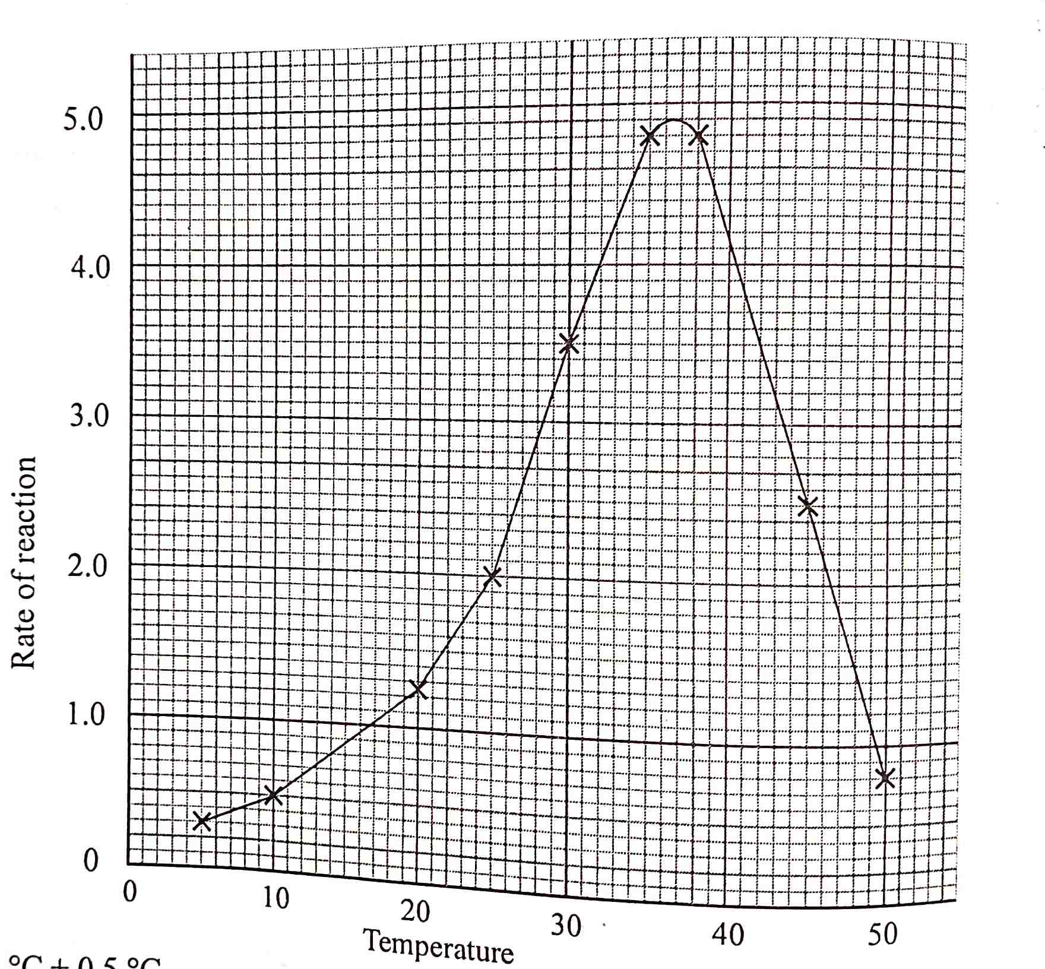
- What is the optimum temperature of this enzyme? (1mk)
- 36.5ºC +0.5ºC

- At what temperature was the rate of reaction 1.4? (2mks)
- 21ºC +0.5ºC and 48ºC +0.5

- Account for the shape of the graph between:
- 5ºC and 35ºC (2mks)
- As the temperature increased, the rate of reaction increased because enzymes salivary amyls because more active with the increasily temperature within that range.

- 30ºC and 50ºC (2mks)
- As the temperature increase the rate of reaction decreased because the enzyme was denatured by temperature above optimum.

- How is HCl from the stomach neutralized and where does it occur? (2mks)
- Through action of NaHCo₃ present in pancreas juice and bile salts. It occurs in the duodenum.

- Name one digestive enzyme that works best in acidic conditions. (1mk)
- Pepsin and rennin
- In an attempt to estimate the number of weaver birds, in a small wood land 435 were captured, marked and released. Three days later, 620 were captured 75 of which were marked.
- What is the name of the population estimation method described above? (1mk)
- Capture - recapture

- Calculate the approximate size of the weaver birds population in the wood land. (2mks)
- First marked x second capture
Marked recaptured
- 435 x 620
75
- 3596 weaver birds

- Describe how the mammalian skin is adapted to its functions. (20mks)
- Cornified layer; is the outermost layer of the epidermis. It is made up of flattened dead cells that become filled with a tough flexible substance called keratin. This layer is very important because it provides protection against mechanical damage and invasion of micro-organisms. It also reduces loss of water by evaporation. Cells of this layer are continuously lost through friction and are replaced from beneath by the cells from the granular layer. Its thickness is not uniform throughout the body, for example, it is thickest in areas of high friction like palms of hands and soles of feet but thinnest on lips and eyeballs.
- Granular layer; is the middle layer of the epidermis and consists of living cells that have granules, when these cells die, they give rise to the cornified layer.
- The malphigian layer is the innermost of the epidermal layers and is made up of actively dividing cells. These cells give rise to the new epidermis. The cells have a pigment called melanin that give colour to skin and also give protection against the harmful effects of the ultra violet rays from the sun.
- The dermis is comparatively thicker than the epidemis. Many structures such as blood vessels, sweat glands and hair follicles are found in the dermis.
- Blood vessels contain blood that supplies nutrients and oxygen to the skin tissues and remove waste products such as carbon (IV) oxide. Blood distributes heat in the body hence plays a role in temperature regulation. Nerve endings of nerve cells detect stimuli of pain, pressure and temperature regulation. Nerver endings of nerve cells detect stimuli of pain, pressure and temperatures of the external environment.
- Sweat glands are made up of coiled tubules of secretory cells that extend into long tubules that open on the surface of the skin as sweat pores. The secretory cells in the coiled tubule absorb excess water, mineral salts, traces of urea , lactic acid acid from the surrounding blood vessels and tissues. These substances are secreted into the tubule lumen to form sweat, which flows through the sweat duct to the skin surface. Sweat glands are involved in temperature regulation excretion and salt and water balance.
- Hair originates from a infolding of the epidermis that forms hair follicle. The hair follicle is lined with granular and malphighian layers of the epidermis. at the base of the hair is a dermal or hair papilla from which the hair root develops. The hair follicle is supplied with sensory nerves to increase the sensitivity of the skin and blood vessels for supply of nutrients and removal of waste products. Each hair is made up of a base called hair root and made up of a base called hair root and hair shaft, which protrudes outwards. ‘Growth’ of the hair follicle is due to continuous addition of new dead cells at the base of the hair. Erector pills muscles attached to the follicle alter the angle between the hair shaft and skin and therefore vary the amount of air trapped between the hair and skin, phenomenon that is important in temperature regulation.
- Sebaceous glands are attached to and open into the follicle. The glands secrete sebum, which keeps the hair and epidermis supple and waterproof. Sebum contains antiseptic substances for protection against micro-organisms.
- Sub-cutaneous fat is a layer of fat cells beneath the dermis. It is also known as adipose tissue. It binds the skin to the muscle and other organs deep in the body. It stores fats and acts as an insulator layer against heat loss.
- Describe how a leaf from a terrestrial habitat is adapted to its photosynthetic functions. (20mks)
- Broad lamina provides a large surface area of absorption of light and diffusion of gases.
- The lamina is thin which provides for a short distance for diffusion of carbon (IV) oxide to palisade cells and oxygen form the leaf cells into the atmosphere.
- Presence of veins, which support the lamina in the most favourable position for absorption of light.
- Presence of stomata for efficient diffusion of carbon (IV) oxide, oxygen and water vapour.
- Transport cuticle and epidermal cells to allow penetration of light to the photosynthetic cells.
- Palisade cells contain many chloroplasts and are next to upper epidermis to receive maximum light for photosynthesis.
- Palisade cells contain many chloroplasts and are next to upper epidermis to receive maximum light for photosynthesis.
- Palisade cells are closely packed and vertically elongated to allow many to be packed beneath the upper epidermis where they can receive maximum light.
- Chloroplast have chlorophyll for trapping light.
- Leaves have veins/vascular bundles which consists of:
- Xylem vessels which conduct water to photosynthetic cells.
- Phloem tubes, which translocate products of photosynthesis to other parts of the plant.
- Interconnected intercellular air spaces for rapid diffusion of carbon (IV) oxide into the palisade cells and oxygen out into the atmosphere.
- Mosaic leaf arrangement, which ensures that all leaves are able to receive light by reducing overlapping.

