MARKING SCHEME
TERM 2 2022 OPENER EXAM FORM 2
FORM TWO,2022
BIOLOGY. 70 MARKS.
TIME 2 HOURS.

- Distinguish between the following terms: - 4marks
- Magnification and resolution of a microscope
Magnification. Ability of a microscope to enlarge tiny objects
Resolution. Ability of a microscope to separate between two tiny structures under
magnification to appear distinct

- Mounting and staining of a specimen

Mounting. The placing of prepared slide on stage of a microscope;
Staining. Use of chemical stain on specimen for clear observation

- Name the organelle that performs each of the following functions in a cell. 3marks
- Transport of packaged glycoproteins
Golgi bodies
- Destruction of worn out cell organelles
lysosome

- Synthesis of proteins
Ribosomes

- Given that the diameter of the field of view of a light microscope is 2000um. Calculate the
size of a cell in mm if 10 cells occupy the diameter of the field of view 2marks

Size of one cell = diameter of field view
No. of cells arranged across the diameter
= 2000μm;
10cells
200μm = 0.2mm
N/B = 1μm = 0.001mms;

- State three physiological processes that are involved in movement of substances a cross the cell membrane 3marks

Osmosis
Diffusion
Active transport

- The diagram below illustrates the behaviour of red blood cells when placed into two different
solutions X and Y.
Placed in solution
X
Placed in solution
Y
Process A
Process B

(a) Suggest the nature of solutions X and Y. 2marks

X – hypotonic solution;
Y – hypertonic solution;

(b) Name the process A and B. 2marks
A Haemolysis;
B – crenation

(c) What would happen to normal blood cell if it were placed in an isotonic solution? 2marks
The cell will maintain/retain its normal shape.

- The diagram below represents a cell organelle
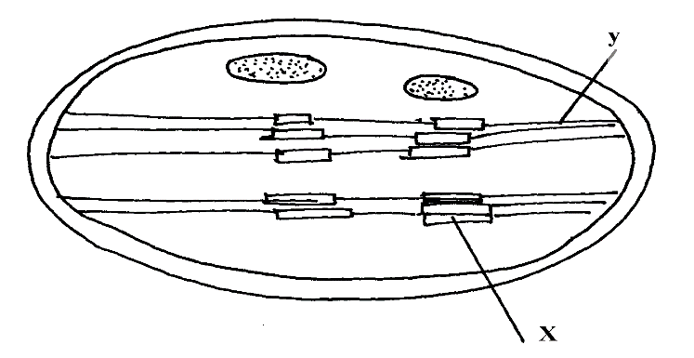

i) Name the part labeled Y 1mark Inter grana

ii) State the function of the part labeled X 1mark
Accept site 4 photolysis; contains chlorophyll pigment that traps light;

- Briefly explain the fate of the following products from the light stage of the process of
Photosynthesis: 3 marks
(a) Oxygen atoms combines to form oxygen gas used for respiration. The rest is diffused out during gaseous exchange
(b) Hydrogen ions enters the dark stage.

(c) ATP provides energy for carbon(IV) oxide fixation

- Name the diseases caused by deficiency of: 2marks

- Iodine
Goiter;

- Vitamin C
Scurvy
- (a) What is peristalsis? 1 mark
Involuntary movement of food along the alimentary canal

- Explain how the process above is brought about.
2marks
Occurs when the Circular and longitudinal muscles on the wall of oesophagus and intestines contract and relax alternately;

- What are the two functions of bile salts during the process of digestion. 2marks
Emulsification
Neutralization of acidic chyme

- The table below shows three enzymes A, B and C and their respective optimum pH.
Enzyme | Optimum pH
A | 6.8
B | 2.0
C | 8.0
(a) (i) Name the most likely region of the alimentary canal of a mammal where enzyme
B would be found. 1 mark
Stomach

(ii) Give a reason for your answer in (a) (i) above 2marks

Presence of hydrochloric acid in the stomach to provide acid conditions

- Study the dental formula given below:
I 0; C 0; PM 3; M 2
4 0 3 3
(a) Identify with reasons the mode of feeding of the animals whose dental formula is
given above
Mode 1mark

Herbivorous

Reasons 2marks

Lack upper canine and upper incisors

(b) Calculate the total number of teeth in the mouth of the above animal . Show your working.
2marks.

15x 2 -= 30 teeth
- (a) Define the term transpiration 2marks
Loss of water inform of water vapour from the plants mainly through the stomata.

(b) State three types of transpiration 3marks
Stomatal
Cuticular
lenticular

(c) List three forces that facilitate the transport of water and mineral salts up the stem.
3marks
Cohesion and adhesion
Capillarity
Root pressure
Transpiration pull.

(d) Name the tissue that is removed when the bark of a dicotyledonous plant is ringed
phloem 1 mark
- The figure below represents a diagram of a photometer;
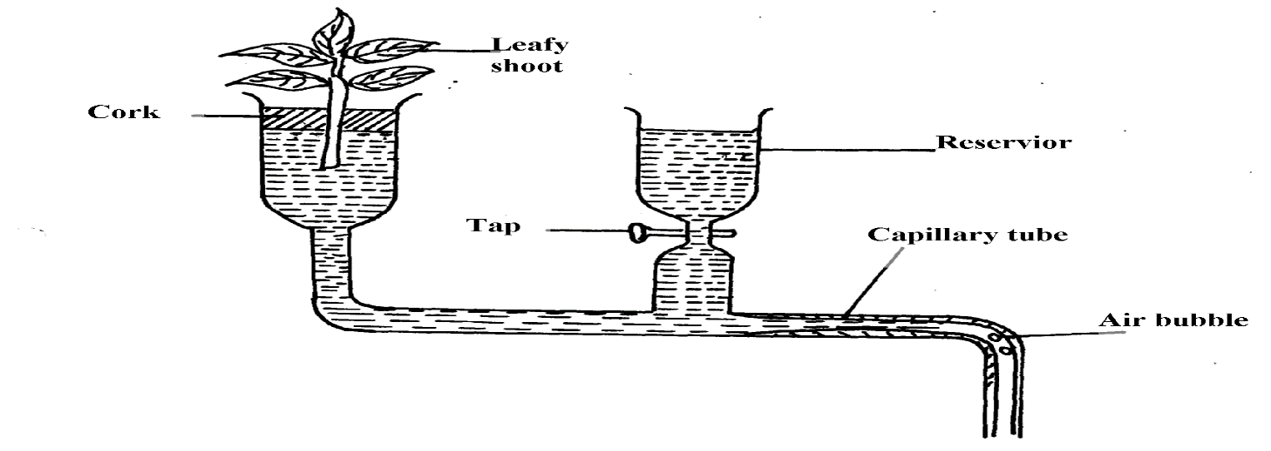

(a) What is the photometer used for? 1 mark

To measure the rate of transpiration in leafy shoot.
(b) give two precautions which should be taken when setting up a photometer 2marks

Assemble apparatus under water;
Apply Vaseline between cork shoot contacts;
Open the reservoir tap;

- Name the blood vessel that nourishes the heart 1 mark Coronary Artery;

- In which form is oxygen transported in the blood. 1 mark
Oxyhaemoglobin;

- (a) State three structural differences between arteries and veins in mammals 3 marks

Arteries | Veins
- Thick muscular  - No valves (except at the base of pulmonary artery and aorta)  - Narrow (small) lumen | - Thin muscular walls  - valves present;  - Wide (large) lumen;

(b) Name a disease that causes thickening and hardening of arteries 1 mark

Arteriosclerosis

- Explain two advantages of closed circulatory system over open circulatory system. (2marks)

oxygenated and deoxygenated blood are completely separated / do not mix;
Blood flow to organs is well regulated based on demand;
Animals tend to be more active due to efficient transport of gases and nutrients
Blood circulates over longer distances at faster rate due to high blood presence;
(mark any 2 correct)

- List the components of animal circulatory systems 3 marks
system of blood vessels in which materials are circulated round the body
Blood, a fluid medium which contains dissolved substances and cells
The heart, a pumping mechanism which keeps blood in circulation

- Give two structural differences between a red blood cell and a white blood cell. 2 marks.

Red blood cells • has haemoglobin • smaller size • lacks nucleus

White blood cells • not pigmented • larger size • nucleated

- (a) what is blood clotting? 1 mark
process in which blood components clump together to prevent loss of blood from an injured/cut vessel
(b)Name a protein, vitamin, and an enzyme involved in blood clotting. 3marks
Protein – fibrinogen/prothrombin
Vitamin - k/quinine
Enzyme – thrombokinase/thromboplatin/thrombin

- (a) What is immunity? 1 mark
Resistance to disease by organisms
(b)Distinguish between natural and acquired immunity 2 marks
Natural immunity is inherited/transmitted from parent to offspring/inborn/innate
Acquired immunity is developed after suffering from a disease or through vaccination

- What is the role of vaccination against certain diseases 1 mark?

protect body against infectious diseases
prevent spread/transmission of certain diseases

