Name|: ……………………………… ADM No…….Class:.…….Signature ……
FORM FOUR BIOLOGY (50 marks)
TIME: 1 ½ HOURS
INSTRUCTIONS
Answer all the questions
- a a) state the function of the following parts of hind brain
i) Cerebellum (1mk)
……………………………………………………………………………………………………….
……………………………………………………………………………………………………….
ii) Medulla oblongata. (1mk)
……………………………………………………………………………………………………….
……………………………………………………………………………………………………….
- i. A person was found to pass out large volumes of dilute urine frequently. Name the;
a) Disease the person was suffering from (1mk)
……………………………………………………………………………………………………….
……………………………………………………………………………………………………….
b) Hormone that was deficient (1mk)
……………………………………………………………………………………………………….
……………………………………………………………………………………………………….

3. The diagram below shows a type of a nerve cell. Study and answer the questions that follow
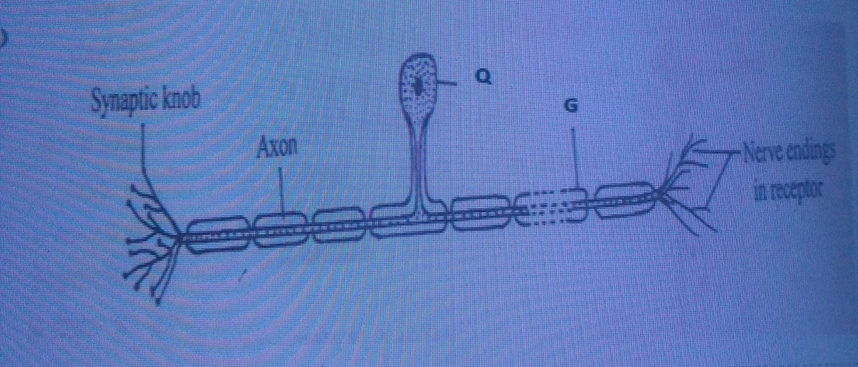
a.i) Identify the type of nerve cell shown above 1mk
……………………………………………………………………………………………………….
……………………………………………………………………………………………………….
ii. Give a reason for your answer in a (i) above 1mk
……………………………………………………………………………………………………….
……………………………………………………………………………………………………….
b. Name parts labeled Q and G 2mks
……………………………………………………………………………………………………….
……………………………………………………………………………………………………….
c. Name the other types of nerve cells 2mks
……………………………………………………………………………………………………….
……………………………………………………………………………………………………….
iii. On the diagram using an arrow indicate the direction of the nerve impulse 1mk

4. The equation below shows an oxidation reaction of Food substances.
C₅₁H₉₈O₆ + 145O2 ------- X CO2 + 98 H2O + energy
a) What do you understand by the term respiratory quotient? (2mark)
………………………………………………………………………………………………….……………………………………………………...…………………………………………….
b) Determine respiratory quotient of the oxidation of food substance. (2marks)

c) Identify the food substances. (1mark)
…………………………………………………………………………………
5. a) Study the photograph below showing a certain trait in man.
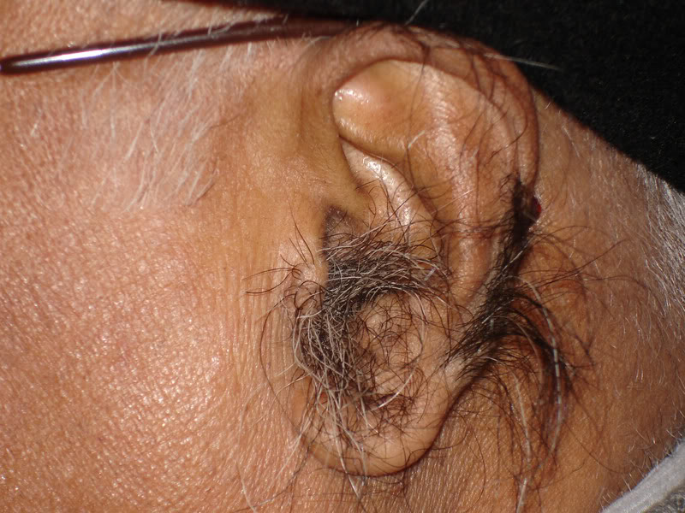
- Identify the trait exhibited in the photograph above. (1 mark)
…………………………………………………………………………………………
- The trait you have identified in (d) (i) above is sex linked. In which chromosome is it contained. (1 mark)
…………………………………………………………………………………………
- Name any other sex linked trait in man. (1 mark)
…………………………………………………………………………………………
- The man in the photograph married a woman. Use a genetic cross to predict the offspring of the above marriage. Let Y^{H} represent the gene for the trait above. (4 marks)

6. Below are photographs of Venus flytrap (an insectivorous plant). Study them and answer the questions that follow.
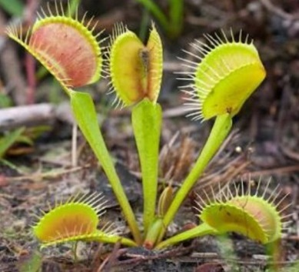
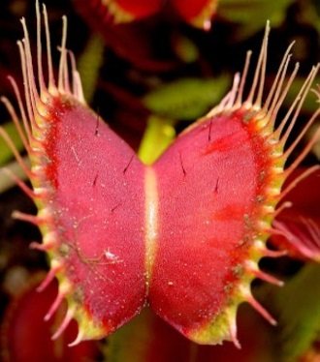
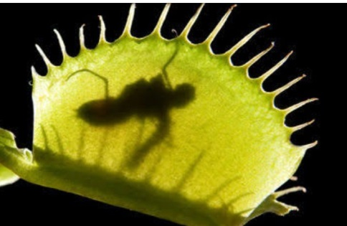
A B C
Spines
Sensitive hairs
Trapped insect
(i) Name one major nutrient that is deficient in the soil where the above plant grows. (1mk)
…………………………………………………………………………………………………

(ii) Name the type of response shown by plate C (1mk)
…………………………………………………………………………………………………..
(iii) Describe how the above plant traps the insect (5mks)
…………………………………………………………………………………………………
………………………………………………………………………………………………….
………………………………………………………………………………………………….
………………………………………………………………………………………………….
………………………………………………………………………………………………
7. a) Explain the various types of tropism in plants 10mks
b) Discuss the various kinds of evidence for evolution 10mks

