TERM 2 2022 OPENER EXAM FORM 4
231/1 (THEORY)
BIOLOGY PAPER 1
TIME: 2 HOURS
MARKING SCHEME
1. Give two reasons why a cell must undergo interphase before mitosis starts. (2mks)
To accumulate enough energy required for cell division;
To duplicate all the plant structures;
To allow replication of DNA;
2. a) State three limitations of quadrat method used in estimation of population of organisms in a given ecosystem. (3mks)
Tedious;
Cannot be used in inaccessible areas like thick forest;
It cannot be used for fast moving animals;
The landing of quadrat scares away some animals
b) Apart from quadrat method, name any other two methods of estimating populations of organisms (2mks)
Line transect
Belt transect
Capture-recapture method
3. The diagram below represents the sporophyte generation of a fern plan. Study it and answer the questions that follow.

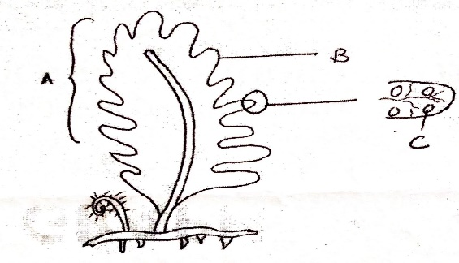
Name the parts labelled A and B (2mks)
A……….Frond
B……….Pinna
Suggest the significance of the structure labelled C (1mk)
Produce spores which germinate into the gametophyte
4. State two importance of aerobic respiration. (2mks)
Energy production;
Source of metabolic water
5. Name two sites of respiration in a cell. (2mks)
Cytoplasm; Mitochondria
6. a) Differentiate between sickle-cell anaemia and sickle- cell trait. (2mks)
Sickle-cell anaemia is a genetic disorder in which all individual's red blood cells have abnormal haemoglobin S that makes the cells to have crescent shape; sickle- cell trait is a genetic disorder in which the individual have a mixture of normal and abnormal red blood cells
Name the type of gene mutation that brings about the sickle cell anaemia. (1mk)
Substitution mutations
7. Through which blood vessels does the blood from the alimentary canal return to the heart? (2mks)
Hepatic vein; vena cava;
8. Name two examples of polysaccharides in plants. (2mks)
Starch; Cellulose
9. The diagram below is a specialized mammalian cell
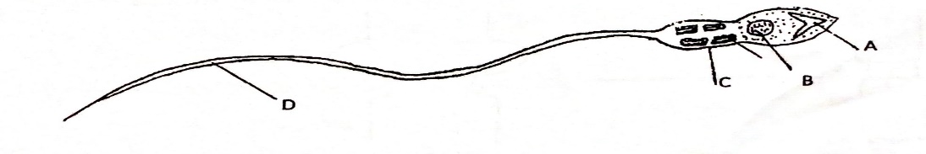
a) Name the parts labelled B and D (2mks)
B………Nucleus
D………..Tail/Tail piece
b) State how the following parts are adapted to their functions (2mks)
i) Part labelled A
Contains/produces lytic enzymes which dissolve the vitelline membrane/wall of egg cell
ii) Part marked C
Contains numerous mitochondria which provides the necessary energy used to propel the sperm
10. What is the name given to the pregnancy that occurs in the fallopian tube? (1mk)
Ectopic pregnancy

11. List the causative agent of the following sexually transmitted infections (STls): (2mks)
(a) Gonorrhoea.
Neisseria Gonorrhoea
(b) Syphilis
Treponema pallidum
12. (a) How would you destarch the leaves of a potted plant? (1mk)
Placing the plant in darkness for 48 hours

(b) Which chemical would you use to test for presence of vitamin C in a food substance? (1mk)
DCPIP
13. Name the two types of chemical compounds which combine to form a lipid. (2mks)
Glycerol; Fatty acids
14. Name the processes by which the following enter the root hair cell. (2mks)
(a) Oxygen.
Diffusion
(b) Water.
Osmosis
15. Give two structural differences between mature white blood cells and red blood cells. (4mks)
White blood cells Red blood cells
Biconcave discs; Irregular in shape
Have haemoglobin Lack haemoglobin
Have nuclei Lack nuclei

16. Give two examples of genetic engineering that are intended to improve crop plants. (2mks)
Coming up with resistant varieties to diseases and drought;
Producing high yielding crops;
Breeding of seedless crops like bananas
17. An animal has 36 chromosomes in each of its body cells. How many of these chromosomes came from its male parent? (1mk)
18
18. Study the diagram below:
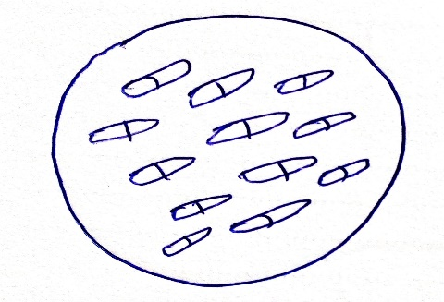
(a) From which type of plant is the section representing? (1mk)
Monocotyledous plant
(b) Give two reasons for your answer in (a) above. (2mks)
Lack of vascular cambium; No pith; scattered vascular bundles in ground tissue
19. (a) Name the organelle involved in formation of cilia and flagella. (1mk)
Centriole
(b) Give two strengthening materials of cell wall of plant. (2mks)
Pectin; Lignin
20. State two homeostatic functions of mammalian kidney. (2mks)
Osmoregulation
Regulation of blood pH
21. a) What type of gene mutations are represented by the following messages? (2mks)
i) Intended message: Lions have pointed claws.
Actual message: Lions have pointed laws.
Deletion;
ii) Intended message: The strong wind caused severe damage.
Actual message: The strong wind paused severe damage.
Substitution
b) At what stage of cell division does exchange of genetic material occur (1mk?)
Prophase I
22. The diagram below shows an embryo sac of a flowering plant
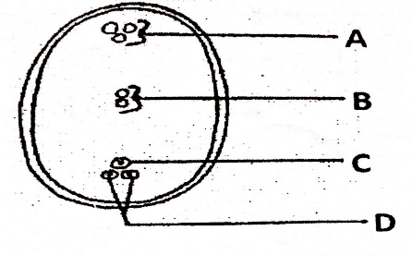
a) Name the parts labelled A and D (2mks)
A………………Antipodal cells
D……………Synergids
b) What is the function of structure labelled B (1mk)
To fuse with the other make nucleus to form the triploid endosperm c) Why is cross pollination more advantageous to a plant species than self-pollination (1mk)
Results to variation that makes the plant adapted for survival
d) What name is given to the type of fertilization exhibited in plants (1mk)
Double fertilization
23. a) What is divergent evolution (1mk)
Emergence of present forms of organisms gradually from pre-existing ones
b) Distinguish between divergent and convergent evolution (2mks)
Divergent evolution-basic structural form is modified to perform different functions
Convergent evolution-different structural forms are modified to perform similar function
24. Name two mechanisms that hinder fertilization in flowering plants (2mks)
Heterostyly/unisexual/dioecious/staminate/pistillate flowers
Protandry
Protogyny/incompatibility/self-sterility
25The diagram below represents an experiment that was set up to investigate a certain process
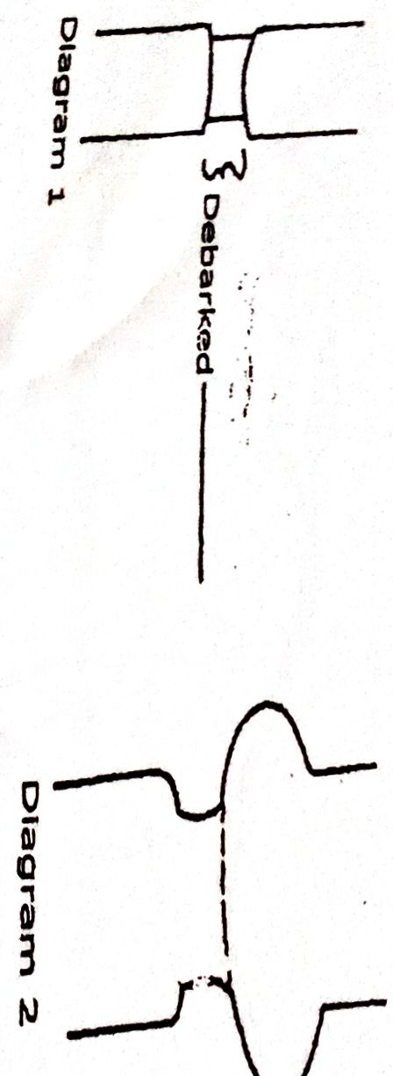

Name the process that was being investigated (1mk)
Translocation of manufactured food
Account for the swelling in diagram 2 (2mks)
Translocated food substances accumulate; it could not get across the ringed part since the phloem tissue was
removed
c) Give a reason why the plant did not dry up during the investigation (1mk)
The xylem tissue was not affected hence transport of water and mineral salts to sites of photosynthesis
26. a) Name one hormone that is involved in insect metamorphosis (1mk)
Ecdysone
Juvenile hormone
b) State the site where the above named hormone is produced (1mk)
Ecdysone-Prothoracic gland
Juvenile-Corpus allatum/corpora allata
c) State two roles of metamorphosis to the life of insects (2mks)
Enables organisms at various stages to occupy different ecological niches thus reducing competition
Can withstand different environmental conditions at different stages
Enables organisms at various stages of development to adapt to the environment
27. Explain why swallowing and breathing cannot take place at the same time (2mks)
During swallowing the bolus is pressed against the soft palate closing the nasal cavity and the glottis (opening to the larynx) is closed by the epiglottis thus prevent entry of air into the trachea
28. State three properties of a cell membrane (3mks)
Semi permeability
Possession of electric charges
Sensitive to extreme changes in temperature and PH
29. Give a reason why it is only mutation in genes of gametes that influence evolution (1mk)
Gametes always form new offsprings and therefore any mutations in gametes affects offsprings
30. State three structural differences between Ribonucleic acid (RNA) and Deoxyribonucleic acid (DNA) (3mks)
RNA | DNA
Has Ribose sugars | Has Deoxyribose sugars
Has Uracil as one of the bases | Has Thymine instead of Uracil
Single strand | Double strand

31. Define the term homeostasis (1mk)
Process that maintains constant internal environment of living organisms
32.
What was the function of the following apparatus. (3mks)
Pooter
Sucking small animals from barks of a tree
Sweep net
Catching small flying insects.
Chloroform
To immobilize fast moving organism

Other than observation, give other two scientific skills developed by studying biology. (2mks)
Identification, recording, classifying, measuring, analyzing, evaluation.
33.(a) What is peristalsis? 1 mark
Involuntary movement of food along the alimentary canal

Explain how the process above is brought about.
2marks
Occurs when the Circular and longitudinal muscles on the wall of oesophagus and intestines contract and relax alternately;

What are the two functions of bile salts during the process of digestion. 2marks
Emulsification
Neutralization of acidic chyme

