231/2

BIOLOGY
(Theory)
Paper 2
PRE-MOCK 1 2021
JULY /AUGUST 2021
2 hours

Name…………………………………………………. Adm.NO……....................Class………
Index No. ………………………………Candidates Signature………………………………..
Instructions to candidates
This paper consists of two sections; A and B.
Answer ALL the questions in section A in the spaces provided.
In section B answer question 6 (compulsory) and either question 7 or 8 in the spaces provided after question 8.
This paper consists of 10 printed pages.

For Examiner’s use only
Section | Question | Maximum  score | Candidate’s score
A | 1 | 09
 | 2 | 08
 | 3 | 08
 | 4 | 10
 | 5 | 06
B | 6 | 20
 | 7 | 20
 | 8 | 20
Total score |  | 80

SECTION A (40 Marks)
1. An analysis was done on the contents of faeces of a cow. The results are as shown in the table below.
Content | Percentage
Carbohydrates  Proteins  Fiber  Fats | 12  0.8  14  1

(a) Name the other component that makes up the faeces of a cow and give its percentage. (1 mark)
………………………………………………………………………………………………………………..
(b) Name the substance that contributes the fiber in the faeces. (1 mark)
………………………………………………………………………………………………………………..
(c) Cow faeces are normally used as fertilizer that increases nitrates in the soil.
(i) State the component in the faeces that yield nitrates. (1 mark)
………………………………………………………………………………………………………………..
(ii) Describe how the component named in (c)(i) above is converted into nitrates (4 marks)
………………………………………………………………………………………………………………
………………………………………………………………………………………………………………
………………………………………………………………………………………………………………
………………………………………………………………………………………………………………,
(d) Explain why the manure would be better if the cows urine was added to the faeces. (2 marks)
………………………………………………………………………………………………………………
………………………………………………………………………………………………………………
2. In an experiment to investigate a plant response, the set up in the diagram below was used.
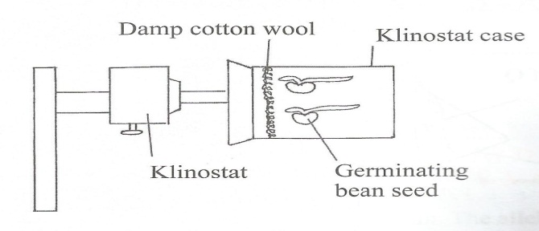

(a) Name the type of response that was being investigated. (1 mark)
………………………………………………………………………………………………………………..
(b) If the Klinostat was not rotating.
(i) State the observation that was made on the seedlings after three days. (2 marks)
………………………………………………………………………………………………………………
……………………………………………………………………………………………………………….
(ii) Explain the observations in (b) (i) above. (3 marks)
………………………………………………………………………………………………………………
………………………………………………………………………………………………………………
…………………………………………………………………………………………………………….....
(c) If the experiment was repeated with the Klinostat rotating;
(i) State the observation that was made on the seedling after three days. (1 mark)
…………………………………………………………………………………………………………….
(ii) Give a reason for the observation made on the seedling. (1 mark)
…………………………………………………………………………………………………………….
3. (a) In an experiment, plants with red flowers were crossed with plants having white flowers. All the F₁ plants had pink flowers. Using R to represent the gene for red flowers and W to represent the gene for white flowers, work out the genotypic ratio and phenotypic ratio of the offspring if the F₁ plants were crossed with white flowered plants. (5 marks)

(b) Give two reasons why Drosophila melanogaster is a suitable organism for genetic studies. (2 marks)
………………………………………………………………………………………………………………
………………………………………………………………………………………………………………
(c) What is genetic engineering? (1 mark)
………………………………………………………………………………………………………………
………………………………………………………………………………………………………………
4. The diagram below shows two cells, X and Y from the same organism. Study the diagrams and answer the questions that follow.
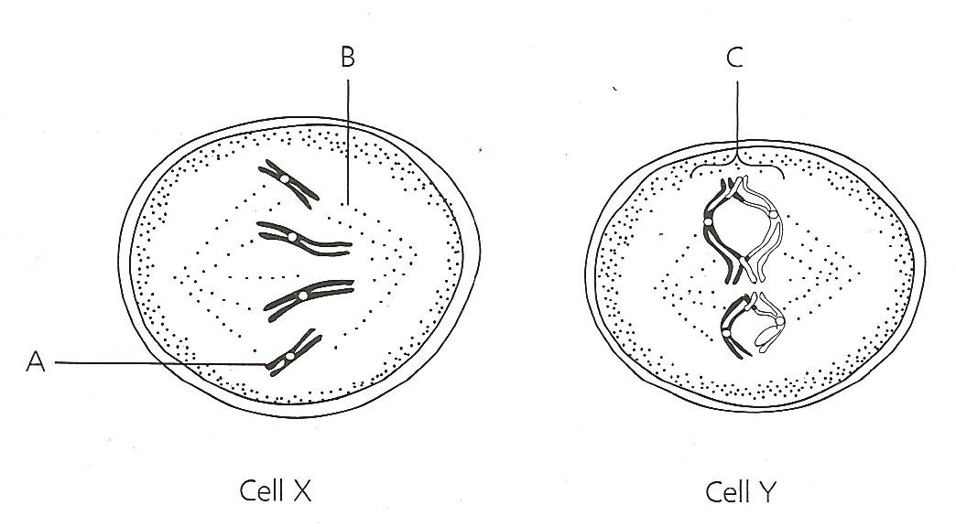
(a) Name the parts labelled A, B and C . (3 marks)
A…………………………………………………………………………………………………………
B…………………………………………………………………………………………………………
C…………………………………………………………………………………………………………
(b) (i) Which cell is diving by meiosis? (1 mark)
……………………………………………………………………………………………………………...
(ii) Give two reasons for your answer in (b) (i) above (2 marks)
………………………………………………………………………………………………………………
……………………………………………………………………………………………………………....

(c) The diagram below represents a flower.
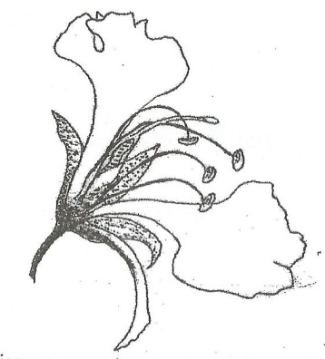
(i) On the diagram, name two structures where meiosis occurs (2 marks)
………………………………………………………………………………………………………………
………………………………………………………………………………………………………………
(ii) How is the flower adapted to prevent self-pollination? (2 marks)
………………………………………………………………………………………………………………
………………………………………………………………………………………………………………

5.(a) State the meaning of the term adaptive radiation. (1 mark)
………………………………………………………………………………………………………………..
(b) Explain how continental drift is an evidence for organic evolution (3 marks)
………………………………………………………………………………………………………………
………………………………………………………………………………………………………………
……………………………………………………………………………………………………………….
(c) State two disadvantages of natural selection to organisms (2 marks)
………………………………………………………………………………………………………………
………………………………………………………………………………………………………………

SECTION B (40 Marks)
Answer question 6 (Compulsory) and either question 7 or 8 in the spaces provided after question 8.
6. In an experiment carried out in a tropical country, carbon (IV) oxide concentration was measured around a plant in an open air at two hour intervals for a period of 24 hours. The results are as in the table below.

Time | Percentage of carbon (IV) oxide concentration ( x10⁻² )
3a.m  5a.m  7a.m  9a.m  11a.m  1p.m  3p.m  5p.m  7p.m  9p.m  11p.m  1a.m  3a.m | 3.40  3.62  3.90  3.20  2.95  2.90  2.90  2.92  3.02  3.10  3.20  3.30  3.40

(a) Using the data, plot a graph of carbon (IV) oxide concentration against time in the grid provided
(6 Marks)

(b) Calculate the rate of change in carbon (IV) oxide concentration between 4a.m and 7a.m (3 marks)
………………………………………………………………………………………………………………
………………………………………………………………………………………………………………
……………………………………………………………………………………………………………….
(c) Account for the shape of the graph between the following times:
(i) 7a.m to 11a.m . (2 marks)
……………………………………………………………………………………………………………
………………………………………………………………………………………………………………
(ii) 12 noon to 4p.m . (2 marks)
………………………………………………………………………………………………………………
………………………………………………………………………………………………………………..
(iii) 5p.m to 5a.m. (3 marks)
………………………………………………………………………………………………………………
………………………………………………………………………………………………………………..
………………………………………………………………………………………………………………..
(d) The experiment was repeated on another day and the results were different.
(i) Name two environmental factors that were likely to have affected the results (2 marks)
………………………………………………………………………………………………………………..
………………………………………………………………………………………………………………..
(ii) State how each of the factor named in (d) (i) above could have affected the results (2 marks)
………………………………………………………………………………………………………………
………………………………………………………………………………………………………………
7. (a) Describe how excretion occurs in plants. (4 marks)
(b) Explain how the osmotic pressure in the human blood is maintained at normal level (16 marks)
8. (a) Describe how reproduction occurs in yeast (5 marks)
(b) Describe secondary thickening in flowering plants (15 marks)

………………………………………………………………………………………………………………
………………………………………………………………………………………………………………..
………………………………………………………………………………………………………………..
………………………………………………………………………………………………………………
………………………………………………………………………………………………………………..
………………………………………………………………………………………………………………..
………………………………………………………………………………………………………………
………………………………………………………………………………………………………………..
………………………………………………………………………………………………………………..
………………………………………………………………………………………………………………
………………………………………………………………………………………………………………..
………………………………………………………………………………………………………………..
………………………………………………………………………………………………………………
………………………………………………………………………………………………………………..
………………………………………………………………………………………………………………..
………………………………………………………………………………………………………………
………………………………………………………………………………………………………………..
………………………………………………………………………………………………………………..
………………………………………………………………………………………………………………
………………………………………………………………………………………………………………..
………………………………………………………………………………………………………………..
………………………………………………………………………………………………………………
………………………………………………………………………………………………………………..
………………………………………………………………………………………………………………..
………………………………………………………………………………………………………………
………………………………………………………………………………………………………………..
………………………………………………………………………………………………………………..
………………………………………………………………………………………………………………
………………………………………………………………………………………………………………..
………………………………………………………………………………………………………………..
………………………………………………………………………………………………………………
………………………………………………………………………………………………………………..
………………………………………………………………………………………………………………..
………………………………………………………………………………………………………………
………………………………………………………………………………………………………………..
………………………………………………………………………………………………………………..
………………………………………………………………………………………………………………
………………………………………………………………………………………………………………..
………………………………………………………………………………………………………………..
………………………………………………………………………………………………………………
………………………………………………………………………………………………………………..
………………………………………………………………………………………………………………..
………………………………………………………………………………………………………………
………………………………………………………………………………………………………………..
………………………………………………………………………………………………………………..
………………………………………………………………………………………………………………
………………………………………………………………………………………………………………..
………………………………………………………………………………………………………………..
………………………………………………………………………………………………………………
………………………………………………………………………………………………………………..
………………………………………………………………………………………………………………..
………………………………………………………………………………………………………………

