NAME_____________________________ADMISSION NO.__________CLASS________

231/2
BIOLOGY (Theory)
2 Hours
KENYA CERTIFICATE OF SECONDARY EDUCATION
FORM FOUR BIOLOGY PAPER 2
Instructions to Candidates
- Write your Name and admission Number in the Spaces Provided.
- Sign and write date of examination in the spaces provided.
- This paper consists of three sections A, B and C.
- Answer all the questions in Sections A in the spaces provided.
- In section B Answer question 6 (compulsory) and either questions 7 or 8 in the spaces provided after questions 8
- You should check the question paper to ascertain that all the pages are printed as indicated and that no questions are missing.
SECTION A

- An investigation was carried out to study the effects of the concentration of sucrose solutions on pieces of tulip stem 44mm in length. The pieces were placed in different concentrations of sucrose solutions and measured after two hours of immersion. The results are shown in the table below.
Sucrose concentration (moles per litre) | 0.2 | 0.3 | 0.4 | 0.5 | 0.6 | 0.7 | 0.8
Length after 2 hours (mm) | 50 | 48 | 46 | 44 | 42 | 42 | 42

  - Explain the effect of the 0.2 moles per litre sucrose solution on the length of the pieces of the tulip stem. (3mks).

  - Use information from the table to predict the concentration of a sucrose solution isotonic to the cells in the tulip stem. (1mk).

  - (i) Give the term which would be used to describe the cells in the tulip stem after immersion in a solution with a sucrose concentration of 0.7 moles per litre. (1mk)

ii. Draw the appearance of a cell from the tulip stem after immersion in a solution with a sucrose concentration of 0.7 moles per litre. (2mks).

  - State one role of the process being investigated in plants. (1mk)

- Below is a diagram of a sperm cell.
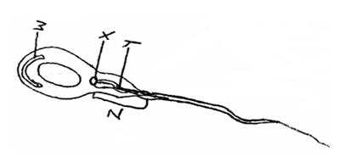

(a) Identify parts labeled X and Y. (2 marks)
X
Y

(b) Explain how parts W and Z adapt the cell to its function. (4 marks)

W

Z

(c) Using letter P identify or label on the diagram the part of the cell rich in DNA. (1 mark)

(d) State the function of part X. (1 mark)

3. Polydactyl is a genetic disorder in which people inherit an extra digit. Polydactyl is caused by a dominant allele (B). The table below describes the different genotypes for polydactyl.

- Complete the table below by giving the correct genotype, alleles of each genotype and the expected number of fingers per hand. (4mks)
Genotype | Alleles | Expected number of digits per hand.
Homozygous dominant |  | Six
 | bb
Heterozygous. | Bb

- The table below shows results of marriages between various parents. Complete the table by writing the probability of each marriage producing a child with polydactyl. One has been done for you. (2mks)
Parental genotypes. | Probability of child with polydactyl
Bb X BB
Bb X bb | 0.5
Bb X Bb

c) State the two types of variation (2mks)

- Cuban pond weed (Elodea cubiensis) is a common water plant that produces tiny air bubbles of oxygen during photosynthesis. The number of bubbles produced per minute indicates the rate of photosynthesis. The graph shows how the rate of photosynthesis in the pond weed relates to light intensity.
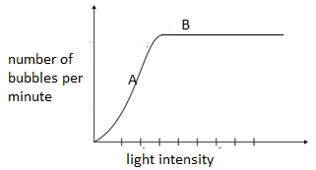
a). write the equation to account for the air bubbles. (1mk)
b). Name the factor that affects photosynthesis at point A. Explain. (2mks)

c). Explain why the rate of photosynthesis does not increase any further at high light intensity.(point B) (2mks)

d). Explain the role of the following in photosynthesis.
i) Chlorophyll. (1mk)

ii) Water. (1mk)

e). Name one product of the light stage of photosynthesis used in the dark stage of photosynthesis. (1mk)

5. Study the diagram below and answer the questions that follow.
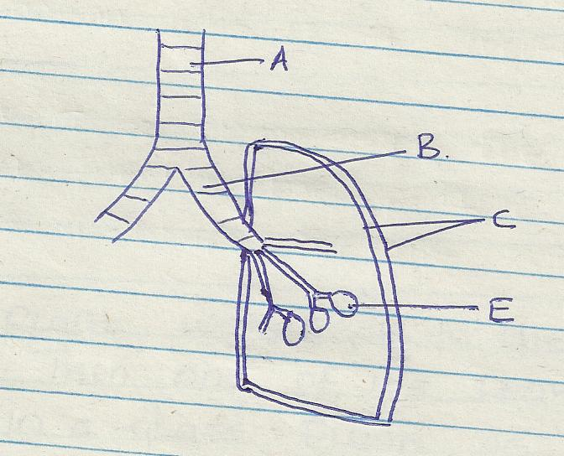

a) Name the part labeled A and B (2marks)

b) State the function of the part labeled C (2marks)

c) How is he part labeled E adapted to its function (2marks)

d) Identify the structure that perform the same function as one illustrated above in (2marks)
i) Amoeba

ii) Fish
SECTION B (40 Marks)
Answer question 6 (compulsory) and either questions 7 or 8 in the spaces provided after questions 8
6. In an ecological study a certain insect population and that of predators was estimated in a certain grassland over a period of one year.
Month | Jan | Feb | March | April | May | June | July | Aug | Sep | Oct | Nov | Dec
No of insects | 10 | 20 | 16 | 24 | 50 | 85 | 45 | 18 | 12 | 30 | 48 | 70
No of predator | 10 | 12 | 8 | 10 | 16 | 30 | 10 | 4 | 2 | 2 | 5 | 20
Rainfall amount(mm) | 20 | 6 | 55 | 350 | 500 | 250 | 12 | 10 | 25 | 190 | 240 | 30

- Using the information above plot on the same axis the graph of number of insects and number of predators against time in months. (7mks)

- Suggest what happens to the insect’s population during dry month. (2mks)

- Explain the relationship between the insect population and that of the predators. (3mks)

- Suggest what happens to the predator’s population during the dry month. (2mks)

- Name the trophic level occupied by (3mks)
- Predator.

- Insect.

- Grass.

- Name the method used to estimate population of (3mks)
i). Predator.

- Insect.

- Grass.

7. State and explain various areas where knowledge about genetics is applied. (20mks)
8. a) Describe the process of fertilization in flowering plant. (15mks)
b) State the changes that take place in a flower after fertilization. (5mks)
………………………………………………………………………………………………………………………………………………………………………………………………………………………………………………………………………………………………………………………………………………………………………………………………………………………………………………………………………………………………………………………………………………………………………………………………………………………………………………………………………………………………………………………………………………………………………………………………………………………………………………………………………………………………………………………………………………………………………………………………………………………………………………………………………………………………………………………………………………………………………………………………………………………………………………………………………………………………………………………………………………………………………………………………………………………………………………………………………………………………………………………………………………………………………………………………………………………………………………………………………………………………………………………………………………………………………………………………………………………………………………………………………………………………………………………………………………………………………………………………………………………………………………………………………………………………………………………………………………………………………………………………………………………………………………………………………………………………………………………………………………………………………………………………………………………………………………………………………………………………………………………………………………………………………………………………………………………………………………………………………………………………………………………………………………………………………………………………………………………………………………………………………………………………………………………………………………………………………………………………………………………………………………………………………………………………………………………………………………………………………………………………………………………………………………………………………………………………………………………………………………………………………………………………………………………………………………………………………………………………………………………………………………………………………………………………………………………………………………………………………………………………………………………………………………………………………………………………………………………………………………………………………………………………………………………………………………………………………………………………………………………………………………………………………………………………………………………………………………………………………………………………………………………………………………………………………………………………………………………………………………………………………………………………………………………………………………………………………………………………………………………………………………………………………………………………………………………………………………………………………………………………………………………………………………………………………………………………………………………………………………………………………………………………………………………………………………………………………………………………………………………………………………………………………………………………………………………………………………………………………………………………………………………………………………………………………………………………………………………………………………………………………………………………………………………………………………………………………………………………………………………………………………………………………………………………………………………

