NAME:………………………………………………………………………………………….…………ADM/NO. ………………………….
SCHOOL:…………………………………………………………..………………SIGNATURE………………………DATE…………….…
231/2
BIOLOGY
PAPER 2
(Theory)
NOVEMBER/DECEMBER 2021
TIME: 2HOURS
ELDORET DIOCESE EXAM 2021
Kenya Certificate of Secondary Education
INSTRUCTIONS TO CANDIDATES
- Write your name and Admission number in the spaces provided.
- Sign and write the date.
- This paper consists of two sections. A and B.
- Answer ALL the questions in section A in the spaces provided.
- In section B, answer question 6 (compulsory) and either question 7 or 8 in the spaces provided.
For examiners use only:
Section | Question | Maximum score | Candidates score
A | 1 | 8
 | 2 | 8
 | 3 | 8
 | 4 | 8
 | 5 | 8
B | 6 | 20
 | 7 | 20
 | 8 | 20
TOTAL SCORE |  | 80

SECTION A ( 40 MARKS)
- Below is a set up that was used to investigate a certain process in plants

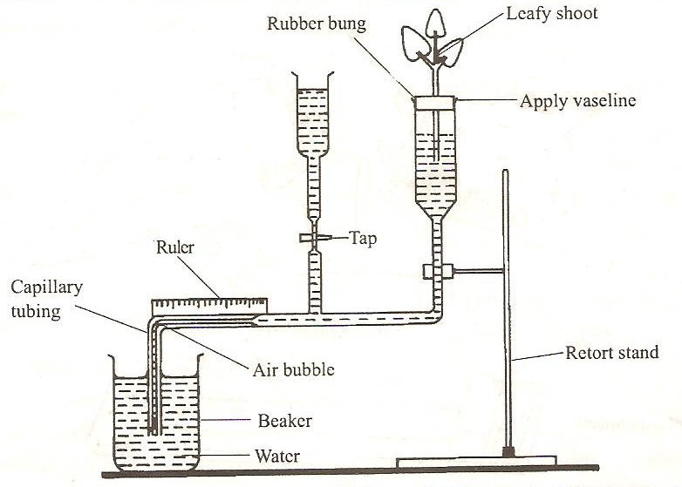

- State what the above apparatus can be used to measure
- Directly [1mark]

- Indirectly [1mark]

- i) Give two precautions that should be taken when setting up the experiment[2marks]

(ii) State a reason for each precautions stated in b(i) above [2marks]

(c) List two structural factors that affect the process under investigation [2marks]
- A Covidiot at Nakuru National park wanted to estimate the population size of grasshoppers , 70 grasshoppers were trapped , marked and released. A week later , a second sample was captured. In this second sample , 27 had marks on their bodies while 13 did not have the marks.
- Calculate the estimated size of the grasshopper population [3marks]

- Explain why it is important that the samples contain as many grasshoppers as possible [1mark]

- Name an appropriate instrument that was used to capture the grasshoppers [1mark]

- Give 3 assumptions that must be made when using this method of population estimation [3marks]

- In an experiment, Drosophila melanogaster (fruit fly) with broad abdomens were crossed with those having narrow abdomens. All the F1 offspring from the crosses had broad abdomens :
- Using A to denote the genes for the abdomen size, give the genotypes of the parents [2marks]

- If 150 fruit flies had narrow abdomens in the F2 generation, how many had broad abdomens in the same generation? Show your working [2marks]

- In a related expt, fruit flies with broad abdomens were crossed with flies with narrow abdomens. The offspring with broad abdomen and the ones with narrow abdomen were in the ratio of 1:1

- What is the genotype of the parent with broad abdomen? [1mark]

- What is the biological significance of this experiment? [1mark]

- Suggest 2 reasons why fruit flies are suitable organisms to use in this genetic experiment [2marks]

- The diagram below shows a fresh water ecosystem. Study it carefully and answer the questions that follow.
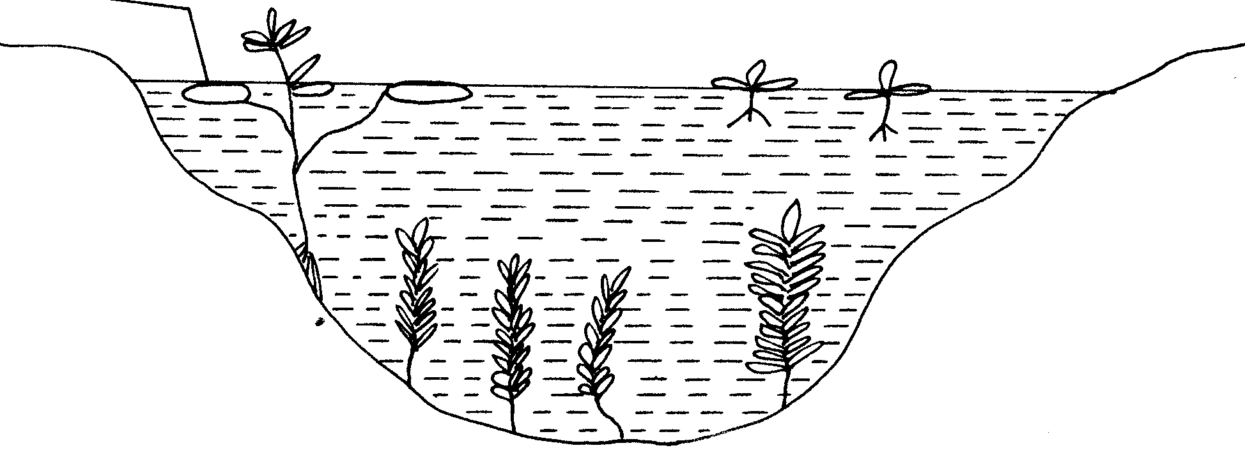
P
Q
S
a) What is an ecosystem. [1mark]

b) Identify the type of plants labeled S,P and Q. [3marks]

c) Explain adaptations of plant P to their environment. [4marks]

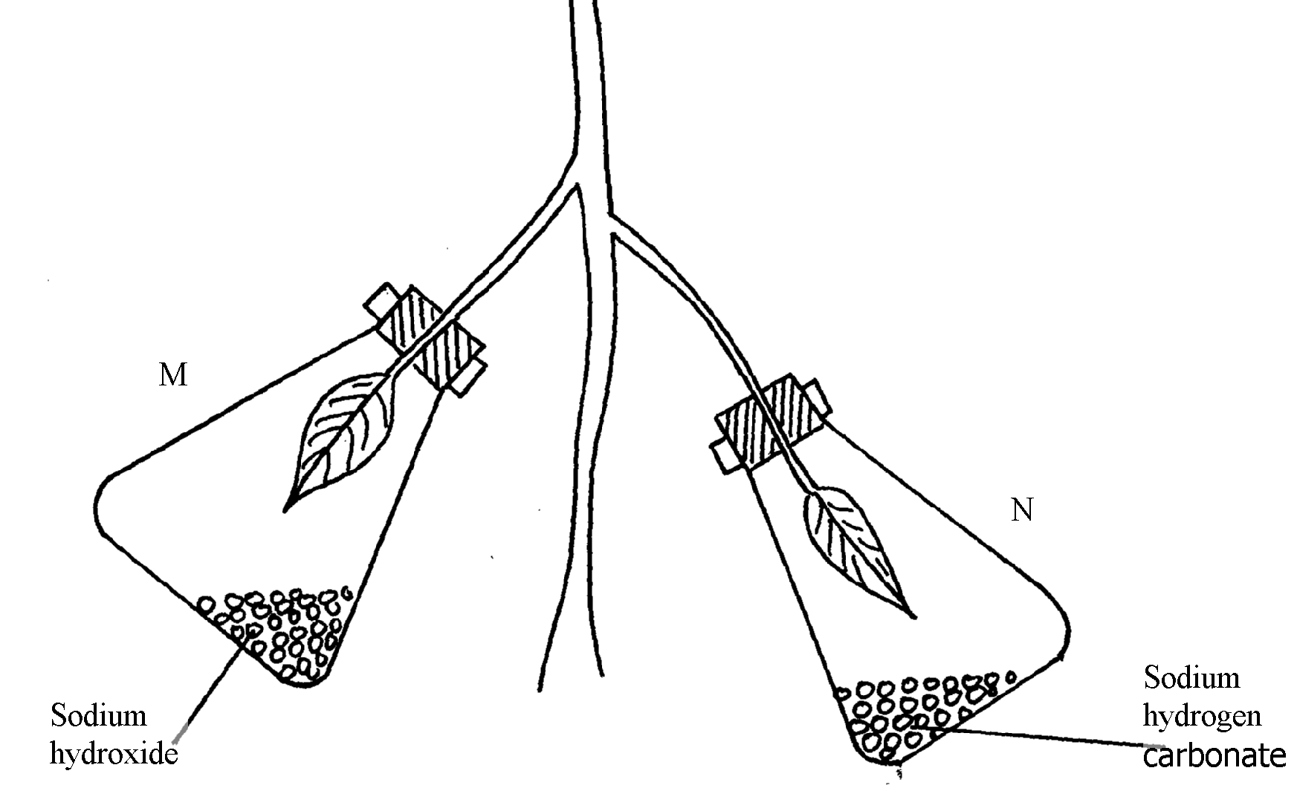
- A healthy plant was kept in the dark for 24hours following which two of its leaves were enclosed in glass flasks as shown below. The set up was the exposed to sunlight for a number of hours.

M
N

(a) Why was it necessary to keep the plant in the dark for 24 hours? [1mark]
(b) Give the function of each of the following in the experiment
(i) Sodium hydroxide [1mark]
(ii) Sodium hydrogen corbonate [1mark]
(c) Explain the expected observations in leaf.
(i) M when tested for starch [2mark]

(ii) N when tested for starch? [2mark]

(d) Apart from light intensity, name one other aspect of light that affects photosynthesis [1mark]
SECTION B (40 MARKS)
Answer question 6 and either question 7 or 8

- An experiment was carried out to investigate a certain physiological process in plants. The experimental set-up was as follows: three vacuum flasks were labelled X, Y and Z. wet cotton wool was placed in flasks X and Y. 50 soaked bean seeds were placed in flask X; while 50 boiled and then cooled seeds were placed in flask Y. Cotton wool soaked in methylated spirit was placed in flask Z. 50 seeds, boiled, cooled and then soaked in methylated spirit was placed in flask Z and a thermometer was placed in each flask and held in place with dry cotton wool. The set-up was left standing on the side bench in the laboratory. Temperature readings were taken at the same time each day for nine days.

The results are as shown below

Flask | Temperature (^{O}C)-recorded daily
 | 1 | 2 | 3 | 4 | 5 | 6 | 7 | 8 | 9 (DAYS)
X | 22 | 25 | 30 | 35 | 38 | 38 | 37 | 33 | 26
Y | 20 | 20 | 20 | 22 | 25 | 30 | 33 | 39 | 45
Z | 20 | 20 | 19 | 20 | 20 | 19 | 20 | 20 | 19

- Using the same axes plot the temperatures against time in days for flask X and Y [8marks]

- Account for the shape of the graphs from day 1 to day 9 in :
- Flask X [4marks]

- Flask Y [3marks]

- Explain the results obtained in flask Z [2marks]

- Explain why :
- Vacuum flask were used in this experiment [1mark]

- Cotton wool and not rubber bungs were used to hold the thermometer in place [1mk]

- State the aim of the above investigation [1mark]

- Evolution of an organism is towards better adaptation and survival to its habitat.
- Explain how this is achieved to members of Class Insecta towards locomotion and protection [7marks]

- Suggest how the modern long necked giraffes may have evolved from short necked stock [13marks]

- Briefly
- Describe the process of fertilization in flowering plants [16marks]

- Describe the changes that take place on the flower after fertilization [4marks]

