Name …………………………………………….……… ADM/NUMBER…………..

231/ 1 Candidate’s Signature…………..
BIOLOGY
Paper 1 Date …………………………..
(Theory)

Time : 2 hours

ELDORET DIOCESE EXAM 2021
Kenya Certificate of Secondary Education

Instructions to candidates

Write your name and class in the spaces provided above.
Append your signature and write the date of examination in the spaces provided above.
Spelling errors especially of biological terms shall be penalized
Candidates should answer the questions in English.
Answer ALL questions in the spaces provided.

For Examiner’s Use Only

Question | Maximum Score | Candidate’s Score
1 – 29 | 80

This paper consists of 12 printed pages.
Candidates should check the question paper to ascertain that
all the pages are printed as indicated and no questions are missing.

- Name the group of organisms that are found on the boarder of living and non-living organisms [1mark]

…………………………………………………………………………………………………………………….

- State two features characteristic of fruits dispersed by animals [2marks]

…………………………………………………………………………………………………………………….

…………………………………………………………………………………………………………………….

…………………………………………………………………………………………………………………….

- Define each of the following biological phenomena

- Irritability [1 mark]

…………………………………………………………………………………………………………………….

…………………………………………………………………………………………………………………….

- Seed dormancy [1 mark]

…………………………………………………………………………………………………………………….

…………………………………………………………………………………………………………………….

- Double fertilisation in angiosperms [1 mark]

…………………………………………………………………………………………………………………….

…………………………………………………………………………………………………………………

…………………………………………………………………………………………………………………….

- Name the disease condition caused by deficiency of each of the following

- Iodine [1mark]

…………………………………………………………………………………………………………………….

- Vitamin B₁ [1 mark]

…………………………………………………………………………………………………………………….

- State the function of the mitochondrial cristae [1 mark]

…………………………………………………………………………………………………………………….

…………………………………………………………………………………………………………………….
- Give the difference between transpiration and guttation [2 marks]

…………………………………………………………………………………………………………………….

…………………………………………………………………………………………………………………….

…………………………………………………………………………………………………………………….

…………………………………………………………………………………………………………………….

- Name two enzymes in the human digestive system which are secreted in an inactive form
[2 marks]
…………………………………………………………………………………………………………………….

…………………………………………………………………………………………………………………….

- Outline the function of the cilia in the mammalian fallopian tube [1 mark]

…………………………………………………………………………………………………………………….

…………………………………………………………………………………………………………………….

…………………………………………………………………………………………………………………….

- Name the blood vessel that supplies blood to the

- Brain [1 mark]

…………………………………………………………………………………………………………………….

- Cardiac muscle [1 mark]

…………………………………………………………………………………………………………………….

- Explain why when placed in fresh water Entamoeba histolytica does not burst [2 marks]

…………………………………………………………………………………………………………………….

…………………………………………………………………………………………………………………….

…………………………………………………………………………………………………………………….
- (a) Name the taxonomic class of woodlice [1 mark]

…………………………………………………………………………………………………………………….

- Name two other organisms in the taxonomic class in (a) above [2 marks]

…………………………………………………………………………………………………………………….

…………………………………………………………………………………………………………………….
- State two features characteristic of organisms in the taxonomic class in (a)(i) above
[2 marks]
…………………………………………………………………………………………………………………….

…………………………………………………………………………………………………………………….

…………………………………………………………………………………………………………………….

- To estimate the population size of grasshoppers in the 5km² field behind the Matope school farm, a group of students caught 100 grasshoppers on the first day. They marked them and released them back into the field. 48 hours later, the students went back to the field and caught 80 grasshoppers. Of these, 40 were found to have been marked

- Suggest a suitable method used to mark the grasshoppers [1 mark]

…………………………………………………………………………………………………………………….

- Calculate the population density of grasshoppers in the field [3 marks]

…………………………………………………………………………………………………………………….

…………………………………………………………………………………………………………………….

…………………………………………………………………………………………………………………….

…………………………………………………………………………………………………………………….

- The diagram below shows a specialized plant cell

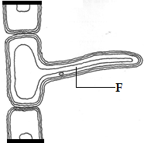

- (i) Identify the cell [1 mark]

…………………………………………………………………………………………………………………….

- State one feature observable in the diagram above that adapts the cell to its function
[1 mark]
…………………………………………………………………………………………………………………….

…………………………………………………………………………………………………………………….

- Name the part labelled F [1 mark]

…………………………………………………………………………………………………………………….
- Shown below is a diagram of a neurone

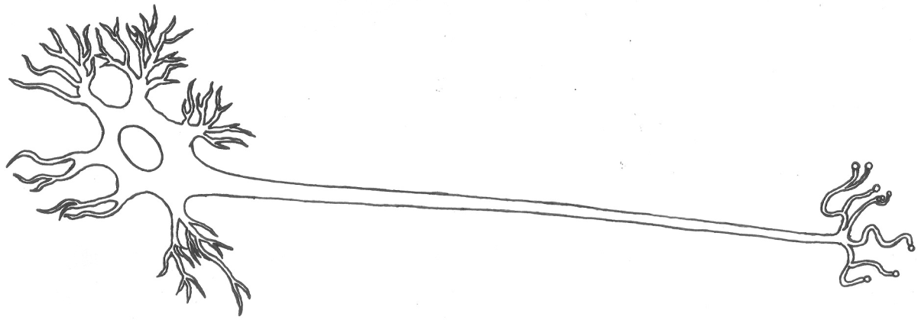

- (i) Identify the type of neurone in the diagram above [1 mark]

…………………………………………………………………………………………………………………….

- Give one reason for your answer in (a)(i) above [1 mark]

…………………………………………………………………………………………………………………….

- Draw an arrow, alongside the diagram above, to indicate the direction of flow of a nerve impulse in the neurone [1 mark]

- Study the equation below which represents a reaction which takes place in the mammalian body

Enzyme X
CO_{2(g)}+ H₂O_{(l)} H₂CO_{3(aq)}

- Where in the mammalian body does the reaction above take place? [1 mark]

…………………………………………………………………………………………………………………….

- Name the enzyme X [1 mark]

…………………………………………………………………………………………………………………….

- The diagram below shows a specialized cell from a human being

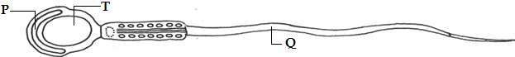

- Name the part labelled P [1 mark]

…………………………………………………………………………………………………………………….

- Give one adaptive feature of the organelle labelled T [1 mark]

…………………………………………………………………………………………………………………….

…………………………………………………………………………………………………………………….

- State the function of the part labelled Q [1 mark]

…………………………………………………………………………………………………………………….

…………………………………………………………………………………………………………………….

- The apparatus shown in the diagram below may be used to demonstrate aerobic respiration. Air is drawn through the apparatus by attaching it to a vacuum pump at the point labelled X. Sodium hydroxide solution is placed in flask 1 to remove carbon(IV)oxide

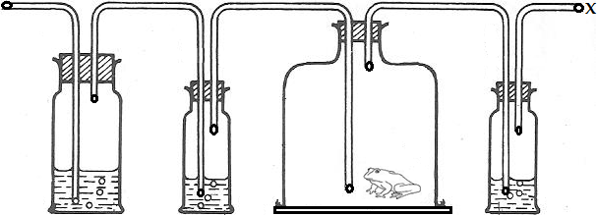
1 2 small animal 3

- Why was it necessary to remove carbon(IV)oxide? [1 mark]

…………………………………………………………………………………………………………………….

- Calcium hydroxide solution is put in the jars labelled 2 and 3. Explain why [2 marks]

Jar 2………………………………………………………………………………………………………

Jar 3………………………………………………………………………………………………………

- Suggest a suitable control for this experiment [1 mark]

…………………………………………………………………………………………………………………….

…………………………………………………………………………………………………………………….

- Illustrated below is the movement of material in a certain physiological process

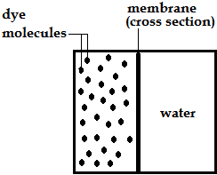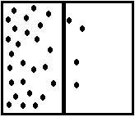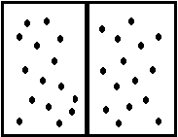

- (i) Name the physiological process illustrated above [1 mark]

…………………………………………………………………………………………………………………….

- Give two examples of applicability of the process named in (a)(i) above in plants
[2 marks]
…………………………………………………………………………………………………………………….

…………………………………………………………………………………………………………………….

…………………………………………………………………………………………………………………….

- State two ways by which the movement of the dye molecules would be slowed down
[2 marks]
…………………………………………………………………………………………………………………….

…………………………………………………………………………………………………………………….

…………………………………………………………………………………………………………………….

…………………………………………………………………………………………………………………….

- The diagrams below represent an experimental set up to investigate a certain biological phenomenon
START OF EXPERIMENT
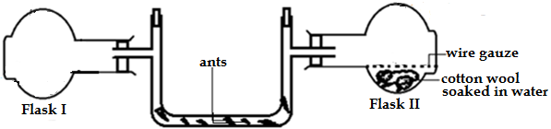

END OF EXPERIMENT
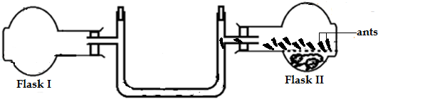

- (i) What was being investigated in the experiment? [1 mark]

…………………………………………………………………………………………………………………….

- Explain your answer in (a)(i) above [3 marks]

…………………………………………………………………………………………………………………….

…………………………………………………………………………………………………………………….

…………………………………………………………………………………………………………………….

…………………………………………………………………………………………………………………….
- What was the role of flask II in the experiment? [1 mark]

…………………………………………………………………………………………………………………….

- Outline two adaptive features of guard cells [2 marks]

…………………………………………………………………………………………………………………….

…………………………………………………………………………………………………………………….

…………………………………………………………………………………………………………………….

…………………………………………………………………………………………………………………….

- The scientific name of the European wildcat, a nocturnal mammal that inhabits forests of Western, Southern, Central and Eastern Europe, is Felis silvestris. Write down

- the scientific name of the European wildcat [1 mark]

…………………………………………………………………………………………………………………….

- the species name of the European wildcat [1 mark]

…………………………………………………………………………………………………………………….

- Name the hormone, in man, responsible for each of the following

- Stimulates secretion of bile by hepatocytes [1 mark]

…………………………………………………………………………………………………………………….

- Stimulates release of bile juice from gall bladder into the duodenum [1 mark]

…………………………………………………………………………………………………………………….

- The following text messages on a cellular phone represent gene mutations

 | Intended message | Actual message
I | Metere is a top school | Metre is a top school
II | The microscope is my tool | The microscope is my loot

Identify the type of gene mutation represented in each case

I………………………………………………………………………………………………… [1 mark]

II……………………………………………………………………………………………….. [1 mark]

- (a) Define omnivores [1 mark]

…………………………………………………………………………………………………………………….
- Name two mammals that are omnivores [2 marks]

…………………………………………………………………………………………………………………….

…………………………………………………………………………………………………………………….

- (a) Two alleles in heterozygous state can be fully expressed phenotypically in an organism e.g.
the alleles for black and white skin colour in guinea pigs (Cavia porcellus). Give the term used
to describe this phenomenon [1 mark]

…………………………………………………………………………………………………………………….

- Give one example of a trait in human beings where the condition whose term is named in (a) above expresses itself [1 mark]

…………………………………………………………………………………………………………………….

- Shown below are diagrams of the same mammalian blood cell

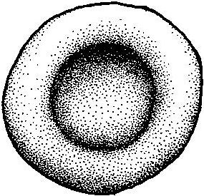
Surface view Cross section

State two morphological features of cell represented in the diagram above [2 marks]

…………………………………………………………………………………………………………………….
- The table below shows the effect of wind, still air and stomatal opening on the rate of transpiration of a plant in milligrams of water lost per hour dm². Study the table and answer the following questions

Stomatal opening (μm) | 1 | 2 | 3 | 4 | 5 | 6 | 7
Windy | 40 | 63 | 74 | 86 | 94 | 110 | 124
Still air | 0 | 6 | 12 | 19 | 23 | 27 | 30
(a) (i) Compare the rates of transpiration in windy and still air conditions [1mark]

(ii) Explain your observation in a(i) above [2marks]

(b) How does stomatal opening affect transpiration rate? [1mark]

- The relationship between oxygen concentration, potassium uptake and sugar consumption in isolated barley roots was determined. The loss of sugar and potassium uptake are in arbitrary units

 | Percentage oxygen in aeration stream
 | 0 | 5 | 10 | 15 | 20 | 100
Sugar loss | 15 | 20 | 42 | 45 | 45 | 48
Potassium gain | 5 | 55 | 70 | 73 | 75 | 70

- Account for the sugar loss and potassium gain at between 5% and 20% oxygen concentration [3marks]

- State two ways in which you can stop the above process from taking place [2marks]

- Illustrated in the diagrams below is the position of chloroplasts (shown as dark structures, ) in a tropical plant species, at two different times of the day
I II
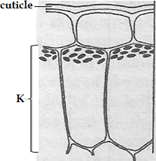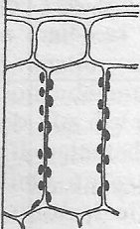
At 6am At 2pm
- Identify the tissue labelled K [1 mark]

…………………………………………………………………………………………………………………….

- Name the response shown by the chloroplasts in diagram I [1 mark]

…………………………………………………………………………………………………………………….

- Outline the importance of the orientation of the chloroplasts as illustrated in diagram II
[2 marks]
…………………………………………………………………………………………………………………….

…………………………………………………………………………………………………………………….

…………………………………………………………………………………………………………………….

…………………………………………………………………………………............................................

