**FORM THREE**

**End of TERM 3 -2022**

NAME: ADMN NO :CLASS .

CANDIDATE’S SIGN:………………… DATE:……………………

**443/1**

**AGRICULTURE**

**(THEORY)**

**TIME: 2 HOURS**

**FORM THREE**

*Kenya Certificate of Secondary Education (KCSE)*

**INSTRUCTION TO CANDIDATES**

*a) Write your name and index number in the spaces provided above.*

*b) Sign and write the date of examination in the spaces provide above.*

*c) Answer* ***all*** *the questions in sections* ***A*** *and* ***B.***

*d) All answers should be written in the spaces provided.*

**FOR EXAMINER’S USE ONLY**

|  |  |  |  |
| --- | --- | --- | --- |
| **SECTION** | **QUESTION** | **MAXIMUM SCORE** | **CANDIDATE’S SCORE** |
| **A** | **1 – 16** | **30** |  |
| **B** | **17 - 19** | **20** |  |
| **C** | **20 - 22** | **40** |  |
| **TOTAL SCORE** | | |  |

**SECTION A (30 MARKS)**

**Answer all the questions in this section in the spaces provide.**

1. Name **two** sources of soil nutrients (1mark)

1. State **two** roles of soil water (1mark)

1. Give **two** advantages of compound fertilizer. (1mark)

1. State **four** effects of high temperature on crop production. (2marks)

1. Outline **four** ways of improving the structure of sandy soils. (2marks)

1. State **two** reasons for rolling when planting wheat crop. (2marks)

1. List down **four** pieces of information found in a land title deed (2 marks)

1. Name **two** types of vegetables (1 mark)

1. List down the **two** agents of soil erosion (1 marks)

1. Outline **four** factors influencing soil erosion (2 marks)

1. State **four** methods of water harvesting in the farm. (2 marks)

1. Give **four** factors that are considered when selecting a nursery site. (2 marks)

1. Distinguish between intercropping and Monocroping. (2 marks)

1. Give **three** ways in which consolidation helps to improve farm management. (3 marks)

1. Name **three** ways in which weeds are classified based on growth cycle. (3marks)

1. What the functions of the following parts of a knapsack sprayer? (3marks)
2. Nozzle

1. Trigger

1. Pneumatic lever

**SECTION B (30 MARKS)**

**Answer all the questions in this section in the spaces provided**.

1. The diagram below shows a common weed. Study it and answer the questions that follow.



a) Identify the weed. (1 mark)

b) Give **one** reason why it is difficult to control the weed. (1 mark)

c) State **two** reasons for controlling the weed in a crop field. (2marks)

(c) At what stage of growth should the weed be controlled using a post emergence herbicide? Give a reason for your answer. (2marks)

1. The diagram below shows a method of soil conservation, study then answers the questions that follow.

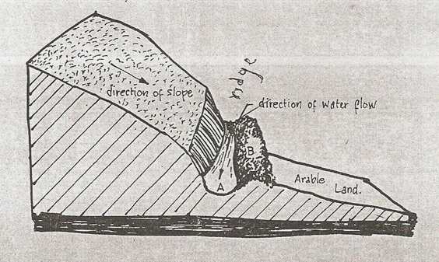

* 1. Identify the method of soil conservation illustrated (1 mark)

* 1. State **two** ways of strengthening the embankment at the lower side of the diagram (2 marks)

* 1. Name **four** areas into which the water collected above is discharged (4marks)

1. 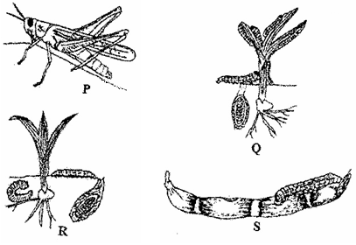Below are the pests that commonly attack the crops. Study them carefully and answer questions that follow.

(a) Identify the pests labeled **P**, **Q**, **R** and **S**. (2 marks)

P…………………………………………………. Q……………………………………

R…………………………………………………. S…………………………………….

(b) What kind of mouth part does the pests above have? (1mark)

(c) Give **two** ways in which pests can be classified depending on their habitat (2 marks)

1. Name three methods that can be used to control the pests (3 marks)

**SECTION C (40 MARKS)**

**Answer any two questions from this section in the spaces provided after question 22**

20**.** a)Outline the economic importance of weeds (12 marks)

b) Discuss on the harmful effects of crop pests in the farm (8 marks)

1. Describe the production of tomatoes under the following sub headings

a) Varieties (4 marks)

b) Transplanting (2 marks)

c) Field management practices (12marks)

d) Harvesting and marketing (2 marks

1. a) Explain the effects of solifluction/mass wasting (6 marks)

b) Discuss on the cultural methods of soil and water conservation (14 marks)