TERM 1-2023
442/1 - F4 ART AND DESIGN - Paper 1

Time: 1 ½ hours
Name………………………………………….………… Index Number…………………….................

Candidate’s signature…………..……..………..…..… Date……………….………………………………..
_______________________________________________________________

Instructions to candidates

- Write your name and index number in the spaces provided above
- Sign and write the date of the examination in the spaces provided above.
- This paper consists of three sections A, B and C.
- Answer all questions in section A and B.
- Answer any one question in section C
- Answers to all the questions must be written in the spaces provided.
- Where drawings and diagrams are appropriate, they should be included within the text of your answers
- This paper consists of 12 printed pages.
- Candidates should check the question paper to ascertain that all the pages are printed as indicated and that no questions are missing.
- Candidates should answer the questions in English
________________________________________________________________

For Examiner’s Use Only

Section | Question | Maximum score | Score
A | 1 | 20
B | 2 | 03
 | 3 | 05
 | 4 | 08
 | 5 | 05
 | 6 | 04
C |  | 15
Max. Score Paper 1 |  | 60

SECTION A (20 marks)
Answer all the questions in this section in the spaces provided.

- Below is an art work.

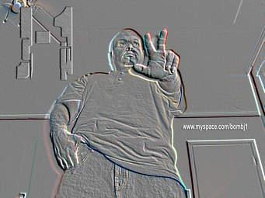

- Identify the style used to create and decorate the artwork (1mark)

- Identify one way through which perspective has been achieved in the composition (1mark)

- At what eye level was the picture created/drawn? (1mk)

- Explain the significance difference between a negative space and a positive space in a composition(2marks)

- Below is a tool used in an art process

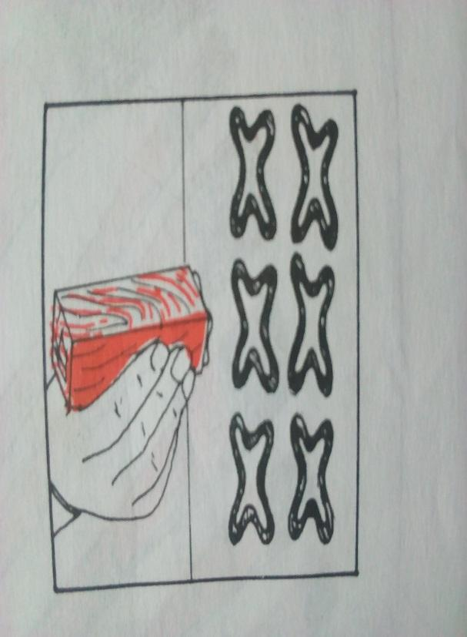

Identify the tool held and state the technique of art where it is used. (2marks)

- Explain the term dabbing as applied in art and design (2marks)

- Explain the difference between objective and subjective colour use in painting (2marks)

- Below are tools used in an art technique,.
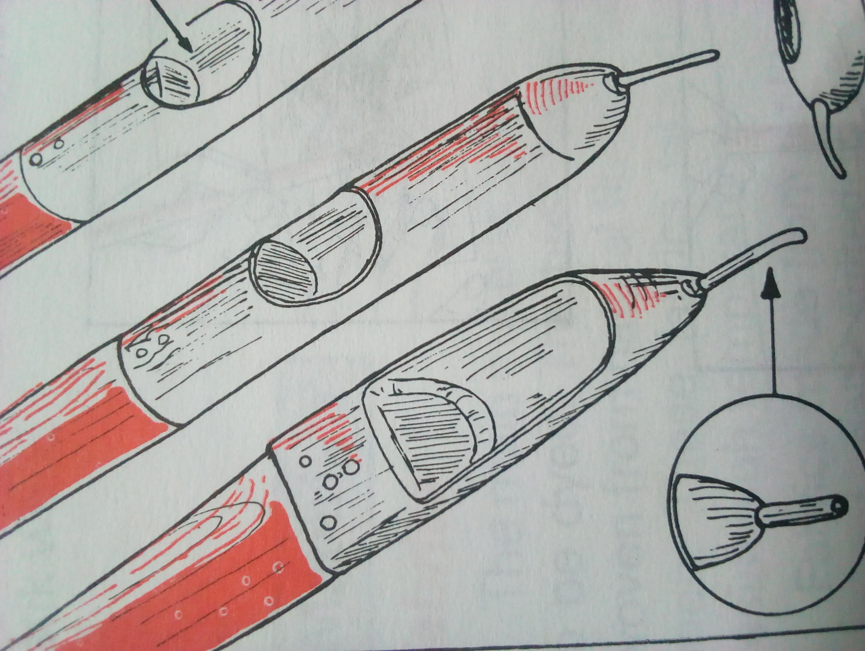

Xx

Y

Z

(i)Name the tools and which art technique they are used for

…………………………………………………… ………………………………………………….. (2mks)

(ii) Label parts X, Y and Z (3marks)

(ii) State the reason why wax is melted in a double container (1mk)
……………………………………………………………………………………………………………………………………………………………………………………………………………………………………………………………………………………………………………………….

- Identify the technique used in decorating the artwork below (1marks)

(g) What is a mordant and State the reason for adding a mordant in the art work process above (2marks)

SECTION B (25 marks)
Answer all the questions in this section in the spaces provided.

- Identify the activity below (1mark)

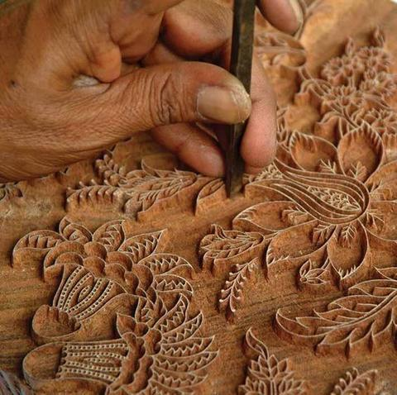

- Highlight two precautionary measures taken during the process (2marks)

- Study the picture below and answer the questions that follow.

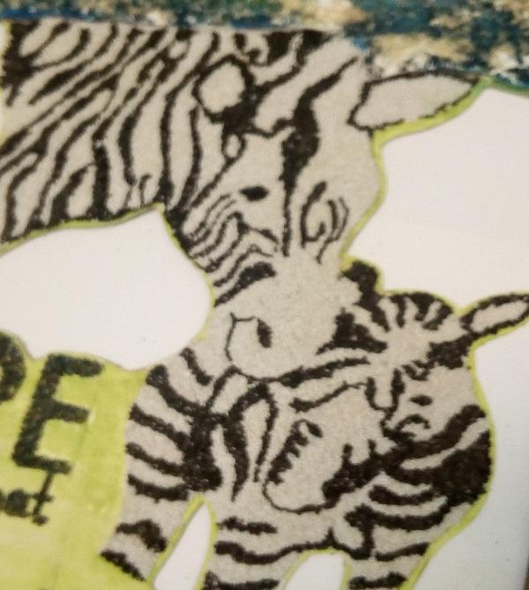

- Name the technique used to make the above picture.(1mark)

……………………………………………………………………………

- Explain the characteristics of the artwork technique above(4mks)

………………………………………………………………………………………………………………………………………………………………………………………
………………………………………………………………………………………………………………………………………………………………………………………
…………………………………………………………………………………………………………………………………………………………………......................
………………………………………………………………………………………………………………………………………………………………………………………

- Below is a stage in the silk screen process

Y
x

- Identify the material labeled x and state its function in the process (2marks)

- Briefly describe the above process.(4mks)

( c) Explain the functional differences between a squeegee and Tjanting in fabric design process (2marks)

- Describe the following techniques of decorating clay items

- Embossing (1mark)

- Inlaying (1mark)

- Excising (1mark)

- Explain two major defects in weaving (2marks)

- The image below shows an art work. Analyse the art work in terms of:
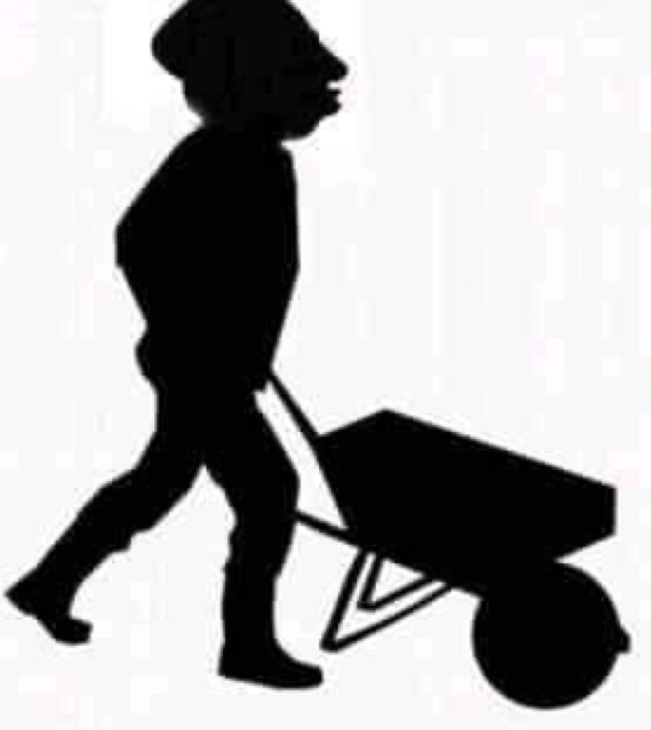

- Type of art work. ……………………………………………………………………………………… (1mrk)

- Technique used ………………………………………………………………………………………. (1mk)

- Subject matter …………………………………………………………………………………………… (1mrk)

- Function ……………………………………………………………………………………………… (1mk)

SECTION C (15 marks)
Answer any one question in the spaces provided after question 9.

- Discuss the process of decorating a two colored fabric using a combination of tie and dye and printing (15marks)

- Describe three types of reliefs in sculpture making (3marks)
- Give two qualities and two limitations of constructed sculptures. (4marks)
- Describe the process of producing a sculpture using the Papier-mâché (8marks)

- Below is an art work in the process. Study it carefully and answer the questions that follow.

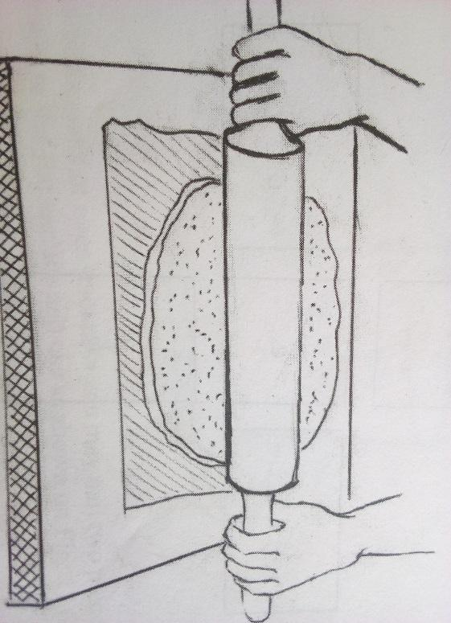

- Name the technique. (1mark)
- Identify five stages in clay preparation before its used to produce the item above (5marks)
- Explain the difference between traditional born firing and electric firing in pottery ( 2marks)
- Describe how pyro metric cones work in an electric kiln (4marks)
- Briefly explain three properties of clay used in pottery(3mks)

