MID TERM SERIES
TERM 1-2023
442/1 - F4 ART AND DESIGN - Paper 1

Time: 1 ½ hours
MARKING SCHEME
Name………………………………………….………… Index Number…………………….................

Candidate’s signature…………..……..………..…..… Date……………….………………………………..
_______________________________________________________________

For Examiner’s Use Only

Section | Question | Maximum score | Score
A | 1 | 20
B | 2 | 03
 | 3 | 05
 | 4 | 08
 | 5 | 05
 | 6 | 04
C |  | 15
Max. Score Paper 1 |  | 60

SECTION A (20 marks)
Answer all the questions in this section in the spaces provided.

- Below is an art work.

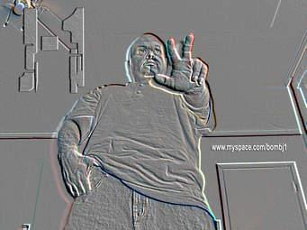

- Style used to create and decorate the artwork –Embossing
/frontage/rubbing (any 1-1mark)

- one way through which perspective has been achieved in the composition-By foreshortening (1mark)

- At what eye level was the picture created/drawn?-Worm’s eye level/view (1mk)
- Explain the difference between a negative space and a positive space in a composition(2marks)
Negative space-the space unused/unutilized /unoccupied y the art work/composition,
Positive space is the space occupied by the art work in the composition.

- Below is a tool used in an art process

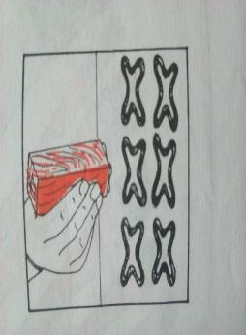

The tool held –Tjap.
Used in batik as a fabric design technique to apply designs using hot wax (2marks)

- Dabbing –painting technique of applying tinny amount of paints on a surface using a sponge or patting with tinny jets using spraying (2marks)

Explain the difference between objective and subjective colour use in painting
Objective colour is the real or actual colour of an object as they exists in nature e.g. painting a tree green.
Subjective colour is inspired by an artist creativity/freedom of expression using abstract colour schemes e.g. painting a tree purple or red.
- (2marks)

- Below are tools used in an art technique,.
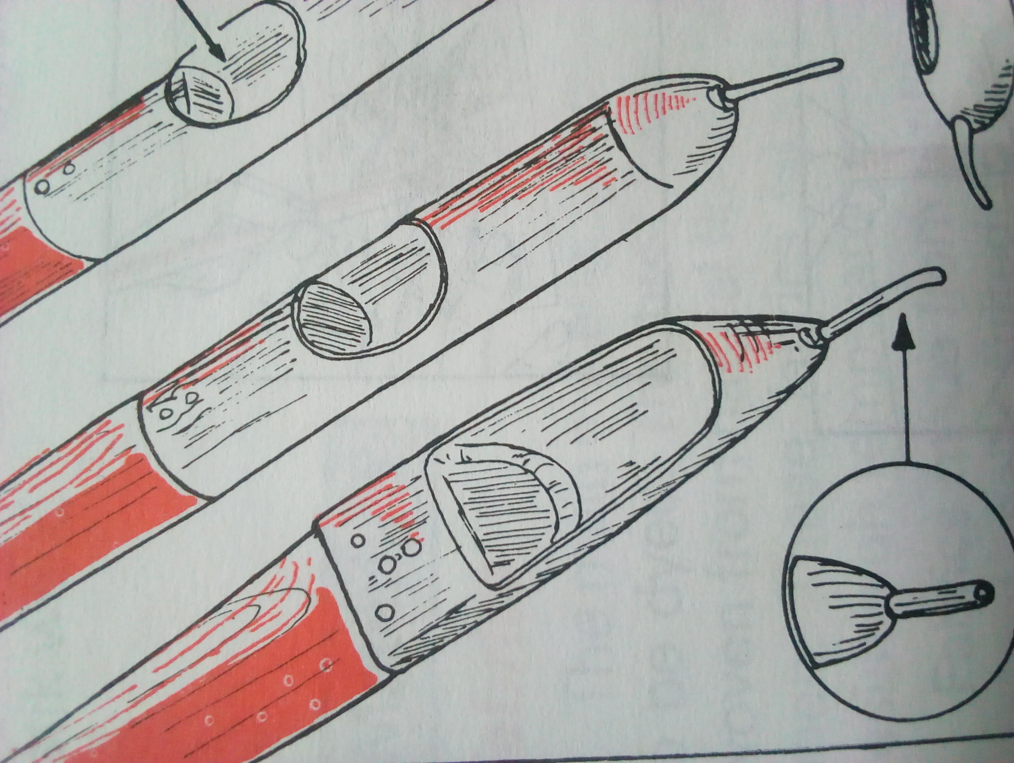

Xx

Y

Z

(i)Name the tools and which art technique they are used for

…………Tjanting………… …………………Batik……… (2mks)

(ii) X-Copper/metallic rod
Y-Wooden handle
Z- Sprout (3marks)

(ii) State the reason why wax is melted in a double container (1mk)
Wax is flammable so it’s melted in a double container to avoid it catching fire flames.

- The technique used in decorating the artwork below -Tie and dye (1mark)

(g)Mordant –special chemical agent applied in fibers/cloth by mixing it with dyes in order to fix the colours permanently and avoid fading on washing or exposure to sunlight (2marks)

SECTION B (25 marks)
Answer all the questions in this section in the spaces provided.

(a)The activity below –Curving (1mark)

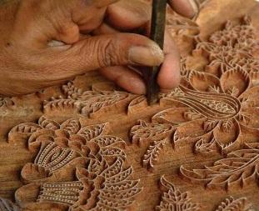
(b) Two precautionary measures taken during the process (2marks)
Wear gloves to avoid being cut
Curve with the tool facing away from you.
Maintain a constant pressure to avoid cutting too deep or too shallow.
Take care not to destroy the pattern.

- Study the picture below and answer the questions that follow.
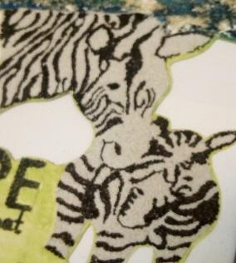

- The technique used to make the above picture.(1mark)
…Mosaic

- Explain the characteristics of the artwork technique above(4mks)

-It is a 2D art work technique
-Tesseraes are juxtaposed
-Has interstices-network of spaces/crevices.
-Uses one type of materials for tesseraes [Monomedia art technique]
-Presence of shimmering effect-a reflection of light caused by interstices.
-colour and value are main elements of this artwork.
- Below is a stage in the silk screen process
Y

- Material x-Silk mesh/organdie
- Used to hold and create the image/motif and there after used to silk screen print. process (2marks)

- Briefly describe the above process.
-Obtain the wooden frame
-Obtain the necessary materials and tools-silk mesh, thumb pins/staple pins,
-Fasten the mesh onto the frame
-Apply photo coat or varnish,
-Superimpose/lay the design on to the prepared mesh and let it dry
-Use splashed jets of water /sponge to wash and expose the positive areas.
-Use it to print. (Any 6 well explained chronologically, 4mks)

(c) functional differences between a squeegee and Tjanting in fabric design process
Squeegee-a tool used in silk screen printing to apply and push painting past through the silk mesh to the printing surface
Tjanting is a tool used in batik to apply hot and molten ax in creating designed outlines.
Bot tools are used in fabric design (2marks)

- Describe the following techniques of decorating clay items
(i)Embossing (1mark)
Sticking shapes on ceramic ware to create relief patterns
(ii)Inlaying (1mark)
Incising shallow voids on a leather hard clay to create patterns and pressing objects into the surface.

(iii)Excising (1mark)
Involves cutting through leather hard clay form to make holes using a sharp tool.

- Two major defects in weaving -Waisting and sagging (2marks)

- The image below shows an art work. Analyse the art work in terms of:
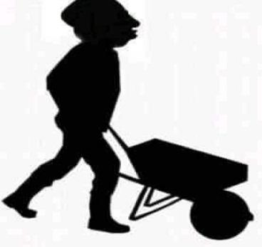

- Type of art work. Caricature (1mrk)

- Technique used Silhouette (1mk)

- Subject matter … political/campaigns/political party- (1mrk)

- Function create humor /showing political affiliation(1mk)

SECTION C (15 marks)
Answer any one question in the spaces provided after question 9.

- Discuss the process of decorating a two colored fabric using a combination of tie and dye and printing (15marks)-

- Describe three types of reliefs in sculpture making
-Projecting relief-High, Medium, low and bas relief,
-Inverse relief/sunken/intaglio. (3marks)
(b)Give two qualities and two limitations of constructed sculptures.
Qualities- uses found materials, it has a natural appearance
Limitations -joining different materials can be difficult, (4marks)
(c)Describe the process of producing a sculpture using the Papier-mâché
Design the sculpture on paper
Prepare the armature for the form
Prepare the paper Mache by smashing soaked paper excess water squeezed off then mixed with glue
Cover the armature using papier mache
Leave it to dry
Apply appropriate finishing i.e. painting, varnishing(8marks)

- Below is an art work in the process. Study it carefully and answer the questions that follow.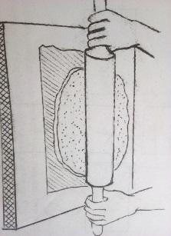

- Name the technique. Slab technique (1mark)
- Identify five stages in clay preparation before its used to produce the item above (5marks)
(i)Mining
(ii) Slaking
(iii)Mixing
(iv)Wedging and kneading
(v)Storing
(c) Explain the difference between traditional born firing and electric firing in pottery (2marks)
Traditional method done in a pit/dug hole or an open space i.e. a pit is dug while electric firing is a modern method whereby firing is done in a closed kiln i.e. gas, or electric kiln
- Describe how pyro metric cones work in an electric kiln
-Expose the ceramic articles to heating in a closed kiln, observe the pyro metric cones as the process goes on such that;
-Warning-1st cone bends.
-Readiness-2nd cone bends -readiness of the ceramic article.
-Turn off the heat/switch off the current source/disconnect such that;
-The third cone should not be let to bend lest the ceramic articles over burn and destroyed (Any well explained it illustration of the cones-4mks).
- Briefly explain three properties of clay used in pottery
-Elasticity and plasticity-the ability of clay to stretch and be manipulated into different forms and shapes without breaking,
-Porosity-the ability of clay to hold, absorb water, air and other fluids.
-Vitrification-the ability of cay to turn into glassy substance especially on firing.-be vitreous (3mks)

The end

