MANGU HIGH SCHOOL
Name………………………………………….....………Index no……………………..
candidate’s signature …………………
Date…………………………….
443/1
AGRICULTURE
Paper 1
OCT/NOVEMBER 2021
Time: 2hours
MANGU HIGH SCHOOL TRIAL 2 MOCK 2021
Kenya Certificate of Secondary Education
443/1
Agriculture
Paper 1
2hours
INSTUCTIONS TO CANDIDATES
- Write your name and index number in the spaces provided
- This paper consists of three sections A,B and C.
- Answer all the questions in sections A and B and any other two in section C
- All answers must be written in the spaces provided in this booklet.
FOR EXAMINERS USE ONLY
SECTION | QUESTIONS | MAXIMUM SCORE | CANDIDATES SCORE
A | 1-17 | 30
B | 18-21 | 20
C | 22-24 | 40
 | TOTAL SCORE | 90

SECTION A: 30 MARKS
- List four methods of farming. (2marks)
…………………………………………………………………………………………………………………………………………………………………………………………………………………………………………………………………………………………………………………………………………………………………………………………………………
- Give four factors that would determine the stage at which a crop is harvested. (2marks)
…………………………………………………………………………………………………………………………………………………………………………………………………………………………………………………………………………………………………………………………………………………………………………………………………………
- Give three reasons for early seedbed preparation. (1½marks)
………………………………………………………………………………………………………………………………………………………………………………………………………………………………………………………………………………………………………
- State four disadvantages of organic mulches. (2 marks)
…………………………………………………………………………………………………………………………………………………………………………………………………………………………………………………………………………………………………………………………………………………………………………………………………………
- Outline four functions of magnesium in crops . (2 marks)
…………………………………………………………………………………………………………………………………………………………………………………………………………………………………………………………………………………………………………………………………………………………………………………………………………
- .State four objectives o f land tenure reform . (2marks)
…………………………………………………………………………………………………………………………………………………………………………………………………………………………………………………………………………………………………………………………………………………………………………………………………………

- .State two disadvantages of late defoliation in pasture management . (1mark)
……………………………………………………………………………………………………………………………………………………………………………………………………
- .Define the following terms as used in economics .
(a) National income (1mark)
……………………………………………………………………………………………………………………………………………………………………………………………………
(b) Per capita income (1mark)
……………………………………………………………………………………………………………………………………………………………………………………………………
9.Give four benefits of a good soil structure in crop production . (2marks)
…………………………………………………………………………………………………………………………………………………………………………………………………………………………………………………………………………………………………………………………………………………………………………………………………………
10.Name four farm records that should be kept by a poultry farmer. (2marks)
…………………………………………………………………………………………………………………………………………………………………………………………………………………………………………………………………………………………………………………………………………………………………………………………………………
11. Give three factors that should be considered when choosing the type of labour to use on the farm. (l¹/₂ marks)
…………………………………………………………………………………………………………………………………………………………………………………………………………………………………………………………………………………………………………………………………………………………………………………………………………

- State four ways in which burning of vegetation may lead to lose of soil fertility (2 marks)
…………………………………………………………………………………………………………………………………………………………………………………………………………………………………………………………………………………………………………………………………………………………………………………………………………
- State four symptoms of viral diseases in crops. (2marks)
…………………………………………………………………………………………………………………………………………………………………………………………………………………………………………………………………………………………………………………………………………………………………………………………………………
- State three methods of classifying herbicides. (1½marks)
…………………………………………………………………………………………………………………………………………………………………………………………………………………………………………………………………………………………………………………………………………………………………………………………………………
- Give four methods of applying fertilizers to crops. (2marks)
…………………………………………………………………………………………………………………………………………………………………………………………………………………………………………………………………………………………………………………………………………………………………………………………………………
- State three advantages of drip irrigation (1½ marks)
…………………………………………………………………………………………………………………………………………………………………………………………………………………………………………………………………………………………………………………………………………………………………………………………………………
- Outline two ways of controlling damping off diseases on vegetable seedlings in a nursery (1mark)
……………………………………………………………………………………………………………………………………………………………………………………………………

SECTION B(20 MARKS)
Answer all the questions in this section in the spaces provided
- The diagram below shows a silo. Study it carefully and answer the questions that follow.
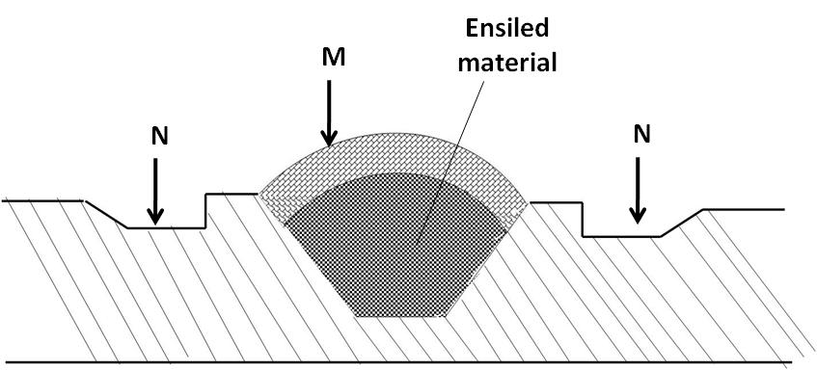

- Identify the type of silo shown on the diagram. (1mark)
.............................................................................................................................................
b) State the use of the part labeled M and N (2marks)
M ...................................................................................................................
N ...................................................................................................................
c) Give two ways of ensuring that anaerobic conditions are achieved during silage making process. (2marks)
................................................................................................................................................
................................................................................................................................................
- Form two student put some soil sample in a measuring cylinder, added some water and sodium carbonate and then covered the cylinder with the hand and shook the cylinder for about two minutes. He left the cylinder on the bench for one hour. The result was as shown below.
(i). Name the layers marked a,b,c, and d. (2marks)
a ……………………………………………………………………………………………………
b ……………………………………………………………………………………………………
c …………………………………………………………………………………………………….
d………………………………………………………………………………………………….
(ii) What was the function of sodium carbonate in this experiment? (1mark)
………………………………………………………………………………………………………………………………………………………………………………………………………………
(iii). What was the aim of this experiment ? (1mark)
…………………………………………………………………………………………………… 20. Study the diagram below of crop propagation and answer the following questions
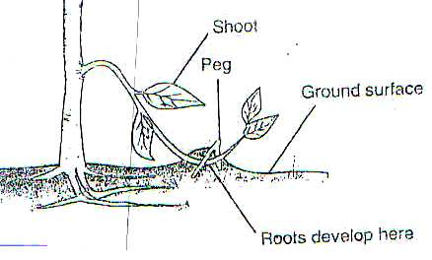

- Identify the propagation method (1mark)
.................................................................................................................................................... b) State two factors that encourage root formation in the above method of propagation (2marks)
..........................................................................................................................................................................................................................................................................................................
c). Name two crops that can be propagated using the above method (2marks)
............................................................................................................................................................................................................................................................................................................
21. (a) Describe the procedure which should be followed in spraying a crop in tomatoes using a fungicide in powder form, water and a knapsack sprayer. (3marks)
………………………………………………………………………………………………………………………………………………………………………………………………………………………………………………………………………………………………………………………………………………………………………………………………………………………………………………………………………………………………………………………………………………………………………………………………
(b) Name one fungal disease of tomatoes that can be controlled using the above procedure. (1marks)
………………………………………………………………………………………
c) State four safety measures that should be taken while spraying the crop with the fungicide. (4marks)
………………………………………………………………………………………………………………………………………………………………………………………………………………………………………………………………………………………………………………………………………………………………
SECTION C (40 MARKS)
Answer any TWO questions from this section in the spaces provided after question.
22. (a) Explain five factors that should be considered when siting a vegetable nursery. (5marks)
(b) Explain six factors that should be considered when selecting seeds for planting. (6marks)
(c) Explain the different ways in which each of the following environmental factors
Influence crop production:
(i) Temperature; (4marks)
(ii) Wind. (5marks)
23. (a) Explain the benefits of land consolidation. (6marks)
b) Briefly explain six factors influencing mass wasting. (6marks)
c) Explain four ways of improving labour productivity (8marks)
24 (a) Explain five factors that determine the spacing to be used in crops. (10marks)
(b) Describe seven nursery practices carried out while seedlings are still growing.(7marks)
(c) Outline three precautions taken in harvesting tea. (3marks)
……………………………………………………………………………………………………………………………………………………………………………………………………………………………………………………………………………………………………………………………………………………………………………………………………………………………………………………………………………………………………………………………………………………………………………………………………………………………………………………………………………………………………………………………………………………………………………………………………………………………………………………………………………………………………………………………………………........................................

