

*FORM 4 ENTRANCE EXAMS 2023*

**Marking scheme.**

**AGRICULTURE 443/1**

***Kenya Certificate of Secondary Education (K.C.S.E.)***

**Agriculture**

**Paper 1**

**SECTION A (30 MARKS)**

1. State **two** conditions under which opportunity cost is zero. (1mk)

*-There is no other alternative*

*-The item is free/plentiful*

1. Name **three** branches of horticulture. $(1\frac{1}{2}mks)$

*-Floriculture*

*-Olericulture*

*-Pomology/pomoculture*

1. State **four** factors a farmer should consider when choosing the farming system to undertake.

(2mks)

*-Size of the farm.*

*-Type of soil in the area.*

*-Government policy.*

*-Aims of the enterprise.*

*-Farmers knowledge and skills.*

*-Environmental factors.*

*-Availability of resources/capital*

*-Cultural factors.*

1. State **four** disadvantages of communal land tenure system. (2mks)

*-No individual has the responsibility of taking care of land or developing it.*

*-Farmers have no incentive to manage and develop the land well nor do they risk investing in permanent development projects because the land can be taken away from them anytime.*

*-Overstocking and overgrazing are common due to uncontrolled number of livestock leading to low yields.*

*-Poor breeding programs due to random mating and uncontrolled breeding.*

*-Pest and disease control is very difficult due to mixing of animals.*

*-Leads to soil erosion and land denudation.*

*-It is virtually impossible for a farmer to get loans from money lending agencies.*

1. Give **four** pieces of information found on a land title deed. (2mks)

*-Number of land title, land parcel, number or location.*

*-Size of land.*

*-Name and identity number of the owner.*

*-Type of ownership eg absolute leasehold or freehold.*

*-Conditions of ownership.*

*-Seal and signature of the issuing office.*

*-Date of registration.*

1. State **four** reasons for deep ploughing during land preparation. (2mks)

*-To improve soil aeration.*

*-Facilitates good drainage.*

*-Breaks hard pans/ facilitates*

*-Bringing up to the surface previously leached nutrients.*

*-Removes deep rooted weeds.*

*-Exposes soil borne pests to ash conditions hence controlling them.*

*-Exposes lower soil layers to weathering agents.*

1. State **four** characteristics of a good top soil. (2mks)

*-It is dark in colour to enhance heat retention.*

*-It is well aerated.*

*-It contains living organisms.*

*-It is well drained.*

*-It contains most plant nutrients.*

*-It contains most plant roots.*

1. Give **three** reasons for sub soiling. $(1\frac{1}{2}mks)$

*-Helps in breaking up of hardpans in areas where they have formed.*

*-Improves drainage and aeration in the soil.*

*-Brings to the surface minerals which might have been leached to the deep layers.*

*-It leads to proper penetration and development of roots.*

*-It pulls out deep rooted perennial weeds.*

1. Differentiate between seed inoculation and seed dressing. (1mk)

*This* ***Seed inoculation*** *is the coating of leguminous seeds with an inoculant to encourage nodulation and hence nitrogen fixation especially in areas where soil is deficient in nitrogen while* ***seed dressing*** *is the coating of seeds with a fungicide or insecticide or combination of the two chemicals to protect the seedlings from soil borne diseases and pests eg in cereals and legumes.*

1. State **four** effects of soil erosion. (2mks)

*-The eroded productive top soil is lost forever.*

*-Soil micro-organisms are also carried away with the top soil some of which break up soil organic matter to humus.*

*-Deposition of eroded materials in dams and rivers turn them into shallow swamps and pools creating silting problems.*

*-Sedimentation and siltation in lakes, rivers and fish ponds lead to decline in fish production.*

*-Excessive surface run-off causes a lot of damage by exposing underground water pipes and destroying roads.*

1. Outline **four** practices necessary to improve and maintain permanent pastures. (2mks)

*-Controlling weeds.*

*-Top dressing with nitrogenous fertilizers.*

*-Practicing controlled grazing in order to prevent land denudation.*

*-Topping to ensure fresh growth of pastures.*

1. State **two** causes of poor drainage on farmland. (1mk)

*-Formation of hard pans in the soil.*

*-Too much rainfall.*

*-High amount of clay particles in the soil/ Type of soil.*

*-Presence of impermeable rock near the soil surface.*

1. State **four** reasons for mulching. (2mks)

*-Prevents water evaporation thus maintaining moisture in the soil for crop use.*

*-Acts as an insulator thus modifies or regulates the soil temperature.*

*-Controls soil erosion by reducing the speed of running water intercepting the rain drops and increasing the rate of infiltration.*

*-Controls weeds by suppressing their growth.*

*-Organic materials improve soil fertility by releasing nutrients after decomposition.*

*-Decomposition of organic matter results into humus that improves soil structure and water holding capacity.*

1. Give the function of each of the following in the preparation of compost manure. (2mks))
2. Top soil

*-Provide micro-organisms which help in decomposition.*

1. Well rotten manure

*-Provides nourishment for the micro-organisms that break down the materials.*

1. A thin layer of wood ash

*-To improve the level of phosphorus and potassium in the resulting manure.*

*-It also reduces acidity produced during fermentation.*

1. Long pointed stick

*-To check the temperature of the manure.*

1. State **four** deficiency symptoms of phosphorus. (2mks)

*-Increased production of anthocyanin.*

*-Stunted growth.*

*-Poor root development and establishment.*

*-Flowering, fruit and seed development are inhibited.*

*-Tubers of root crops fail to get established or are very small eg sweet potatoes.*

*-Lateral buds remain dormant leading to less branching.*

*-Leaves fall prematurely.*

1. State **four** characteristics of nitrogenous fertilizers. (2mks)

*-They are highly soluble in soil water/ they are easily leached to lower horizons/ they have a short or no residual effect.*

*-Have a scorching or burning effect on plants.*

*-They are highly volatile.*

*-They are hygroscopic.*

*-Most of them are highly corrosive.*

1. State **four** reasons why a nursery is important in crop production. (2mks)

*-Facilitates production of many seedlings in a small area.*

*-Routine management practices are easily and timely carried out in the nursery than in the main seedbed.*

*-It makes it possible to provide the best conditions for growth eg fine tilth, levelled field and shade.*

*-Facilitates the planting of small seeds which develop into strong seedlings that are easily transplanted.*

*-Ensures transplanting of only those seedlings that are healthy and vigorously growing.*

*-Facilitates the transplanting of seedlings that are already established thus reducing the period taken in the field.*

*-Excess seedlings from the nursery may be sold thus become a source of income to the farmer.*

**SECTION B (20 MARKS)**

1. The illustrations labelled A and B show some farm structures used in soil and water conservation. Study them carefully and answer the questions that follow.

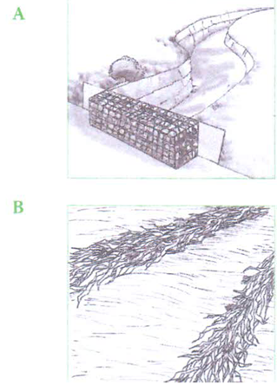

A B

1. Identify structures A and B. (1mk)

*A-Gabion.*

*B-Trash lines.*

1. Name the type of soil erosion controlled by structures A and B. (2mks)

*A-Gully erosion.*

*B-Sheet or rill erosion.*

1. State **two** ways in which the structures help to control soil erosion. (2mks)

*-They reduce the speed of run-off.*

*-They trap eroded soil particles.*

1. The diagrams below illustrate irish potato seed preparation before planting. Study it carefully and answer the questions that follow.



1. Name the practice used in preparing the seed potato above before planting. (1mk)

**Chitting/sprouting**

1. Describe the procedure followed in preparing the seed potatoes for planting. (3mks)

*-Arrange the setts/tubers in a store/ chitting box with the rose ends facing upwards.*

*-Tubers are arranged 2 to 3 layers deep*

*-Allow diffused light through the store. This encourages the production of short, green and healthy sprouts.*

*-Dust/ spray the setts/tubers with an appropriate insecticide to control aphids, tuber moths.*

*-Sprinkle some water on the tubers if the conditions are dry.*

1. Give **one** reason for carrying out the practice named above. (1mk)

*It ensures uniform sprouting /establishment in the field after planting.*

1. The photograph below shows an irish potato plant attacked by a disease. Study it and answer the questions that follow.

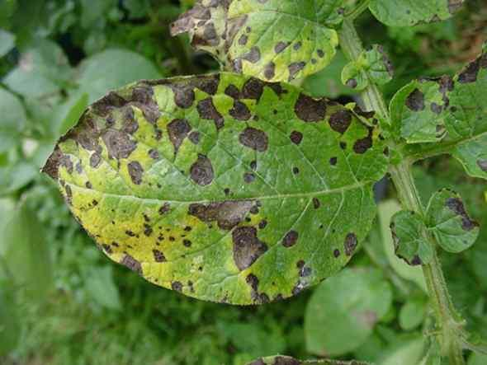

1. Identify the disease represented by the photograph. (1mk)

*Late blight*

1. Name the causative agent of the diseases. (1mk)

*Fungus/ Phytophthora infestans*

1. Give **one** other crop that can be attacked by the same disease. (1mk)

*Tomatoes*

1. List **two** control measures of the disease. (2mks)

*-Spraying with appropriate fungicides.*

*-Crop rotation.*

*-Use of certified seeds*

*-Roguing*

1. The photographs below show common weeds C and D in pasture land. Study them carefully and answer the questions that follow.

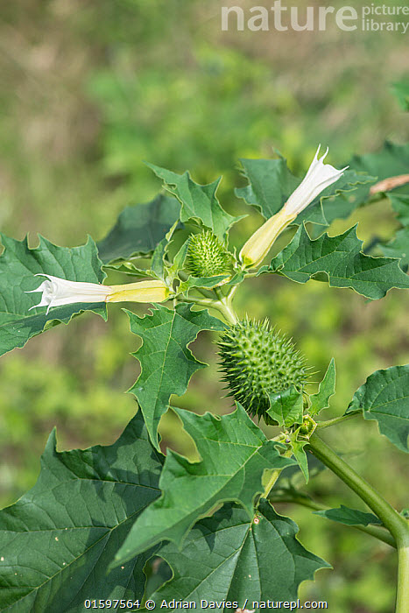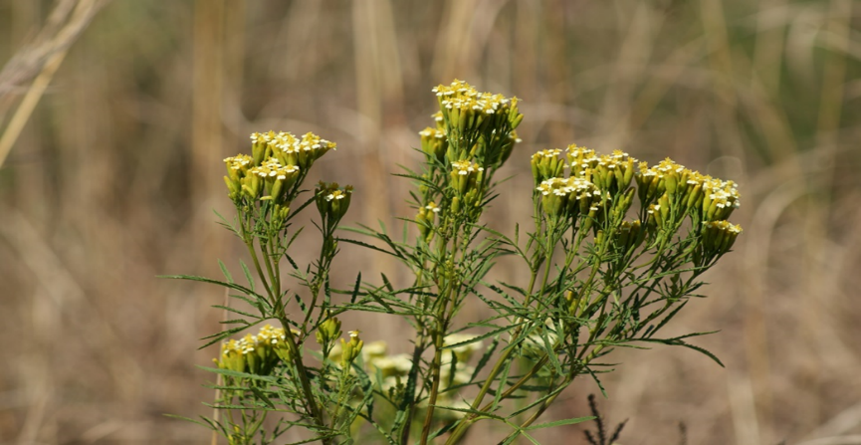

C D

1. Identify weeds C and D. (2mks)

C- Thorn apple/  *Datura stramonium*

D- Mexican marigold / *Tagetes minuta*

1. Classify weed D according to plant morphology. (1mk)

*Broad leafed.*

1. State the major problem posed by each of the weeds above in pasture land. (2mks)

*C-Poisonous to livestock.*

*D-It taints milk when fed to lactating cows.*

**SECTION C (40MARKS)**

1. a) State **four** benefits of sowing annual crops early. (4mks)

*-Enables the crop to withstand competition from weeds.*

*-Enables the crop to escape attack by pests and diseases.*

*-To better utilization of nutrients in the soil.*

*-For better utilization of available rainfall.*

*-To get good market.*

*-To reduce competition for labour.*

*-To time harvesting to occur during appropriate weather conditions.*

b) Describe **eight** effects of fragmentation and sub division of land. (8mks)

*-Time is wasted while travelling from one holding to another or from the farmstead to the various fragments.*

*-Proper and effective control of weeds and pests become difficult since the fragments are surrounded by other farmers’ holdings.*

*-It is difficult to allow a sound farm plan arising from the distribution between fragments and the farmers’ home.*

*-It is difficult to supervise the scattered plots.*

*-Control of livestock parasites and diseases will become difficult.*

*-It is difficult to carryout various soil conservation measures especially without the cooperation and concerted efforts from all the farmers.*

*-The size and shape of such holdings may be such that it is virtually impossible for the farmers to restrict grazing in one holding only.*

*-There are difficulties of offering agricultural extension advice.*

*-Agricultural productivity remains poor resulting in low standards of living.*

c) Explain **eight** effects of weeds. (8mks)

*-They compete with crops for nutrients, space, and light and soil moisture hence reducing crop yields.*

*-Some eg witch weed (Striga sp) are parasitic to cultivated crops eg maize.*

*-Some weed seeds lower the quality of agricultural produce. Some get attached to sheep wool lowering its quality.*

*-Some weeds are poisonous to man and livestock eg Datura stramonium.*

*-Some weeds act as alternate hosts for insect pests and others for diseases eg wild oats is an alternate host for rust.*

*-Some weeds are allelopathic ie produce poisonous substances that may suppress the growth or germination of cultivated plants*

*-Some block irrigation channels.*

*-Aquatic weeds affect fishing.*

*-Weeds lower the quality of pastures eg Lantana camara*

*-Some weeds are difficult to handle and control because they irritate the workers hence reducing the efficiency in which they are controlled eg stinging nettle and devils horsewhip.*

1. a) Describe the various field management practices for tomatoes. (8mks)

***-Gapping-****Any seedlings that dries after transplanting should be gapped to maintain the correct plant population.*

***-Top dressing-****At 25-30cm high tomato plants should be top dressed with nitrogenous fertilizers at the rate of 100kg CAN or SA per ha.*

***-Weeding-****The field should be kept weed free. Hand cultivation is done to control weeds. Care must be taken not to injure tomato roots and stems during weeding.*

***-Staking-****This is the practice of supporting tomatoes especially tall varieties using sticks which are about 2m high.*

***-Pruning-****This encourages the development of large fruits and controls upward growth.*

***-Tomato pests*** *eg American bollworm are controlled using appropriate pesticides to improve quality of fruits.*

*-****Tomato diseases*** *like tomato blight, bacterial wilt and blossom-end rot should be controlled using the appropriate ways.*

***-Mulching*** *to conserve moisture and smother weeds.*

*-****Watering*** *early in the morning and late in the evening during dry weather conditions.*

*(Any eight practices well described)*

b) State the precautions that should be observed when harvesting cotton. (4mks)

*-Picking should be done immediately the bolls open/split to prevent staining by dust.*

*-Picking should be done when the lint is dry to prevent fibres from sticking together.*

*-Use clean containers for picking to avoid contamination.*

*-Hands should be clean to avoid staining of the lint.*

*-Do not mix cotton with foreign matter eg leaves and small twigs.*

*-Use separate containers for separate cotton grades to ensure quality.*

*-Avoid using sisal bags for collecting the bolls because their fibres may mix with the seed cotton thus creating problems during ginning. (Any four)*

c) Explain **four** importance of crop rotation. (8mks)

***-Maximum utilization of nutrients****- Alternating shallow with deep rooted crops ensures that nutrients from different layers are well utilized.*

***-Control of soil borne pests and disease build up****- Eg root eelworms in pyrethrum. Pests and diseases are specific to various crops.*

***-Control of weeds*** *-Parasitic weeds eg witch weed (Striga weed) are susceptible to grass family crops and can be controlled by planting non grass crops for some time.*

***-Improvement of soil fertility****-When leguminous crops are included in the rotation programme, they help in fixing nitrogen with the help of Rhizobium bacteria. This nitrogen is made available for subsequent crops.*

***-Improvement of soil structure-*** *It is recommended that at the end of the rotation programme a grass ley be established. The roots of grass are so extensive that they bind soil particles together.*

***-Control of soil erosion****-If crops planted in rows eg maize is alternated with cover crops eg sweet potatoes.*

1. a) Explain **four** factors to consider in choosing the type of irrigation to use in the farm.

(8mks)

***-Capital availability-*** *Putting up irrigation structures requires money.*

***-Topography of the land-*** *For flood irrigation the land ought to be level enough. Furrow irrigation is only possible on gentle sloping land.*

***-Water availability-****If water is limited; drip irrigation will be preferred offer sprinkler irrigation.*

***-Type of soil-*** *Heavy soils such as clayey is suitable for furrow irrigation.*

***-Type of crop to be irrigated-*** *For rice growing basin irrigation is preferred over sprinkler irrigation.*

b) Explain **five** farming practices that destroy soil structure. (5mks)

*-Over cultivation which leads to pulverization of soil ie breaking soil into fine particles.*

*-Use of heavy machinery to cultivate soil.*

*-Cultivation at the wrong time such as when soils are too wet or too dry.*

*-Deforestation exposes soil to erosion hence destruction of soil structure.*

*-Overstocking/overgrazing exposes soil to erosion hence destruction of soil structure.*

*-Burning of vegetation-Destroys organic matter leading to the destruction of soil structure.*

*-Monocropping/ monoculture- This is the practice of growing one type of crop in a farm or one piece of land without alternating which may lead to destruction of soil structure.*

*(Any five)*

c) Describe **seven** reasons why farmers need to keep good farm records. (7mks)

*-They help a farmer in planning and making decisions in the farm.*

*-Help to compare the performance of different enterprises within a farm or other farms.*

*-Show the history of the farm.*

*-Guide a farmer in planning and budgeting of farm operations.*

*-Help to detect losses or theft on the farm.*

*-Help in the assessment of income tax to avoid over or under taxation.*

*-Help to determine the value of the farm or to determine the assets and liabilities of the farm.*

*-Makes it easy to share the profits and losses in partnership.*

*-Helps in settling disputes among heirs eg if a farmer dies without a will.*

*-Helps to show whether the farm business is making profits or losses.*

*-Provides information to help determine a farmer’s credit worthiness.*

*-Helps in supporting insurance claims on death, theft and fire of farm assets.*

*-Provide labour information like terminal benefits eg NSSF dues.*

*(any seven)*